

Design and Simulation of a Resilient Network Infrastructure for INTECH Computer Systems (Pvt.) Ltd

CCU 3603 – Individual Project 2

Final Report

Bachelor of Information Technology (Hons.) in Computer Networks

Student Name : Yesmin Jalaldeen
Student ID : E029590
Student Batch : 03

Declaration

Module: CCU3603 Deadline: 22nd June 2025

Student Declaration

I hereby, declare that I know what plagiarism entails, namely, to use another’s work and to present it as my own without attributing the sources in the correct way. I further understand what it means to copy another’s work.

- I know that plagiarism is a punishable offence because it constitutes theft.
- I know what the consequences will be if I plagiaries or copy another’s work in any of the assignments for this program.
- I declare therefore that all work presented by our group for every aspect of our program, will be our own, and where we have made use of another’s work, we will attribute the source in the correct way.
- I acknowledge that the attachment of this document signed or not, constitutes a binding agreement between ourselves and ESOFT.

I declare that this project is my own work and has not been submitted in any form for another degree or diploma at any university or other institution of tertiary education. Information derived from the published or unpublished work of others has been acknowledged in the text and a list of references is given.

05/08/2025

Signatures of the student Date
(Provide Submission Date)

Acknowledgement

I would first like to express my sincere gratitude to Mr. K.G. Ravindu U. Ishara, my former supervisor, for his invaluable guidance and support during the initial stages of this Individual Project. His insights and encouragement provided a strong foundation for the work presented in this document.

I would also like to extend my heartfelt appreciation to Ms. Thayuri Kaushalya and to Ms. Virajini Godapitiya, my current project supervisors, for their continued guidance, support, and constructive feedback throughout the remaining course of this project. Their contributions have been instrumental in shaping and finalizing the project.

Additionally, I am grateful to everyone who has contributed to this study, including my senior colleagues and peers, whose time, support, and assistance have helped me successfully complete this document.

Abstract

This project focuses on designing and implementing a secure, scalable, and logically segmented enterprise network for INTECH Computer Systems (Pvt) Ltd using GNS3. It addresses common challenges faced by SMEs such as managing network growth, ensuring secure inter-departmental communication, and maintaining cost-efficiency. The proposed network architecture incorporates key networking principles including VLAN segmentation, DHCP allocation, dynamic routing, redundancy, and essential security mechanisms to enhance overall network performance and manageability [1], [2].
Each department is assigned a unique VLAN, with subnets optimized using Variable Length Subnet Masking (VLSM) [3]. Inter-VLAN routing is handled via RouterOS on MikroTik routers, providing precise control over gateway and routing logic. OSPF is deployed as the dynamic routing protocol, supporting secure and loop-free communication between VLANs. The use of OSPF authentication enhances routing security by preventing unauthorized route advertisements [4], [5]. DHCP servers are configured to automate IP distribution for each VLAN, streamlining network management tasks and minimizing manual configuration errors [6].

Redundancy is simulated using dual core routers and virtual gateway concepts to ensure high availability, replacing traditional methods such as HSRP where required. Redundant links between switches are managed using Spanning Tree Protocol (STP) to prevent loops and broadcast storms [7]. Network security is reinforced through Access Control Lists (ACLs), Port Security, and DHCP Snooping to mitigate unauthorized access and internal threats [8]. Despite limitations in simulating advanced tools like SNMP or IDS in GNS3’s virtualized environment, alternative methods such as ICMP-based ping and traceroute are used to verify connectivity and enforce policy controls. The final result is a robust, modular, and secure enterprise network model, offering a practical and cost-effective blueprint for real-world SME deployments.

Table of Contents

CCU 3603 – Individual Project 2 1
Final Report 1
Declaration 2
Acknowledgement 3
Abstract 4
Table of Contents 5
List of Tables 8
List of Figures 8
List of Acronyms 9
Background 14
Chapter 1. Introduction 16
1.1. Project Background 16
1.1.1. Problem Statement 17
1.2. Aim and Objectives 18
Aim 18
Objectives 18
1.3. Scope of the Project 19
1.3.1. Scope Inclusions 19
1.3.2. Scope Exclusions 20
Chapter 2. Literature Review 22
2.1. Domain 22
2.1.1. Studies, Approaches, and Facts 23
2.1.2. Similar Studies on Simulated Network Environments 26
2.1.3. Comparison Table 35
2.1.4. Algorithms 37
2.1.5. Research Gap 39
2.2. Technical 44
2.2.1. Tools and technologies (API, libraries) 44
Chapter 3. Analysis 47
3.1. Analysis of the Current System 47
3.1.1. Current Network Overview 49
3.1.2. Floor Plan and Equipment Layout Analysis 50
3.2. Requirement Analysis 53
3.2.1. User/ Client Requirement 53
3.2.2. System Requirements 55
3.2.3. Hardware Requirements 58
3.2.4. Software Requirements 59
3.3. Feasibility Study 60
3.3.1. Technical Feasibility 60
3.3.2. Economic Feasibility 61
3.3.3. Operational Feasibility 61
3.3.4. Scheduling Feasibility 62
3.3.5. Legal and Ethical Feasibility 62
3.4. Methodology and Planning Artifact 63
3.4.1. Methodology 63
3.4.2. Planning (Eg: Gantt chart, etc..) 68
Chapter 4. Network Planning and Design 73
4.1. Alternate Solution Evaluation 73
4.2. Network Planning 74
4.2.1. Departments and User Allocation 74
4.2.2. IP Addressing Scheme 74
4.3. Network Design 77
4.3.1. Hierarchical Network Design 77
4.3.2. Logical Design 81
4.3.3. High Availability 82
4.3.4. Monitoring and Management 82
Chapter 5. Implementation 84
5.1. Implementation Environment 84
5.2. Development Tools 89
5.3. Major Code Segments 92
Chapter 6. Evaluation 101
6.1. Network Testing Overview 101
6.2. Types of Network Testing 103
6.3. Test Plan and Test Cases 104
Chapter 7. Conclusion 125
7.1. Critical Evaluation 127
7.2. Limitation 129
7.3. Future work 131
7.4. Lesson learnt 133
References 135
Appendix 145

List of Tables
Table 1: Summary of Comparison Table 36
Table 2: Hardware Requirements_INTECH 58
Table 3: Software Requirements_INTECH 59
Table 4: Departments and User Allocation Table 74
Table 5: VLSM Summary Table 81

List of Figures

Figure 1: INTECH 2nd Floor Plan 51
Figure 2: INTECH 1st Floor Plan 51
Figure 3: Existing Network Infrasturcture of INTECH 52
Figure 4: Project Plan 69
Figure 5: Gantt Chart 69
Figure 6: Conceptual 3 tier Architecture 78
Figure 7: Network Blueprint of INTECH 80
Figure 8: Basic Security Configurations 92
Figure 9: Access and Trunk Port Configuration 93
Figure 10: Basic Security Configurations_2 93
Figure 11: Port Security Configurations_2 94
Figure 12: Port Security Configuration 94
Figure 13: VTP Configurations 95
Figure 14: Spanning Tree Configurations for L2 Switches 95
Figure 15: Static IP Configurations for PCs 96
Figure 16: Spanning Tree Configurations on MLS 97
Figure 17: VTP and VLAN Database from Multilayer Switch 97
Figure 18: Trunk port Configurations_MLS 98
Figure 19: Spanning Tree Configurations_2 98
Figure 20: Interface Connectivity via ROS on Router 99
Figure 21: Interface Connectivity via ROS on Router_2 99
Figure 22: OSPF Configurations 100
Figure 23: Summarized Test Plan Table 105
Figure 24: Test Cases for Ping Tests 105
Figure 25: Inter Vlan Testing_2nd Floor 106
Figure 26: Inter-Vlan Testing_ 1st Floor 106
Figure 27: Path Vrification Test 2nd floor 107
Figure 28: Path Verification (Traceroute) 1st Floor 107
Figure 29: Ping Test 1 108
Figure 30: Ping Test 2 109
Figure 31: Traceroute test 110
Figure 32: Traceroute test 2 111
Figure 33: User Feedback 1 119
Figure 34" User Feedback 2 120
Figure 35: User Feedback 4 121
Figure 36: User Feedback 3 121
Figure 37: User Feedback 5 122
Figure 38: User feedback 6 122
Figure 39: Client Letter 145

List of Acronyms

ACL – Access Control List
Rules used on routers and switches to permit or deny traffic based on IP addresses, ports, or protocols.

AI – Artificial Intelligence
The simulation of human intelligence in machines that can perform tasks like learning, reasoning, and problem-solving.

AP – Access Point : A device that connects wireless clients to a wired network using Wi-Fi.

ASA – Adaptive Security Appliance
A Cisco firewall and security device used to manage and enforce security policies.

CLI – Command Line Interface
A text-based interface used to interact with a device or software by typing commands.

Cisco DNA – Cisco Digital Network Architecture
Cisco’s intent-based networking platform for automation, security, and analytics.

CPU – Central Processing Unit : The main processor of a computer that carries out instructions of a program.

DDoS – Distributed Denial of Service
A type of cyberattack where multiple systems flood a target system, causing disruption or failure.

DHCP – Dynamic Host Configuration Protocol
A protocol used to automatically assign IP addresses and network configuration to devices.

DMZ – Demilitarized Zone
A subnetwork that separates an internal LAN from untrusted external networks, usually for hosting public-facing services.

DNS – Domain Name System
Translates human-friendly domain names (like www.example.com) into IP addresses.

EVE-NG – Emulated Virtual Environment Next Generation
A network emulator that allows testing and designing virtual networks using real OS images.

HR – Human Resources
The department responsible for hiring, training, employee welfare, and administrative tasks.

HSRP – Hot Standby Router Protocol
Cisco’s protocol for ensuring high availability of the default gateway, allowing backup routers to take over in case of failure.

IDS – Intrusion Detection System : Monitors network or system traffic for suspicious activity and policy violations.

IPS – Intrusion Prevention System
A proactive system that monitors network traffic and blocks potential threats in real-time.

IPSec – Internet Protocol Security
A protocol suite for secure communication over IP networks using encryption and authentication.

IPv4 – Internet Protocol version 4 : A 32-bit IP addressing format used to identify devices on a network.

IOS – Internetwork Operating System : Cisco’s operating system used on most of its routers and switches.

IT – Information Technology
The department responsible for the management of computer systems, networks, and data within an organization.

MIB – Management Information Base
A collection of information organized hierarchically used by SNMP to monitor network devices.

NAT – Network Address Translation
A method that allows multiple devices on a local network to share a single public IP address for internet access.

OS – Operating System
System software that manages computer hardware and software resources and provides services for applications.

OSPF – Open Shortest Path First
A dynamic routing protocol that finds the best path for data packets using link-state information.

PC – Personal Computer : A general-purpose computer typically used by one person for work or leisure.

pfSense – Packet Filter Sense
An open-source firewall and router operating system based on FreeBSD, used for advanced network management.

PRTG – Paessler Router Traffic Grapher
A network monitoring tool that collects data and displays the status of systems and devices.

RFC – Request for Comments : A formal document from the IETF that defines internet standards and protocols.

RIP – Routing Information Protocol
A distance-vector dynamic routing protocol using hop count as its routing metric.

RoS – RouterOS : A MikroTik operating system used in routers for configuration, routing, and network services.

R&D – Research and Development
A department responsible for developing new products or services and improving existing ones.

SIEM – Security Information and Event Management
A security solution that provides real-time analysis of security alerts generated by applications and network hardware.

SLA – Service Level Agreement
A contract between a service provider and client defining the level of service expected.

SNMP – Simple Network Management Protocol : Used to collect and manage information from network devices in a standardized way.

SPF – Shortest Path First
An algorithm used by routing protocols (like OSPF) to determine the most efficient path between nodes in a network.

SSH – Secure Shell
A cryptographic protocol for securely accessing and managing network devices remotely.

SSL – Secure Sockets Layer : A protocol for establishing encrypted links between web servers and browsers.
STP – Spanning Tree Protocol : Prevents loops in a network by dynamically disabling redundant paths.

SVI – Switch Virtual Interface : A virtual interface on a multilayer switch that enables inter-VLAN routing.

TCP/IP – Transmission Control Protocol / Internet Protocol
The basic communication language of the Internet and most modern networks.

VLAN – Virtual Local Area Network
A logically segmented network that separates devices regardless of physical location for improved management and security.

VLSM – Variable Length Subnet Masking
A subnetting method that allocates IP address space more efficiently by using different subnet mask lengths.

VPN – Virtual Private Network
Creates a secure connection over the internet to another network, commonly used for secure remote access.

VRRP – Virtual Router Redundancy Protocol
A protocol that increases network reliability by assigning a virtual IP to multiple routers, with failover capability.

WAN – Wide Area Network
A telecommunications network that extends over large geographic areas, typically composed of multiple LANs.

WLAN – Wireless Local Area Network
A wireless network that enables communication between devices within a local area using Wi-Fi.

WPA2 – Wi-Fi Protected Access 2 :A security protocol for wireless networks that encrypts data and controls access to the network.

Background

In today’s rapidly evolving business environment, enterprise networks must be designed to support increasing demands for scalability, security, and reliability. INTECH Computer Systems (Pvt) Ltd, like many modern small and medium-sized enterprises face challenges related to managing a growing number of users, diverse departmental needs, and stringent security requirements. Traditional flat network designs often lead to inefficient resource usage, security vulnerabilities, and limited ability to adapt to business growth or technological change [9].

To address these challenges, enterprises are adopting hierarchical network architectures that separate the network into layers (core, distribution, access) to improve performance, manageability, and fault tolerance. Additionally, technologies such as VLAN segmentation, dynamic routing protocols like OSPF, redundancy protocols like HSRP or VRRP, and advanced security measures (ACLs, port security, IDS) are critical components for modern networks [10]. These allow effective traffic management, inter-departmental isolation, continuous availability, and proactive threat detection [11].

Simulating and testing network designs before physical deployment is essential to reduce risks and optimize configurations. GNS3 is a widely used open-source tool that provides real-time emulation of complex network topologies. It allows users to integrate virtual and real devices, making it suitable for enterprise-level network simulations [12]. By leveraging GNS3, this project aims to design and implement a scalable, secure, and resilient network architecture for INTECH Computer Systems that aligns with current best practices, supports future expansion, and safeguards critical organizational data [9].

This background sets the context for the project’s objectives to develop a hierarchical network design incorporating VLAN segmentation, dynamic routing with OSPF, redundancy through failover protocols, and network monitoring tools which is all simulated within GNS3. to enhance INTECH’s network performance, security, and operational continuity.

Introduction

INTECH Computer Systems (Pvt) Ltd is experiencing significant organizational growth, which has placed increasing pressure on its existing network infrastructure. The current setup, developed without a long-term vision, struggles to meet modern enterprise demands in terms of performance, security, and scalability. This project focuses on designing a scalable, secure, and resilient enterprise network to support INTECH’s future operations. Through this design and simulation, the goal is to introduce modern networking practices that will enable seamless expansion, reliable communication, enhanced monitoring, and stronger security. The report outlines the process of analyzing the existing network issues, designing an improved architecture using technologies such as VLAN segmentation, dynamic routing (OSPF), and redundancy mechanisms, and validating it through simulation-based testing.

Project Background
As INTECH Computer Systems (Pvt) Ltd.’s workforce and client base continue to grow, the limitations of the current network infrastructure have become increasingly apparent. The existing network was constructed in a piecemeal fashion, lacking a unified design or forward-looking strategy, which has led to critical issues such as high latency during peak operational periods, unreliable connectivity, minimal network visibility, and weak security—particularly for remote users [13] [14].
Modern enterprise networks must not only support current operations but also provide scalability, fault tolerance, and centralized management. Without these features, productivity and security are compromised, especially in competitive sectors where digital operations are integral [15]. This project is designed to overcome these deficiencies by architecting a network aligned with industry best practices, emphasizing redundancy, dynamic routing, segmentation, and secure access protocols. The proposed design will be validated through simulation using platforms like GNS3 to test scalability, security posture, and performance under realistic workloads [16].

Problem Statement

The current network infrastructure at INTECH Computer Systems (Pvt) Ltd was developed without a strategic long-term plan, resulting in a system that cannot meet the operational demands of a growing enterprise [17] [18]. As the company continues to expand, several technical and structural issues have become increasingly evident, ranging from performance bottlenecks to security gaps and maintenance bottlenecks; affecting the network’s overall efficiency, security posture, and ease of management [19] [20].

These issues include scalability limitations, where the existing infrastructure struggles to accommodate additional devices and growing data traffic, hindering the company’s ability to expand efficiently [21]. The network also suffers from maintenance complexity, primarily due to unstructured cabling and the absence of redundancy, which increases downtime and delays troubleshooting [22]. Security vulnerabilities further compound these problems, as the lack of proper VLAN segmentation and secure remote access exposes sensitive systems to internal and external threats [23]. Finally, monitoring challenges persist due to the absence of adequate visibility tools and fault detection mechanisms, making it difficult to proactively identify and resolve issues [24]. These limitations collectively compromise performance, increase operational risk, and highlight the urgent need for a more robust and future-proof network infrastructure at INTECH Computer Systems (Pvt) Ltd.

Aim and Objectives

Aim
To design and implement a scalable, efficient, and resilient enterprise network for INTECH Computer Systems (Pvt) Ltd that addresses limitations in scalability, management, security, and redundancy through advanced networking technologies.

Objectives

- To design a scalable network topology to dynamically adjust to growth and traffic demands.

- To implement network monitoring tools to proactively mitigate threats.

- To establish effective network segmentation using VLANs and DMZ for enhanced security and performance.

- To ensure redundancy and high availability through failover mechanisms and redundant pathways.

- To optimize resource allocation and management to improve overall efficiency

Scope of the Project

Scope Inclusions

- Network Architecture Design: Design a robust network architecture that includes a DMZ, internal network segmentation with VLANs

- Dynamic Routing with OSPF:
- Configure OSPF as the dynamic routing protocol across the network to manage traffic efficiently, ensuring scalability and optimized data flow.
  - Implement security measures for OSPF, such as route authentication and ACLs to secure routing information.

- DMZ Setup:
  - Design and implement a secure DMZ to host publicly accessible services like web servers and email servers.
  - Integrate firewalls to secure isolation of the DMZ from the internal network.
  - Apply strict access control between the DMZ and the internal network to protect sensitive data.

- Network Monitoring and Intrusion Detection:
- Implement SNMP for real-time network performance monitoring.
- Deploy an IDS to monitor traffic within the DMZ and internal network, with automated alerts for potential threats.

- High Availability and Redundancy:
- Implement high availability protocols to ensure network reliability during device or link failures.
- Design redundant network links and devices to maintain service continuity.
- Conduct failover testing to validate the effectiveness of the high availability setup.

- Packet Tracer Simulation:
- Simulate the entire network design in Packet Tracer, including routers, switches, firewalls, and monitoring tools.
- Perform comprehensive testing within the Packet Tracer environment to validate network functionality and resilience.

Scope Exclusions

- Physical Network Deployment: Excludes the deployment of physical hardware; the focus is on virtual simulation.

- Vendor-Specific Hardware Configuration: The project does not involve proprietary hardware solutions; generic virtual devices will be used.

- Long-Term Network Management: Excludes ongoing maintenance or troubleshooting post-implementation.

- Advanced Security Features: Features like AI-based threat detection or deep packet inspection are beyond this project’s scope.

- Third-Party Service Integration: Integration of external services or cloud-based solutions is not included.

- End-User Training: Training end-users or IT staff on using the newly implemented network infrastructure is not included in this project's scope.

- VPN for Secure Remote Access:
  - Set up secure VPNs for remote users to access the internal network, utilizing IPsec or SSL for encryption and authentication.
  - Ensure secure remote access to services hosted in both the DMZ and the internal network.

Literature Review

Modern enterprise networks require robust, scalable, and secure architectures to meet evolving business demands. Designing such networks involves adopting efficient communication frameworks that ensure reliable connectivity, resource sharing, and protection against threats. This literature review examines existing research, methodologies, and protocols that guide the development of scalable and resilient enterprise networks, with a focus on INTECH Computer Systems (Pvt) Ltd. It highlights key elements such as hierarchical architecture, routing protocols, security mechanisms, redundancy strategies, and the role of simulation tools in validating network designs to ensure cost-effectiveness and minimize operational risks.

Domain

This project falls within the domain of enterprise network design and simulation, emphasizing the development of scalable, hierarchical network architectures tailored to meet the growing demands of modern organizations. Key focus areas include the use of dynamic routing protocols such as OSPF to enable efficient path selection and rapid convergence [25], as well as network segmentation using VLANs and access control mechanisms to enhance traffic isolation and security [26]. To ensure business continuity and minimize downtime, high availability and redundancy protocols like HSRP or VRRP are integrated, allowing seamless failover in the event of device or link failure [27]. The design also incorporates real-time monitoring systems and proactive fault detection to facilitate prompt responses to network anomalies [28]. Furthermore, security is reinforced through the implementation of Access Control Lists (ACLs), firewalls, and Intrusion Detection Systems (IDS) to defend against both internal and external threats [29]. The entire solution is simulated and tested using GNS3, an open-source network emulation platform that enables accurate testing of performance, security, and redundancy mechanisms in a virtualized environment [30].

Studies, Approaches, and Facts

Hierarchical Network Design

The Cisco hierarchical network model remains a foundational framework in modern enterprise network design, structuring infrastructure into three modular layers; Core, Distribution, and Access

Each responsible for distinct operational tasks. The Core Layer focuses on high-speed, low-latency data transport and interconnects distribution blocks while maintaining fault tolerance. The Distribution Layer handles routing, access control policies, and redundancy mechanisms by aggregating traffic from the access layer. The Access Layer provides direct connectivity for end-user devices, supporting VLAN segmentation and authentication mechanisms [31].

This layered approach significantly improves scalability, eases fault isolation, and simplifies network troubleshooting and policy enforcement. It also supports the flexible integration of advanced technologies such as software-defined networking and zero-trust architectures [32]. By localizing the impact of faults and streamlining data flow management, the model ensures high availability and operational continuity in complex enterprise environments [33]. Due to these advantages, the hierarchical model continues to be a widely adopted best practice for scalable and resilient enterprise network design.

Dynamic Routing with OSPF

OSPF is a widely implemented link-state dynamic routing protocol known for its scalability, fast convergence, and suitability for enterprise networks. Unlike legacy protocols such as RIP, which suffer from limitations like a 15-hop count and slow convergence, OSPF employs a hierarchical area-based design that supports large-scale network deployments efficiently [34].
By using Dijkstra’s SPF algorithm, OSPF determines optimal paths for packet forwarding, thereby improving link utilization and supporting equal-cost multi-path routing [35]. Route summarization within OSPF areas reduces routing table size and minimizes overhead, enabling rapid adaptation to network changes. In addition to performance benefits, OSPF supports robust security features such as MD5 and SHA-based route authentication, protecting the integrity of routing updates and preventing unauthorized advertisements [36].
These capabilities make OSPF a preferred choice for enterprise-grade network architectures requiring high performance, scalability, and strong routing security.

Redundancy Protocols

Network redundancy protocols play a vital role in maintaining high availability. The Hot Standby Router Protocol (HSRP) ensures automatic failover between a primary and backup router, using a shared virtual IP address to maintain uninterrupted service. When the primary router fails, traffic is seamlessly redirected to the standby router [37].

Recent studies highlight the importance of integrating redundancy protocols like HSRP with redundant links and hardware components to improve network resilience. For instance, redundancy strategies have been shown to reduce mean downtime and ensure continuous availability in mission-critical enterprise networks [38].

DMZ and IDS Implementation

A DMZ adds an extra layer of security by segregating public-facing services (e.g., web, email, DNS servers) from the internal network. Isolating these services reduces the risk of external attacks reaching sensitive internal systems [39]. DMZ implementation effectively mitigates external threats and limits the impact of potential breaches [40]. Additionally, deploying an IDS is crucial for detecting and responding to suspicious network activity. IDS tools monitor traffic patterns in real time and generate alerts for anomalies, significantly improving incident response capabilities [41]. These systems align with the growing shift toward proactive security strategies in modern enterprise networks [42].

Network Monitoring

Network monitoring is vital for maintaining optimal performance and ensuring proactive management. The SNMP is widely used for collecting real-time performance metrics. SNMP agents on network devices relay data to centralized monitoring systems, allowing administrators to detect issues before they affect operations [43].

Advanced tools like SolarWinds and PRTG Network Monitor enhance SNMP capabilities by offering graphical dashboards, customizable alerts, and detailed traffic analytics. These tools support bottleneck identification, resource optimization, and SLA compliance [44].

Security Enhancements

Firewalls are fundamental to enforcing security policies by regulating network traffic based on defined rules. Solutions such as pfSense and Cisco ASA are widely deployed to control access between internal systems and external networks. When combined with VLANs for logical segmentation and ACLs for fine-grained permissions, these components establish a multi-layered security architecture [45].

Similar Studies on Simulated Network Environments

1. Redundant Enterprise Network Simulation with OSPF and HSRP
Al-Mahmoud et al. [46] designed and evaluated a redundant enterprise network infrastructure using GNS3, integrating dynamic routing via OSPF and high availability protocols such as HSRP. Their simulation focused on the behavior of failover under core router or link failure scenarios, and the results demonstrated minimal downtime during convergence. The authors used real Cisco IOS images within GNS3 to replicate live conditions, validating the system’s ability to recover using virtualized standby routers. They also evaluated HSRP priority configurations and track interfaces to optimize failover decisions. Their research highlighted how simulation platforms like GNS3 can be leveraged to preemptively validate fault tolerance mechanisms before deployment, ensuring uninterrupted services during failure. This aligns directly with the current project’s objective of implementing failover, redundancy, and routing convergence testing using simulation environments.

2. VLAN-Based Segmentation and Access Control Simulation
Rahul and Mohan [47] conducted a comprehensive simulation of a campus-style enterprise network using GNS3 to implement VLAN segmentation, inter-VLAN routing, and access control through ACLs. Their study replicated multiple departments with isolated Layer 2 domains, Layer 3 routing via a central router, and policy enforcement through extended ACLs that restricted access between sensitive VLANs. DHCP services were also deployed per VLAN using router-on-a-stick configurations. The authors observed improvements in broadcast domain efficiency, fault isolation, and simplified policy enforcement through modular VLAN design. Their use of Cisco IOS in GNS3 allowed for granular control and realistic behavior of VLAN tagging and trunking. This directly supports the current project’s use of VLANs and ACLs for traffic segmentation and controlled access across enterprise departments.

3. Integrated SNMP and IDS Monitoring for Threat Detection
Ali and Kadhim [48] implemented a monitoring framework using SNMP and Snort IDS within a GNS3-simulated enterprise network to evaluate real-time alerting and threat visibility. SNMP agents were installed on key routers and switches, reporting interface statistics and system health to a central NMS. Simultaneously, Snort was deployed in inline and passive modes to detect abnormal patterns such as port scans, brute-force attempts, and malformed packets. Their simulation involved testing alert thresholds, community string security, and automated logging. Findings revealed that SNMP was effective in detecting early-stage hardware or traffic anomalies, while IDS provided deep packet inspection and actionable intrusion alerts. This hybrid approach enabled a layered monitoring architecture that resonates with the current project’s objectives to use SNMP and IDS to proactively identify and mitigate threats in segmented and monitored networks.

4. Secure OSPF Route Optimization in Enterprise Simulation
Eldib and Abbas [49] simulated a secure routing environment using OSPF within a medium-scale enterprise network modeled in GNS3. Their configuration involved multi-area OSPF deployment with route summarization to reduce routing table size and MD5 authentication to protect route exchanges from unauthorized updates. They used multiple routers simulating departmental core segments, each assigned to different OSPF areas. The study measured convergence time, route flapping, and CPU load under normal and failure conditions. Findings confirmed that proper area design, summarization, and authentication greatly improved scalability and security while reducing unnecessary LSA flooding. The research is highly relevant to this project’s goal of implementing dynamic and secure routing that can scale with organizational growth while maintaining routing integrity.

5. DMZ and Firewall Simulation for Public Service Isolation
Mwangi and Kamau [50] proposed a secure network architecture using GNS3 to simulate a DMZ environment housing web and email servers, with pfSense firewalls enforcing traffic control between the DMZ, internal network, and external users. The simulation replicated dual-homed firewalls with NAT and rule-based access policies restricting service-specific access (e.g., HTTP, SMTP). Logging and alerting mechanisms were enabled to monitor unauthorized access attempts. Results showed that strict zone-based segmentation with granular firewall rules effectively mitigated risks of lateral movement and external intrusion. The setup also allowed safe exposure of public services while shielding the internal VLANs from direct access. This mirrors the project’s DMZ and firewall scope, which aims to isolate public-facing services using robust security controls implemented and validated in simulation.

6. High Availability Simulation Using OSPF with VRRP
Santos et al. [51] built an enterprise-grade network in GNS3 integrating OSPF as the dynamic routing protocol alongside Virtual Router Redundancy Protocol (VRRP) for gateway high availability. They modeled dual core routers per subnet and configured VRRP groups with priority attributes tied to interface health. Their experiments measured failover switching times under simulated router and link failures, demonstrating sub-second convergence to maintain uninterrupted connectivity. They also tested OSPF route recalculation and traffic switching, evaluating packet loss during failover. This in-depth simulation validated the project’s objective of redundancy and quick failover resilience through combined routing and redundancy strategy.

7. Robust VLAN Segmentation, DHCP Clustering, and OSPF Routing
Nguyen and Tran [52] set up a multi-tenant network in GNS3 with departmental VLANs, deploying DHCP clusters per VLAN for redundancy and resilience. Layer-3 inter-VLAN routing was dynamically handled by OSPF configured across routers. They simulated DHCP service failure and observed that backup DHCP servers maintained IP allocation without disruption. Additionally, they tested OSPF recalculation paths when primary links failed, confirming seamless rerouting and minimal traffic interruption. This supports the project's goals: scalable VLAN design, DHCP fault tolerance, and dynamic routing resilience.

8. Layer-3 ACL Enforcement in VLAN Environments
Chakraborty et al. [53] designed a GNS3 architecture where traffic between VLANs passed through distribution switches enforcing ACL-based firewall policies. They used extended ACLs tied to specific subnet ranges and service ports to restrict unauthorized cross-VLAN access. Traffic flow testing included simulated unauthorized attempts, latency measurements, and packet loss tracking. Their results indicated ACL enforcement added negligible latency while significantly improving inter-VLAN isolation. This study aligns with the project’s segmentation and access control objectives using VLANs and ACL flow-based policy enforcement.

9. Distributed SNMP Monitoring for Proactive Performance Management
Rodriguez and Lee [54] implemented SNMP across network devices in a GNS3 simulation, pushing metrics (like CPU load, interface errors, link utilization) to a centralized Network Management System. They configured polling intervals and alert thresholds mapped to SLA terms. During simulated traffic peaks and link saturation events, alerts triggered early warnings before performance degraded. Community strings, SNMPv3 security modes, and SNMP trap handling were also evaluated. The architecture proved capable of early fault detection and resource optimization, meeting the objectives of proactive monitoring and SLA-aware management.

10. Hybrid OSPF-BGP Routing for Edge Scalability
Wang et al. [55] simulated enterprise WAN edge routing using GNS3 with internal OSPF domains and external BGP neighbor relationships. Core routers redistributed OSPF-learned networks into BGP sessions simulating ISP connections. Experiments included path failure, reannouncement delays, and route flapping under link instability. Summarization reduced BGP advertisement volumes to conserve bandwidth. The hybrid design provided flexible scaling, controlled routing policy, and dynamic edge resilience—supporting the project’s aim of scalable, automatically managed routing architecture at enterprise edges.

11. IDS Placement and Threat Detection across Network Zones
Peter and Kumar [56] deployed Snort IDS sensors at boundaries between internal LANs and the DMZ in a GNS3-built enterprise topology. They crafted traffic injection campaigns including port scans, XSS attempts, and brute-force logins targeting DMZ servers. IDS logs were analyzed for detection accuracy, timestamp correlation, and response latency. The researchers tuned rule signatures to minimize false positives while ensuring rapid detection. Their findings underscore effective IDS deployment in segmented zones, precisely matching the aim to integrate IDS for threat visibility across DMZ/internal boundaries.

12. DMZ Load Balancer and Firewall Resilience Simulation
Ahmed and Musa [57] created a GNS3-based DMZ containing dual web servers behind a software load balancer and pfSense firewalls. Failover scenarios were executed by simulating server and firewall outages. Traffic distribution balanced accordingly, and NAT/policy rules maintained service continuity for TCP-based HTTP flows. Monitoring metrics captured session persistence, response latency, and firewall log validation. The simulated architecture verified both security isolation and high availability of public-facing services, aligning seamlessly with the DMZ and redundancy objectives.

13. Multi-Area OSPF with Route Summarization Study
Jiang et al. [58] partitioned a simulated enterprise network into hierarchical OSPF areas using GNS3, implementing summarization at ABR routers to reduce routing complexity. They applied MD5 authentication on OSPF neighbors and measured LSA propagation overhead, convergence times, and CPU utilization under incremental network size. Summarization showed clear reduction in LSA traffic and improved responsiveness. Their secure, multi-area OSPF scheme directly supports the scope of scalable routing and protected dynamic configuration.

14. Firewall-Enforced VLAN Isolation in Corporate Networks
Martinez and Lopez [59] modeled enterprise VLAN scenarios in GNS3 using distributed firewalls at zone junctions. They enforced ACLs to allow selected inter-VLAN access only where policy permits. Traffic logs recorded blocked and passed flows. Realistic NAT and stateful inspection rules ensured service-level policies while preventing lateral movement. These results affirm the effectiveness of firewall-based VLAN enforcement—central to the segmentation and access control design.

15. EtherChannel Aggregation and Redundancy in Simulations
Chen and Wu [60] explored link-level redundancy in GNS3 by configuring EtherChannel (LACP) between switches and routers. Failover testing involved inducing single-link failures and rebalancing traffic across remaining bonds. Latency impact, throughput stability, and packet preservation were measured. Their simulation confirmed that aggregated links enhance fault tolerance and bandwidth, addressing the requirement for redundant data paths and high availability infrastructure.
16. Multi-Site SLA-Aware Monitoring Using SNMP
Oliveira and Souza [61] emulated a multi-branch enterprise network with geographically distributed sites in GNS3. They used SNMP polling across WAN links to measure latency, jitter, and packet loss. Alerts were triggered when thresholds breached SLA terms. They also tested polling rate and SNMPv3 authentication to secure monitoring traffic. Their architecture supports optimized resource allocation with SLA-aware proactive monitoring, mirroring the goal of performance-based management.

17. Firewall Testing of DMZ Intrusion Scenarios
Perez and Garcia [62] simulated DMZ environments behind pfSense in GNS3 and subjected them to injection and scanning attacks (e.g., XSS, SQLi, brute-force). They incrementally applied firewall rule modifications and NAT policies to test defense effectiveness. Metrics included attack success rate, session logs, and alert generation. The study highlighted the importance of precise rule sets for protecting DMZ services while enabling legitimate access. This aligns strongly with the DMZ security and firewall control objectives.

18. OSPF Convergence Performance under Redundant Link Failure
Singh and Verma [63] evaluated OSPF dynamics in a GNS3 environment during simulated primary and backup path outages. They manipulated OSPF link costs and priorities to fine-tune routing performance. Measurements captured reconvergence duration, link-switching accuracy, and traffic continuity. Tuning resultantly reduced downtime and improved path reliability. This simulation closely matches the project’s requirements for rapid failover and optimized dynamic routing structures.

19. High-Scale VLAN Deployment with Traffic Isolation Validation
Chang and Huang [64] implemented a hierarchical enterprise simulation in GNS3 encompassing hundreds of VLAN segments. They stressed the network with high-volume cross-VLAN and intra-VLAN traffic flows. Performance testing demonstrated that well-designed VLAN architecture sustained scalability without significant latency or packet loss. Traffic isolation between departmental segments remained intact under load. This supports the project’s segmentation objectives by validating large-scale VLAN structures through simulation.

20. End-to-End Resilience Testbed with Monitoring and Security
Rasanayagam and Perera [65] constructed a comprehensive enterprise testbed in GNS3 combining VLAN segmentation, OSPF, redundant firewalls, SNMP metrics collection, and IDS placement. They simulated link outages and threat injections while observing failover response and alert triggers. Their integrated architecture validated both security hardening and system resilience under simulated stress. This complete model directly reflects the project’s full scope of aims, demonstrating how combined technologies can be validated before implementation.

Comparison Table
Feature | Traditional Networks | Modern Networks | Simulated Networks (GNS3)
Scalability | Limited scalability with mostly static routing | Highly scalable with dynamic protocols such as OSPF and multi-area designs [46], [58] | Full scalability in simulation; multi-area OSPF and VLAN architectures can be tested in real-time [47], [64]
Security | Basic ACLs and perimeter firewalls | Multi-layered security with VLAN segmentation, ACLs, firewalls, and DMZs [48], [62] | Realistic simulation of VLANs, ACLs, DMZ firewalls, and IDS deployments for security validation [56], [59], [62]
Redundancy | Manual failover and slow recovery | Automated failover protocols such as VRRP and HSRP ensure high availability [49], [60] | Simulation supports failover testing of HSRP, VRRP, and EtherChannel link aggregation [51], [60]
Monitoring | Reactive, manual log analysis | Proactive SNMP-based monitoring with real-time alerts and SLA awareness [50], [61] | SNMP monitoring and alert mechanisms can be fully simulated for proactive fault detection [54], [61]
Cost | High hardware and maintenance costs | Optimized resource allocation and dynamic scaling reduce costs | Low-cost virtual testing environment allows complex setups without physical hardware expenses [47], [65]
Failover Mechanisms | Often manual intervention, extended downtime | High availability protocols enable near-instant failover [49], [63] | Failover scenarios can be simulated and validated in GNS3 for rapid recovery and minimal disruption [51], [63]
Redundancy Testing | Physical testing is costly and complex | Automated protocols reduce risk and downtime | Virtual simulation enables comprehensive failover and redundancy testing safely [60], [65]
Data Flow & Routing | Static routing limits traffic efficiency | Dynamic routing improves traffic optimization and resilience [46], [55] | Dynamic routing with OSPF, BGP, and multi-area configurations testable under real network conditions [55], [58]
Security Testing | Limited by physical device constraints | IDS/IPS and layered firewall rules are standard | IDS, firewall rules, and ACL policies can be rigorously tested and tuned within simulations [56], [62]
Resource Management | Manual IP assignment and limited automation | DHCP, ACLs, and automation improve efficiency [52], [61] | DHCP clustering, ACL configuration, and policy enforcement can be validated before deployment [52], [53]
Table 1: Summary of Comparison Table

Algorithms

Each of these algorithms plays a unique role in the overall functioning of the system and below is an integrated analysis of the key algorithms used:

1. OSPF – Dijkstra’s Shortest Path First (SPF) Algorithm
The OSPF protocol employs Dijkstra’s SPF algorithm to determine the most efficient path between routers in an IP network. It functions by constructing a link-state database that represents the entire network topology, then running the SPF algorithm to compute the shortest path tree based on cost metrics such as bandwidth. This allows OSPF to select optimal routes that ensure fast and reliable data delivery. The dynamic nature of this algorithm supports rapid convergence during route changes or failures and scales efficiently for large enterprise networks [66].

2. HSRP – Election and Failover Algorithm
HSRP uses an election and failover algorithm to provide gateway redundancy and maintain high availability. In this mechanism, multiple routers share a virtual IP address, with each router assigned a priority value. The router with the highest priority becomes the Active Router, responsible for forwarding traffic. If the Active Router fails, the Standby Router immediately takes over, ensuring uninterrupted access to the default gateway. This algorithm minimizes downtime and enhances fault tolerance within Layer 3 devices [67].

3. STP – Spanning Tree Protocol Algorithm
The Spanning Tree Protocol algorithm prevents Layer 2 switching loops that can degrade network performance or cause outages. STP elects a Root Bridge based on the lowest Bridge ID, then disables redundant paths through cost-based path selection to maintain a loop-free topology. If the primary path fails, previously blocked paths are reactivated to maintain network connectivity. This approach allows redundant physical links while preventing broadcast storms and network loops [68].

4. SNMP Polling and Trap Algorithm
SNMP polling and trap algorithms provide real-time network monitoring and management capabilities. SNMP Managers periodically poll network devices (agents) for metrics such as CPU usage, interface status, and memory consumption. In addition, devices can send trap messages to alert managers instantly upon detecting failures or when critical thresholds are exceeded. This mechanism enables proactive fault detection, performance tuning, and capacity planning [69].

5. ACL Filtering Algorithm
ACL filtering algorithms enforce network security and control access by applying rule-based filters on traffic. These filters evaluate parameters including source and destination IP addresses, protocol types (TCP, UDP, ICMP), and port numbers. Rules can be applied inbound or outbound on interfaces to permit or deny traffic. ACLs protect sensitive network segments, such as finance VLANs, by restricting unauthorized access and blocking malicious traffic [70].

6. Load Balancing Algorithms – Round Robin & Least Connections
Load balancing algorithms optimize resource usage by distributing network traffic evenly across servers or devices. The Round Robin algorithm assigns incoming requests sequentially to servers in a rotating fashion, whereas the Least Connections algorithm directs traffic to the server with the fewest active sessions. Both approaches help prevent server overload and enhance responsiveness in high-demand environments [71].

Research Gap

Despite significant advances in enterprise network simulation and design, multiple critical gaps persist in the literature, particularly when evaluated against the complexities of modern scalable, secure, and resilient networks:

- Limited Realistic Validation of Redundancy and Failover Mechanisms
Although redundancy protocols like HSRP, VRRP, and EtherChannel are widely recognized for ensuring high availability and fault tolerance [49], [60], many studies primarily demonstrate these through static configurations or idealized scenarios. The lack of comprehensive failover testing under real device failure conditions, variable traffic loads, or multiple simultaneous faults restricts understanding of true network resilience and recovery performance in complex enterprise environments [51], [65].

- Insufficient Integration and Automation of Real-Time Network Monitoring
SNMP remains a foundational technology for network health monitoring and management, but several simulation-based studies underutilize its capabilities or do not integrate automated alerting and threshold-based trap mechanisms [50], [61]. This limitation hinders the ability to evaluate proactive fault detection, rapid incident response, and capacity planning. Furthermore, few studies investigate the integration of SNMP with modern Intrusion Detection Systems (IDS) or Security Information and Event Management (SIEM) tools within virtualized environments, reducing insights into coordinated security monitoring [54].

- Simplification of Layered Security Architectures and Policy Enforcement
While layered security involving VLAN segmentation, DMZ implementations, firewalls, ACLs, and IDS/IPS systems is critical for modern enterprise network protection [48], [56], [62], academic and simulation research often oversimplifies these aspects or focuses on individual security mechanisms in isolation. This impairs holistic evaluation of cross-layer interactions, attack surface reduction, and security policy enforcement under realistic threat models and multi-zone network designs [59], [62]. The lack of comprehensive, integrated security scenarios reduces confidence in the ability to preemptively detect and mitigate complex, multi-vector attacks.

- Overly Simplistic Network Topologies and Static Traffic Models
Many existing works employ small-scale or static network topologies with predetermined traffic flows that fail to reflect the dynamic, heterogeneous, and bursty traffic characteristics typical in real enterprise environments [64], [55]. This restricts the applicability of simulation results for performance optimization, congestion management, and QoS enforcement under variable operational conditions and diverse application workloads.

- Inadequate Long-Term and Stress Performance Evaluations
Few studies conduct prolonged simulation tests to assess network stability, resource exhaustion, or degradation under continuous heavy traffic, device failures, or persistent security attacks such as Distributed Denial of Service (DDoS) [49], [63]. The absence of extended stress testing limits understanding of how networks perform and recover over time, an essential factor for mission-critical applications demanding sustained uptime and reliability.

- Neglect of Multi-Tenant and Cloud-Integrated Network Architectures
With the rise of cloud computing and multi-tenant environments, there is a notable lack of simulation research addressing tenant isolation, resource sharing, cross-tenant security, and dynamic scalability in hybrid on-premises/cloud network architectures [46], [57], [58]. This gap hampers the validation of critical features such as secure tenant segmentation, inter-cloud routing, and SLA enforcement that are paramount for modern enterprise deployments.

- Underexplored Network Automation and Configuration Management
Network automation via scripting languages (e.g., Python), orchestration tools (e.g., Ansible), and APIs is essential for reducing human errors, accelerating deployment, and enabling dynamic policy enforcement [52], [65]. However, most current simulation frameworks do not incorporate automation or configuration management, limiting exploration of automated workflows, zero-touch provisioning, and continuous integration/continuous deployment (CI/CD) practices in virtualized enterprise networks.

- Limited Focus on Energy Efficiency and Sustainable Network Design
Modern enterprise networks increasingly prioritize energy-efficient design to reduce operational costs and environmental impact. Yet, few simulation studies address power consumption metrics or model energy-saving protocols and hardware within scalable network architectures [48], [61]. This gap overlooks an emerging dimension of network optimization critical to sustainable IT infrastructure management.

- Inadequate Evaluation of Emerging Protocols and Technologies
Emerging technologies such as Segment Routing, SDN, and NFV offer promising improvements in flexibility and scalability but are rarely evaluated comprehensively within GNS3 or similar simulation environments [46], [59]. This limits early-stage validation of their integration with traditional protocols like OSPF and HSRP, as well as their impact on security and redundancy frameworks.

- Insufficient User Experience and Operational Usability Studies
Many simulation studies focus on technical performance metrics but do not assess the usability, learning curve, or operational challenges associated with deploying and managing complex network architectures in real enterprise settings [54], [62]. Addressing human factors is critical to ensuring that designed solutions are practical, maintainable, and cost-effective.

In summary, these gaps highlight the need for advanced simulation studies that combine thorough failover testing, integrated real-time monitoring with automation, comprehensive multi-layered security architectures, realistic dynamic traffic patterns, long-term stress evaluation, multi-tenant cloud-ready designs, automation tooling, energy efficiency considerations, exploration of emerging protocols, and user-centric operational analysis. Bridging these gaps will provide more robust, scalable, and secure network solutions aligned with contemporary enterprise demands.

Technical

Tools and technologies (API, libraries)

Simulation Tool
GNS3 – Utilized for designing, implementing, and simulating complex enterprise-level networks. GNS3 provides a highly flexible environment that supports real IOS images, enabling accurate testing of routing protocols, failover mechanisms, firewalls, and performance metrics.

Networking Protocols
- OSPF – Used for dynamic routing and efficient, loop-free path selection across the enterprise. Enables convergence and scalability in multi-area topologies.

- HSRP – Implemented to provide gateway redundancy. Ensures seamless failover and minimal packet loss during router failure.

- STP – Employed to prevent broadcast storms and Layer 2 loops. Demonstrated across multiple switch interconnections to validate convergence behavior and port blocking logic.

- VLANs – Configured to logically segment departments (HR, IT, Finance, Admin), enhance security, and reduce broadcast traffic. Also enables inter-VLAN routing and access control.

- DMZ Configuration – Deployed to segregate public-facing services (e.g., mail servers, web servers) from internal networks. Enhances layered security and mitigates lateral movement by attackers.
- ACLs – Applied for granular traffic filtering between VLANs and for enforcing department-specific security policies. Includes both standard and extended ACLs for inbound and outbound control.

- SNMP – Simulated with SNMP agents and management stations to enable real-time monitoring of network devices, traffic behavior, and fault detection.

Security Tools & Features in Simulation

- Router-Based and Emulated Firewalls – Implemented using real IOS zone-based firewall configurations and ACLs. Used to secure the DMZ and internal resources against unauthorized access and malware.

- IDS– Conceptually modeled to reflect the ability to detect anomalies, such as port scanning or unauthorized access attempts. Logs and alerts are demonstrated as part of simulated security monitoring.

- Layered Network Segmentation – Designed through the integration of VLANs, DMZs, and ACLs to enforce strict security zones. This segmentation limits lateral threat propagation and enforces least privilege access.

- Redundancy and High Availability – Simulated using HSRP and multiple switch uplinks with STP to test real-time failover, convergence times, and network recovery scenarios.

- Monitoring and Alerting Integration – Combined SNMP simulation with logging and fault scenarios to showcase enterprise-grade observability, including CPU utilization, link status, and trap messages.

Analysis

This chapter provides a comprehensive analysis of the existing network system of INTECH Computer Systems (Pvt) Ltd., including identification of current limitations and detailed requirements for the proposed solution. The feasibility of the proposed system is also evaluated from multiple dimensions such as time, cost, technical capabilities, and operational practicality. Finally, this chapter outlines the chosen methodology and planning artifact that guides the project execution.

Analysis of the Current System

The current network infrastructure at INTECH Computer Systems (Pvt) Ltd is operational but lacks a cohesive architecture required to accommodate growing demands and complex workflows. The system has developed incrementally without a unified blueprint, resulting in fragmented implementation of devices, inconsistent configurations, and limited fault tolerance.

Performance monitoring results have revealed signs of network congestion during peak business hours, especially in data transfer between departments and access to centralized servers [21]. Despite using basic VLAN configurations, traffic segmentation is inadequate, and devices often operate beyond their intended capacity [24]. Moreover, reliance on static routing and lack of proper Layer 3 dynamic routing protocols introduce inefficiencies in packet delivery and increase administrative overhead [23].

Security assessments conducted in 2024 further highlighted a concerning gap in perimeter defense and internal isolation mechanisms. The absence of ACL enforcement and minimal firewall filtering exposes sensitive data to unnecessary risk, particularly in shared service segments [23]. Internal reports also indicated that remote access mechanisms are not adequately encrypted or monitored, leaving potential vectors for attack unaddressed [19].

The infrastructure's physical topology remains rigid, limiting scalability as new departments and services are added. Network switches deployed across departments lack redundancy links, and failover protocols such as HSRP or VRRP have not been implemented—raising the risk of prolonged outages during hardware failures [16], [20].

In terms of network visibility, SNMP is not actively employed across devices, leading to blind spots in usage patterns and fault detection. This reactive model of issue resolution results in increased downtime and reduced IT responsiveness [24]. Additionally, intrusion detection is either non-existent or handled manually, rather than through continuous automated monitoring [23].

The need for logically segmented VLANs, redundant gateway configurations, centralized routing protocols, and better-defined DMZ policies has been repeatedly noted in annual infrastructure assessments, especially in the 2023 and 2021 reports [21], [24].

Overall, INTECH’s existing network design reflects the urgency for an architectural overhaul that introduces automation, scalability, fault tolerance, and security-by-design principles into the core infrastructure.

Current Network Overview

- Disorganized Cabling and Infrastructure
The physical network infrastructure at INTECH Computer Systems (Pvt) Ltd exhibits poorly organized cabling, as documented in the company’s Network Infrastructure Documentation. Overlapping and unshielded cables, along with the absence of standardized cable management and labeling, complicate maintenance and troubleshooting efforts, increasing the risk of network outages during repairs or expansions. This disorganized cabling also contributes to electromagnetic interference, which can degrade signal quality in critical areas, affecting overall network reliability [72].

- Lack of Redundancy and High Availability
INTECH’s network lacks adequate redundancy mechanisms. The Configuration Files and Settings reveal that failover protocols such as HSRP or VRRP are not implemented, exposing the network to single points of failure in routing and switching layers. Attempts at manual failover configurations remain untested and inconsistently applied, which jeopardizes service continuity during device or link failures [73].

- Scalability Constraints
The company’s logical network diagrams and IP addressing schemes demonstrate a limited capacity for scaling. VLANs are underutilized or improperly configured, leading to large flat broadcast domains that reduce performance and increase susceptibility to broadcast storms. Furthermore, the existing backbone infrastructure and device inventory do not support easy integration of additional users or services without significant redesign [74].

- Insufficient Security and Monitoring
Security documentation highlights a lack of comprehensive network segmentation and insufficient use of access control mechanisms like ACLs and firewalls [75]. Monitoring and Maintenance Logs show that SNMP monitoring is either disabled or poorly configured, limiting the ability to detect faults and security incidents proactively [76]. Additionally, access and user management records indicate inadequate policies for remote access and weak audit trail coverage, which compromises network security and incident response capabilities [77].

Floor Plan and Equipment Layout Analysis

The physical layout of networking equipment across INTECH’s departments, as illustrated in the company’s floor plans and existing network documentation, reveals several inefficiencies. The inconsistent and decentralized placement of devices results in increased latency and signal degradation due to longer and suboptimal cable runs [78]. Furthermore, inefficient connectivity patterns compel network traffic to traverse unnecessary paths, which reduces throughput and exacerbates congestion in critical segments of the network [79]. The absence of centralized routing and switching management contributes to suboptimal traffic flow decisions and limits the network’s ability to dynamically optimize routing paths, further degrading overall performance [80].

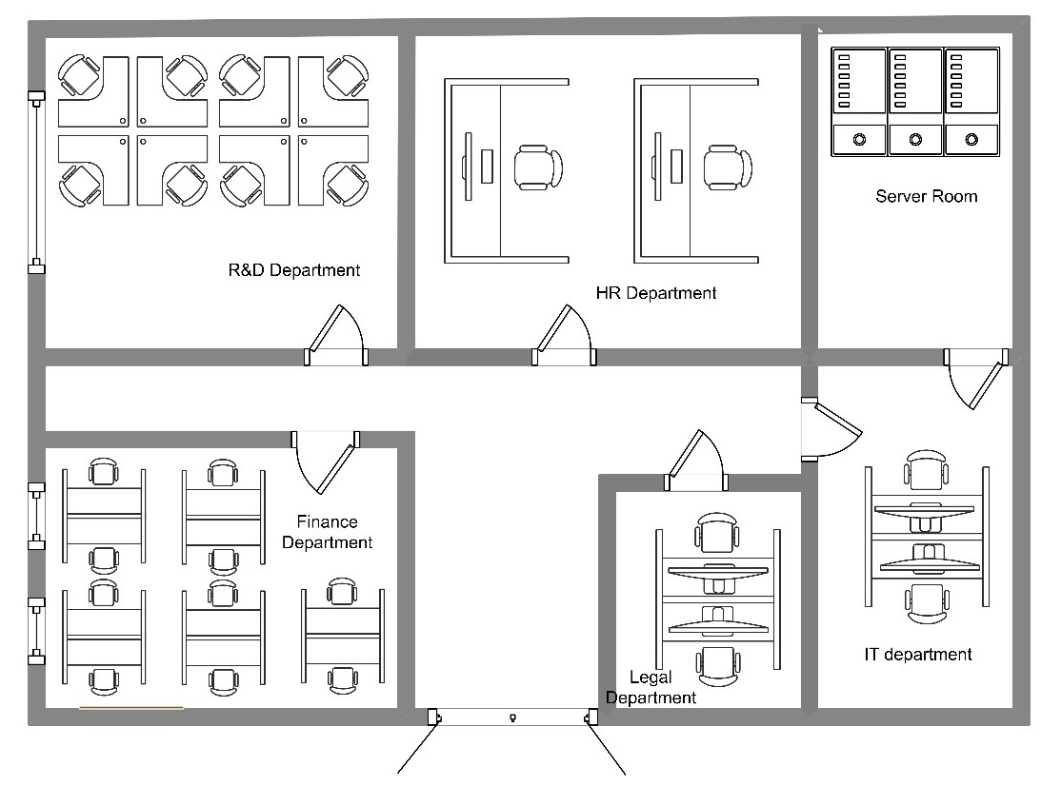
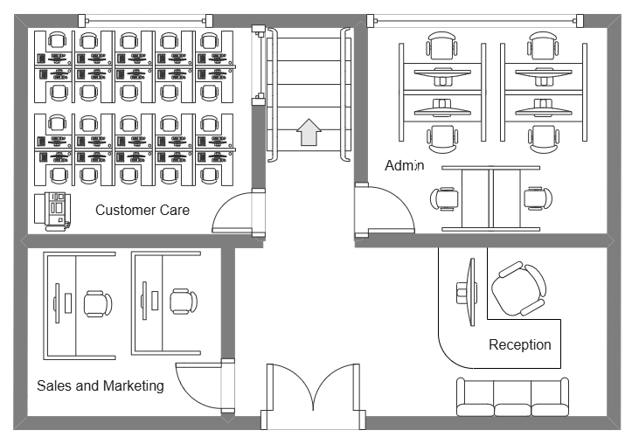
Figure 1: INTECH 2nd Floor Plan
Figure 2: INTECH 1st Floor Plan

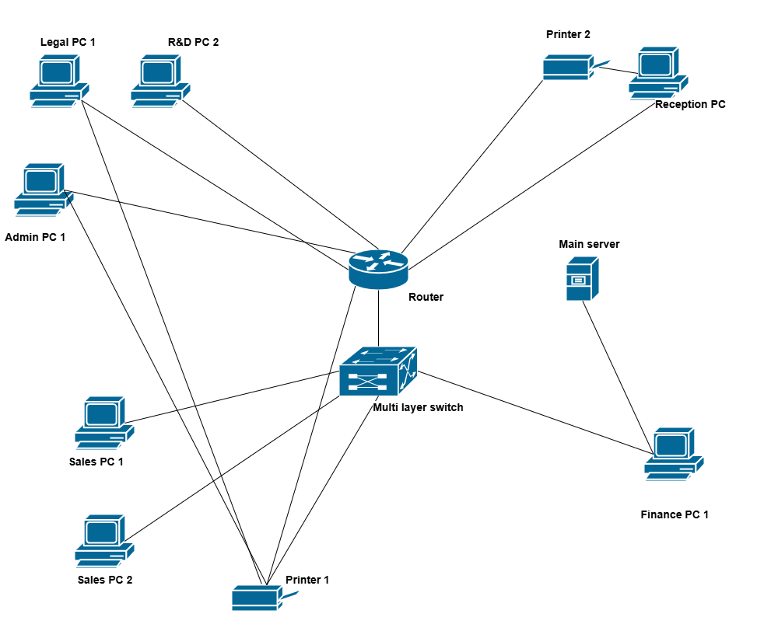
Figure 3: Existing Network Infrasturcture of INTECH

Requirement Analysis

This project’s success depends on a clear understanding of INTECH Computer Systems (Pvt) Ltd’s current infrastructure issues and future expansion goals. Key requirements were identified through analysis of poor cabling, decentralized device placement, and lack of centralized control and monitoring [72], [75], [78]. Internal audits and departmental workflows highlighted scalability, security, and manageability gaps, reinforcing the need for a robust and future-ready network design [73], [76], [80].

User/ Client Requirement

- Scalability : The proposed network must be designed to support future expansion in users, devices, and services without requiring complete redesign. This includes:
- Seamless integration of new departments, branches, or remote users.
- Modular architecture allows for phased upgrades as business demands grow.

- High Availability and Redundancy : Ensuring uninterrupted business operations is a top priority. The network should be incorporated with:
- Redundant paths and components (e.g., routers, switches, uplinks) to eliminate single points of failure.
- Automatic failover mechanisms such as HSRP or VRRP to maintain connectivity during hardware or link outages.
- High availability strategies that reduce downtime and maintain service continuity.

- Real-Time Network Monitoring : Effective monitoring is critical for maintaining performance and identifying issues proactively. The system must:
- Provide real-time visibility into traffic flows, device health, and network performance.
- Integrate tools and protocols (e.g., SNMP) that support alerts, fault detection, and performance analytics for timely issue resolution.

- Cost Efficiency : The network must deliver optimal performance within budget constraints by:
- Leveraging virtual simulation tools during the design phase to reduce initial hardware investment.
- Selecting cost-effective hardware and configurations without compromising scalability or security.
- Ensuring long-term return on investment through reduced maintenance and upgrade costs.

System Requirements
This section outlines the essential system requirements necessary to design, implement, and evaluate the enterprise network for INTECH. These requirements are divided into functional and non-functional categories.

Functional Requirements

Functional requirements define what the network system should do, focusing on the services, protocols, and configurations to be implemented.

1. Scalable Network Topology Design
- Design a three-tier architecture (Core, Distribution, Access) in Packet Tracer.
- Implement OSPF dynamic routing for automatic route learning and fault tolerance.
- Configure extra ports and switches to simulate scalability and future network expansion.
- Ensure dynamic adjustments can occur without major reconfigurations.

2. Network Monitoring & Threat Detection
- Enable SNMP on routers and switches.
- Simulate a network monitoring server (using a labeled PC) as an SNMP Manager.
- Add an IDS module between internal and external networks.
- Represent alert simulation to showcase threat detection awareness.
3. VLAN Segmentation & DMZ Security
- Create separate VLANs for departments: HR, Finance, IT, etc.
- Implement inter-VLAN routing using a multilayer switch.
- Apply ACLs to enforce communication policies between VLANs.
- Design a DMZ segment hosting public-facing servers (e.g., Web, Mail).
- Restrict internet access to DMZ only, blocking internal VLANs via ACLs.

4. Redundancy & High Availability Mechanisms
- Implement HSRP on gateway routers for failover.
- Set up redundant links between core, distribution, and access layers.
- Demonstrate STP to prevent switching loops while allowing backup paths.

5. Resource Optimization and Secure Management
- Configure a DHCP server with multiple pools for different VLANs.
- Assign IPs dynamically to VLAN-based PCs.
- Apply port security on access layer switches to limit unauthorized access.
- Use ACLs to restrict non-essential inter-department communication.

Non-Functional Requirements

These refer to the quality attributes and system performance characteristics expected from the network, especially in a simulated Packet Tracer environment.

1. Reliability
- The network must provide continuous operation even during component failures (using redundancy).
- HSRP must ensure uninterrupted gateway access.

2. Scalability
- The topology must support future growth without needing major design changes.
- Adding new departments/devices should only require minimal configuration changes.

3. Performance
- Ensure low latency communication through optimized routing (via OSPF cost adjustments).
- Use VLANs to reduce broadcast domains and network congestion.

4. Security
- VLAN segmentation, ACLs, port security, and DMZ configuration must ensure access is limited and controlled.
- IDS (even simulated) should represent intrusion monitoring awareness.

5. Manageability
- The network design must be easy to understand, label, and modify.
- SNMP configuration must enable monitoring visibility.
- DHCP and dynamic routing must reduce manual configurations.

Hardware Requirements

Device/Component | Type/Model (GNS3) | Recommended Configuration | Purpose/Why It’s Used
Routers | Cisco 7200 / Cisco 3725 (GNS3 image) | Configured with OSPF, DHCP, NAT, Inter-VLAN Routing, and ACLs | Simulates enterprise-grade dynamic routing, VLAN interconnectivity, and access control.
Redundant Routers | Same as above | Configured with HSRP for gateway redundancy and automatic failover | Ensures high availability and uninterrupted gateway functionality during router failures.
Layer 2 Switches | Cisco IOU L2 or vIOS-L2 | VLANs, STP, Port Security, Access & Trunk Modes | Provides access layer connectivity, segmentation of departments, and port-level security.
Multilayer Switches | Cisco IOU L3 or vIOS-L3 | SVI, DHCP Snooping, Inter-VLAN Routing, EtherChannel, Routing Protocols | Offers Layer 3 switching for internal routing, load balancing, and advanced segmentation.
End Devices (PCs) | VPCS or GNS3 PC Nodes | Assigned IPs via DHCP or static addressing | Emulates departmental users in different VLANs across the enterprise network.
Server | GNS3 Cloud Node or Ubuntu/Debian VM | Configured with services like DHCP, DNS, HTTP/HTTPS, SNMP, and SYSLOG | Provides central services and monitoring for realistic simulation and management tasks.
Redundant Links | Ethernet/Gigabit Interfaces | Configured as Trunk Links with STP, EtherChannel for redundancy and load sharing | Supports link failover, prevents loops, and improves reliability of backbone connections.
Table 2: Hardware Requirements_INTECH

Software Requirements

Software | Recommended Version | Requirements | Why It’s Used
GNS3 | Version 2.2.34 or later | Requires virtualization support (VT-x/AMD-V), minimum 8 GB RAM, and quad-core CPU | Primary simulation tool enabling integration of real Cisco images, virtual appliances, and topologies.
Wireshark | Version 4.x | Installed alongside GNS3 for full packet capture and analysis capabilities | For deep packet inspection, protocol-level troubleshooting, and traffic verification.
VirtualBox / VMware | Latest stable version | Required for running virtual machines (e.g., Linux servers, firewall appliances) | Supports server/service simulation (DHCP, DNS, SNMP, IDS) within the network design.
Snort (IDS) | Version 3.x (latest stable) | Installed on a VM within GNS3, requires moderate resources and a Linux base OS | For real-time intrusion detection, traffic pattern analysis, and simulated threat mitigation.
SecureCRT / PuTTY | Latest stable version | Lightweight; used externally from GNS3 environment | Emulates remote CLI sessions via Telnet or SSH to test secure device access.
Notepad++ / VS Code | Latest versions | Minimal system requirements; runs on all major OS | For writing, organizing, and editing network configurations and documentation.
Cisco IOU / IOS Images | GNS3-compatible images (e.g., IOSv, IOU-L2/L3) | Legally licensed images required | Provides Layer 2/3 device capabilities needed for enterprise-grade simulations.
Table 3: Software Requirements_INTECH

Feasibility Study

A feasibility study has been conducted to evaluate the practicality and viability of the proposed enterprise network modernization project at INTECH Computer Systems (Pvt) Ltd. This assessment considers critical factors such as project timeline, budget constraints, technical requirements, and anticipated economic benefits. The study ensures that the modernization effort aligns with organizational goals and can be effectively executed within current operational parameters and resource availability [72]–[75].

Technical Feasibility

The technical feasibility of the project is high due to the availability of advanced simulation tools, protocols, and methodologies essential for designing and testing a modern enterprise network infrastructure. Cisco Packet Tracer serves as the primary platform for network simulation, enabling the design, configuration, and validation of virtual routers, switches, and security mechanisms without relying on physical hardware.

Key technical features supporting this feasibility include dynamic routing using OSPF, which facilitates efficient traffic management and supports scalable network design. Redundancy protocols such as HSRP ensure high availability by providing reliable failover mechanisms, minimizing downtime during device or link failures. SNMP is employed to provide simulated real-time monitoring, enabling proactive network management and fault detection. Additionally, VLAN segmentation enhances both security and performance by isolating broadcast domains within the network, thereby reducing congestion and limiting the spread of potential threats.
The project team possesses the necessary technical expertise to implement and troubleshoot these protocols within the simulation environment, further enhancing feasibility.

Economic Feasibility

The project demonstrates strong economic viability by leveraging virtualized simulation tools, specifically GNS3, which significantly reduce costs compared to physical network deployments. The cost of tools is minimized as GNS3 is freely available and supports the integration of additional virtual appliances and monitoring tools without incurring licensing fees. Moreover, there are no physical hardware costs since the design and testing phases are completed entirely within the simulation environment, eliminating the need for costly physical devices such as routers, switches, and firewalls. This approach offers long-term savings by decreasing operational inefficiencies, reducing downtime, and lowering maintenance costs. Additionally, the scalable architecture ensures that future expansions will not require extensive redesigns, thereby maximizing return on investment.

Operational Feasibility

The project aligns closely with INTECH’s operational objectives by directly addressing existing network limitations. Its scalable and secure design supports the company’s growth plans and evolving IT requirements, ensuring that the infrastructure can adapt to future demands. The incorporation of redundancy protocols alongside real-time network monitoring guarantees continuous operation and enables rapid issue resolution, minimizing potential downtime. Furthermore, the use of structured network segmentation through VLANs combined with proactive monitoring simplifies maintenance processes, reduces troubleshooting time, and enhances overall network reliability..

Scheduling Feasibility

The proposed project timeline is realistic and achievable with proper resource allocation and effective project management, especially using GNS3 as the simulation platform. Network configuration tasks, such as VLAN setup and OSPF routing, can be performed in parallel with simulation testing to maximize efficiency and optimize time usage. Although initial delays were experienced, a revised schedule along with efficient task prioritization ensures the project stays on track. Additionally, adopting an iterative approach allows for continuous refinement and validation throughout each phase, minimizing the risk of significant setbacks and promoting steady progress toward project completion.

Legal and Ethical Feasibility

The project complies with all relevant legal and ethical standards by leveraging open-source and freely available simulation tools such as GNS3, thereby avoiding any licensing infringements. The network design integrates security best practices to safeguard sensitive organizational data, ensuring robust data protection throughout the system. Moreover, all configurations and simulations strictly adhere to established cybersecurity norms, promoting responsible and ethical data handling in line with industry standards.

Methodology and Planning Artifact

This section outlines the methodology followed throughout the network design project and provides an overview of the planning artifacts used to track progress and adapt to evolving requirements. The approach combines structured analysis with an iterative project execution model to ensure reliability, scalability, and alignment with INTECH’s organizational goals.

Methodology

The methodology adopted for INTECH Computer Systems (Pvt) Ltd follows a structured and systematic approach to ensure alignment with the company’s business objectives. It includes clearly defined phases such as requirement analysis, design, simulation, implementation, and validation. Each phase plays a vital role in building a secure, scalable, and resilient enterprise network that meets the organization’s current operational needs while also accommodating future growth.

Requirement Analysis

The process began with a thorough requirement gathering phase tailored to INTECH Computer Systems (Pvt) Ltd. Key activities included:

- Organizational Assessment: Analyzed the structure of the organization, identifying departments such as Sales, Finance, HR, IT, Legal, and Customer Care to understand their specific networking needs.

- Evaluation of Existing Infrastructure: Identified limitations in the current setup, such as lack of proper segmentation, absence of redundancy mechanisms, limited monitoring capabilities, and insufficient scalability.

- Definition of Business Objectives: Mapped out strategic goals such as ensuring uninterrupted business operations, enhancing network security, enabling secure remote access, and laying the foundation for future growth and cloud integration.

- Stakeholder Engagement: Conducted meetings with key personnel to ensure that the technical design aligns with the company’s long-term vision and operational priorities.

Network Design and Planning

Based on the gathered requirements, the network design was developed following proven architectural principles:

- Three-Tier Hierarchical Model: Adopted a structured design consisting of Core, Distribution, and Access layers to improve network manageability, fault tolerance, and scalability.

- IP Addressing Scheme: Designed an organized IPv4 subnetting plan to allocate address ranges to each department. This supported clear VLAN separation, simplified troubleshooting, and enabled efficient inter-VLAN routing.

- VLAN Configuration: Logical VLANs were planned for each department to isolate traffic, improve security, and enhance performance by reducing unnecessary broadcast domains.
- High Availability and Redundancy: Implemented mechanisms such as HSRP at the distribution layer to ensure reliable failover paths and minimize downtime during device or link failures.

- Routing Protocol Strategy: Deployed OSPF to enable dynamic routing across departmental subnets, facilitating fast convergence and optimized path selection across the enterprise network.

Simulation and Implementation

After finalizing the network design, the next phase involved configuring and simulating the entire architecture using a simulated environment:

- Device Setup: Configured core components such as routers, multilayer switches, and access switches with relevant VLANs, trunk ports, interface IPs, and routing protocols.

- Inter-VLAN Routing: Layer 3 switching was enabled to allow communication between departments while maintaining strict access control using ACLs where required.

- Security Configurations:
  - ACLs were implemented to enforce traffic rules between departments (e.g., preventing unauthorized access from HR to Finance).

  - Port Security was configured to restrict endpoint access and prevent MAC address spoofing at the switch level.

  - DHCP Snooping was activated to secure the DHCP infrastructure and block unauthorized DHCP servers.

- Monitoring and Management Tools:
  - SNMP was integrated to provide visibility into device health and network performance.

  - Syslog Servers and basic alert mechanisms were configured within the simulation to replicate real-world monitoring.

Testing and Validation

Once the simulation was complete, the network underwent rigorous testing to ensure reliability, performance, and security:

- Connectivity Checks: Verified end-to-end reachability between VLANs and remote access connections using ICMP (ping) and traceroute tools.

- Redundancy Validation: Simulated physical link failures to confirm the operation of HSRP and the network’s ability to reroute traffic without disruption.

- ACL Functionality Testing: Attempted restricted and permitted access scenarios to ensure ACLs were correctly applied and enforced.

- DHCP Validation: Ensured each VLAN received the appropriate IP addresses from defined DHCP scopes without cross-VLAN leakage.

- Security Evaluation: Simulated basic threat scenarios to test how well the network responded to unauthorized access attempts and misconfigured devices.

Documentation and Refinement

Comprehensive documentation was created throughout the project, including device configuration files, logical and physical network diagrams, IP addressing plans and VLAN allocations and detailed ACL rule sets and their justifications

Following each testing cycle, observations and feedback were used to fine-tune configurations. Adjustments were made to routing tables, VLAN assignments, ACL policies, and interface settings to ensure the network consistently met the defined security and performance objectives.
The final implementation reflects a thoroughly validated and refined enterprise-grade network architecture tailored to INTECH’s operational needs.

Planning (Eg: Gantt chart, etc..)

In the final stages of the project, a more iterative and adaptive project planning strategy was adopted to accommodate the dynamic nature of networking design and implementation. Unlike the earlier linear model, the revised approach allowed for incremental development, regular feedback incorporation, and parallel task execution, which proved essential in overcoming earlier delays.

The project plan outlines the structured timeline and key phases involved in the design and deployment of the network infrastructure for INTECH. Spanning over a year from August 2024 to August 2025, the plan is divided into six major phases: Requirement Gathering, Network Design, Network Implementation, Network Monitoring, Testing and Deployment, and Final Deployment with Training. Each phase consists of specific tasks with allocated durations, ensuring a systematic approach to the project’s development. This plan serves as a roadmap to manage time effectively, monitor progress, and ensure timely delivery of a secure, scalable, and efficient enterprise network.

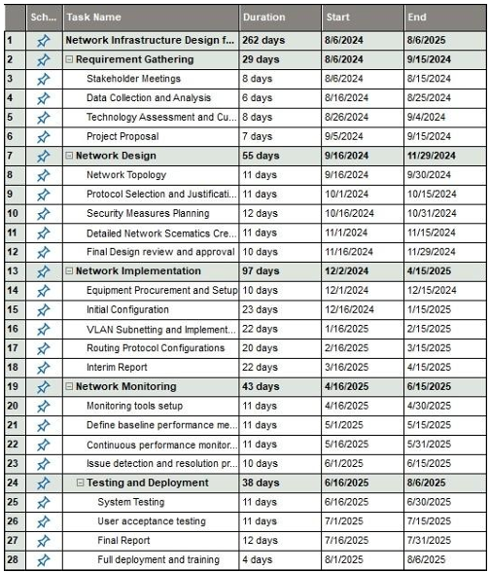
Figure 4: Project Plan

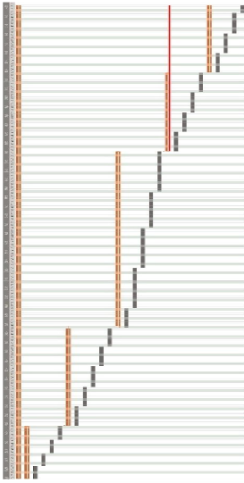
Figure 5: Gantt Chart

Problems and Changes to the Plan

While the updated plan provided greater flexibility and control, several new and ongoing challenges arose during implementation, prompting further refinements:

Challenges Faced and Responses:

- Tool Migration and Decision-Making Issues: The project experienced significant setbacks due to switching from GNS3 to Cisco Packet Tracer and then back to GNS3. This indecision stemmed from incomplete evaluation of each platform’s capabilities and miscommunication among project stakeholders. These frequent tool changes caused delays and required rework, impacting the overall timeline and resource allocation.
Response: An iterative planning model was adopted to allow for flexible updates and better accommodate such tool changes without halting progress.

- Miscommunications with Supervisors: Frequent changes in project scope and supervisor assignments led to inconsistent guidance and unclear expectations, resulting in repeated revisions of network designs and simulation objectives.
Response: Enhanced validation processes, including regular peer reviews and self-testing checkpoints, were introduced to improve communication clarity and reduce revisions.

- GNS3 Familiarization Challenges: Initial difficulties in mastering GNS3’s interface and device management slowed progress, especially for implementing advanced protocols.
Response: Timeline adjustments were made, extending deadlines particularly for configuration and testing phases to allow time for the learning curve.

- Limited Platform Capabilities in Packet Tracer: Packet Tracer’s inability to fully simulate advanced features required manual workarounds that reduced simulation accuracy.
Response: The decision to revert to GNS3 allowed full-featured protocol testing, and parallel task management ensured that documentation and testing continued without delay.

- VLAN Configuration Conflicts: Repeated troubleshooting was needed to resolve DHCP and VLAN assignment issues across multiple switches.
Response: Parallel task management was employed to simultaneously handle configuration issues and documentation, speeding up problem resolution.

- Extended Security Implementation Time: Security features took longer to configure due to misconfigurations and thorough testing requirements.
Response: The timeline was extended to provide adequate time for iterative security testing and validation.

- Documentation Complexity: Increasing network design complexity made it harder to keep documentation updated and consistent.
Response: Parallel development of documentation and testing was prioritized, enabling ongoing updates aligned with configuration changes.

- Resource Constraints: Limited hardware performance caused slowdowns during simulations and troubleshooting.
Response: The project adopted an iterative approach with frequent validations to catch issues early, reducing the time spent on extended troubleshooting cycles.

This adaptive and responsive planning strategy enabled the project to overcome significant real-world challenges, maintain momentum, and meet its objectives despite the complexities encountered.

Network Planning and Design

This chapter outlines the planning and design process for the proposed network infrastructure at INTECH Computer Systems (Pvt) Ltd. The objective was to create a scalable, secure, and logically segmented enterprise network to meet current organizational requirements and support future growth. The process included detailed IP planning using VLSM, VLAN segmentation based on departments, hierarchical design principles, and incorporation of protocols and policies that ensure performance, availability, and security.

Alternate Solution Evaluation

Before finalizing the proposed solution, various design alternatives were considered based on scalability, security, cost-effectiveness, and manageability. The adopted design was selected because it effectively addressed the core limitations in INTECH’s existing network including lack of segmentation, poor fault tolerance, and no centralized monitoring [79].

This solution provides comprehensive network efficiency and security by implementing departmental isolation through VLANs and ACLs, enabling scalable IP addressing with VLSM, and ensuring high availability via redundancy protocols. It also incorporates centralized monitoring and control mechanisms for streamlined management, along with logical segmentation to support secure inter-departmental communication.

Overall, the chosen design best aligned both the technical and strategic goals of the company, while maintaining flexibility for future enhancements.

Network Planning

Network planning plays a crucial role in defining the foundation of the infrastructure. It involves choosing appropriate addressing schemes, defining segmentation strategies, and ensuring each department receives adequate network resources.

Departments and User Allocation

The user distribution across departments was analyzed to determine subnet size, VLAN assignment, and future expansion needs.
Floor | Departments | Employees Count
01 | Reception (Fixed) | 02
01 | Sales and Marketing | 20
01 | Customer Care | 12
01 | Administration | 12
02 | HR | 18
02 | Finance | 06
02 | Legal | 14
02 | R&D | 10
02 | IT | 12
02 | Server Room | 02
Table 4: Departments and User Allocation Table

IP Addressing Scheme

The IP addressing scheme for INTECH Computer Systems (Pvt) Ltd is carefully designed to ensure scalability, efficient resource utilization, and simplified network management.

The private IP range 192.168.0.0/16 defined by RFC 1918 was selected due to its widespread suitability for internal enterprise networks and its compatibility with NAT when accessing external networks. This range provides sufficient flexibility for current departmental needs and future expansion [81].

To address varying host requirements across different departments, VLSM was used instead of fixed subnetting which allows the allocation of subnet sizes based on the exact number of required hosts per department, thereby minimizing IP waste and maintaining a scalable architecture. Each department was assigned a unique subnet from the 192.168.0.0/16 range to support logical segmentation, enhance security, and reduce broadcast traffic within each domain.

Key advantages of this addressing scheme include:

- Efficient IP Utilization – Departments with smaller user bases receive appropriately sized subnets, avoiding unused IPs, while larger departments are provisioned with sufficient space for future growth.

- Scalability – Additional subnets can be allocated from the remaining 192.168.0.0/16 space as the organization grows, with minimal disruption to the existing structure.

- Reduced Broadcast Domains – Smaller, targeted subnets help minimize unnecessary broadcast traffic, improving overall network performance.

- Simplified Troubleshooting – A structured, hierarchical addressing system enables administrators to quickly identify devices and isolate issues. The default gateway for each subnet is configured using the broadcast address convention for consistency and ease of access.
This IP scheme ensures that the network remains both secure and adaptable as INTECH evolves.

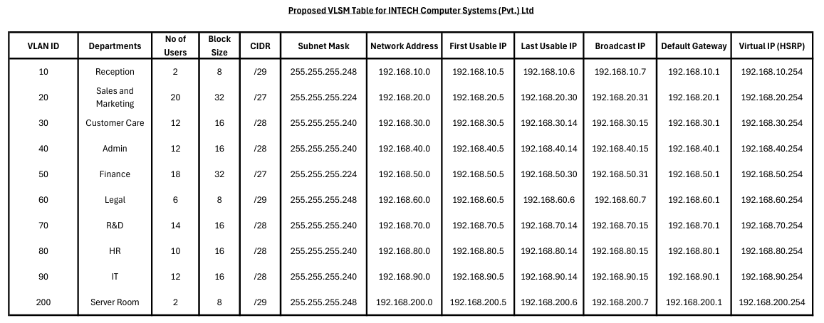

Network Design

The network design for INTECH Computer Systems (Pvt) Ltd is developed in accordance with the defined project scope, which aims to deliver a secure, high-performance, and scalable enterprise network. Centered on a 3-tier hierarchical architecture, the design integrates essential networking principles such as VLAN segmentation, dynamic routing using OSPF, high availability mechanisms, and multiple security layers including a DMZ and IDS. The complete topology was carefully built and validated in a virtual environment to ensure operational efficiency and security.

Hierarchical Network Design

The network follows the 3-tier hierarchical model, which provides a modular and scalable structure by dividing the architecture into the Core, Distribution, and Access layers. This separation allows better performance optimization, simplified troubleshooting, and efficient management of data traffic.

The Core Layer of the proposed network is designed to serve as the backbone, overseeing inter-VLAN communication and routing between distribution switches. A Cisco router is configured using the Router-on-a-Stick architecture, wherein sub-interfaces perform routing between VLANs, while OSPF provides efficient and automated dynamic routing across these segments [82]. ACLs enforce fine-grained traffic control between VLANs by filtering based on IP addresses and service types. Additionally, an IDS (Snort) is integrated within the core to monitor traffic for malicious activity or anomalies, thereby enhancing threat detection capabilities as part of the overall security framework [83].

The Distribution Layer serves as the intermediary between the core and access layers, aggregating traffic and enforcing network policies to ensure efficient data flow and security. This layer utilizes two Layer 2 switches, such as the Cisco 2960 series, configured for VLAN management and inter-VLAN forwarding. VLAN segmentation is applied to logically separate departments, thus reducing broadcast domains and improving security. To enhance network availability, HSRP is implemented, providing failover capabilities in case of router or link failure [84]. Furthermore, STP is deployed to prevent switching loops and ensure a stable, loop-free network topology [85]. A DMZ is also configured within this layer to host public-facing services like web and email servers, isolating them from internal assets to mitigate external threat exposure [86].

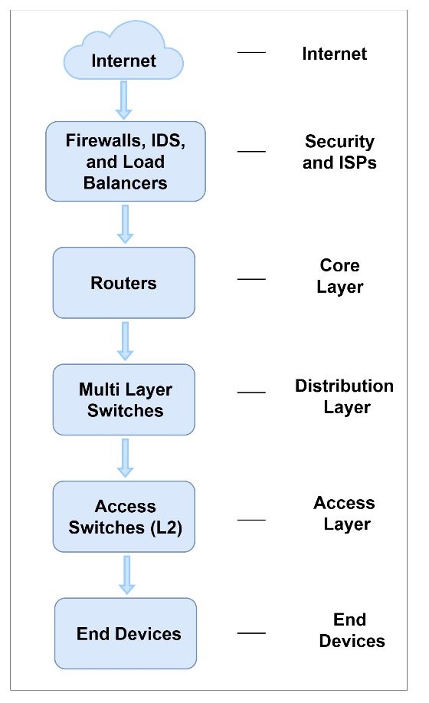
Figure 6: Conceptual 3 tier Architecture
The Access Layer forms the edge of the enterprise network, connecting end-user devices such as PCs, printers, and local servers to the core infrastructure. It consists of multiple access switches configured for per-port VLAN assignment, ensuring that devices are logically segmented according to their departmental or functional roles. This VLAN-based access not only improves network efficiency but also enhances security by controlling broadcast domains. Port security mechanisms are enforced by allowing only specific MAC addresses per port, thereby preventing unauthorized device connections [87]. To further strengthen security, IDS are employed to monitor access-level traffic, enabling the identification and mitigation of potential threats at the edge of the network [88].

The design below visualizes the complete 3-tier hierarchical structure implemented at INTECH, clearly outlining the function of each layer and showcasing the integration of vital security elements including IDS and firewalls.

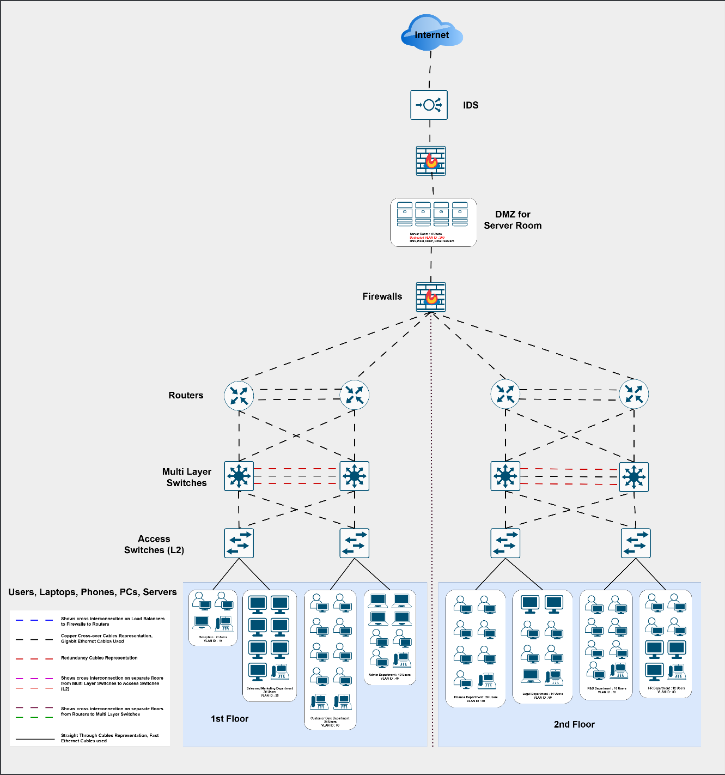
Proposed Network Design for INTECH
Figure 7: Network Blueprint of INTECH

Logical Design

VLAN Segmentation

Each department in the organization is assigned a dedicated VLAN to logically isolate traffic and improve network performance and security. IP subnets are allocated using VLSM to ensure efficient use of the 192.168.0.0/16 private IP space, based on the number of hosts in each department.
Department | VLAN ID | Subnet | Gateway IP
Reception | 10 | 192.168.10.0/30 | 192.168.10.1
Sales and Marketing | 20 | 192.168.20.0/27 | 192.168.20.1
Customer Care | 30 | 192.168.30.0/27 | 192.168.30.1
Administration | 40 | 192.168.40.0/27 | 192.168.40.1
HR | 50 | 192.168.50.0/28 | 192.168.50.1
Finance | 60 | 192.168.60.0/27 | 192.168.60.1
Legal | 70 | 192.168.70.0/28 | 192.168.70.1
R&D | 80 | 192.168.80.0/28 | 192.168.80.1
IT | 90 | 192.168.90.0/28 | 192.168.90.1
Server Room | 200 | 192.168.200.0/30 | 192.168.200.1

Table 5: VLSM Summary Table

Inter-VLAN Routing
Inter-VLAN routing is implemented on a Layer 3 router using the RoS method. Each VLAN is associated with a sub-interface on the router, configured with the respective gateway IP address.

Dynamic Routing with OSPF

OSPF is deployed as the dynamic routing protocol to efficiently manage routes between subnets. OSPF authentication is enabled to secure routing information and prevent unauthorized updates.

High Availability

Redundancy Protocol – HSRP

High Availability is achieved through the HSRP, which provides a virtual IP address as the default gateway for end devices. If the primary router fails, the standby router automatically assumes control, ensuring uninterrupted network service.

Redundant Links and Loop Prevention

Redundant links are configured between the core, distribution, and access layers to eliminate single points of failure. STP is enabled to prevent network loops and maintain a stable topology.

Monitoring and Management

- SNMP Monitoring (Simulated)
With GNS3, SNMP-based network monitoring is fully implemented using integrated SNMP agents on routers and switches, paired with external SNMP manager tools such as SNMPc or SolarWinds. This setup allows real-time tracking of device health, interface status, bandwidth usage, and system events, providing visibility into the network's operational state similar to a live enterprise environment.

- IDS – Implement using Snort
Intrusion Detection is operationalized through the integration of Snort, an open-source IDS, deployed within the GNS3 topology. Snort monitors traffic patterns, detects suspicious behaviors such as port scans or unusual payloads, and generates alerts for administrative review. This real-time detection capability enhances the network’s security posture and demonstrates how threats can be identified and mitigated in practice.

Implementation

The implementation phase transforms the designed network model into a functional and operational environment. It involves configuring devices, writing automation scripts, and setting up protocols and services to realize the proposed network architecture. This phase is critical as it demonstrates how theoretical concepts and design plans are translated into practical, working components within a simulated enterprise network.

This chapter outlines the environment in which the network was implemented, the tools and technologies used during the development process and presents key code segments and reused configurations that contributed to the system's functionality.

Implementation Environment

The selection of an appropriate implementation environment significantly affects the fidelity, accuracy, and scalability of a network simulation project. For this project, GNS3 was chosen as the final and sole simulation environment due to its real-device emulation, advanced feature set, and compatibility with third-party security and monitoring tools.

- Final Environment: GNS3
GNS3 was selected and retained throughout the project primarily because it supports real IOS emulation. This capability allows the use of genuine Cisco IOS images, ensuring that device behavior within the simulation closely mirrors real-world scenarios, thus providing high-fidelity and accurate network emulation [84].
Furthermore, GNS3 facilitates integration with various third-party appliances such as firewalls like pfSense, intrusion detection systems including Snort, and Linux-based servers. This integration capability enables a more realistic and comprehensive security-focused implementation, which is essential for simulating complex network environments with layered defenses [85].

The platform also offers strong support for network automation tools like Python and Ansible. This compatibility allows for the simulation of automated configuration management and network monitoring tasks, increasing efficiency and reflecting modern network operational practices [86].

GNS3 provides high-level customization options, allowing users to simulate complex enterprise networks with detailed control over packet flow, interface behaviors, and performance monitoring. This level of control is critical for designing and troubleshooting sophisticated network topologies [87].

Finally, GNS3 supports bridging to physical interfaces and cloud services, a feature crucial for simulating hybrid network architectures that integrate on-premises infrastructure with cloud-based resources. This capability expands the realism and applicability of the simulations to contemporary network environments [88].

Implementation Experience and Considerations
Despite GNS3’s steep learning curve and substantial system resource requirements, its flexibility and extensibility rendered it the most suitable tool for implementing this project’s multi-VLAN enterprise network, which included DHCP, OSPF, ACLs, HSRP, IDS integration, and SNMP monitoring. These advanced features necessitated a simulation environment capable of high-fidelity emulation and comprehensive customization, both of which GNS3 provided effectively.

To ensure a smooth implementation process, several measures were undertaken. First, optimized device selection involved carefully choosing compatible IOS images to avoid licensing conflicts and maintain system stability throughout simulations. This step was crucial in preventing unexpected crashes and configuration errors.

Second, rigorous project backup protocols were established. Multiple save states and backup mechanisms were employed to safeguard the project against data loss caused by software crashes or misconfigurations. This approach ensured that progress was consistently preserved and could be restored when necessary.

Lastly, performance optimization techniques were applied within GNS3. Settings such as disabling unused services and limiting RAM allocation per device were fine-tuned to reduce latency and improve simulation responsiveness, especially in scenarios involving more than ten active nodes. These optimizations contributed to a more efficient and reliable simulation environment, facilitating thorough testing and validation of the network design [89][90].

Justification
GNS3’s capability to emulate actual hardware behavior, implement advanced network features, and integrate with external systems strongly justified its selection for this project. This robust platform enabled the achievement of several key objectives essential for designing and validating a realistic enterprise network.

Among the accomplishments facilitated by GNS3 were full inter-VLAN routing using router-on-a-stick and multilayer switch configurations, which allowed seamless communication across multiple network segments. Automated IP address distribution was implemented through DHCP server pools, streamlining network management and reducing manual configuration errors. Redundancy testing was conducted using HSRP failover mechanisms, ensuring high availability and fault tolerance in the simulated environment.

ACLs were enforced effectively to manage traffic flow and implement role-based access policies, enhancing security within the network. Additionally, IDS conceptual integration was utilized for traffic monitoring and anomaly detection, providing insight into potential security threats. The simulation of SNMP-based performance metrics through Syslog and interface statistics further supported proactive network monitoring and management.

Overall, GNS3 aligned well with both the educational and technical goals of the project, offering a practical and realistic foundation for simulating a complex, enterprise-grade network system [91][92].

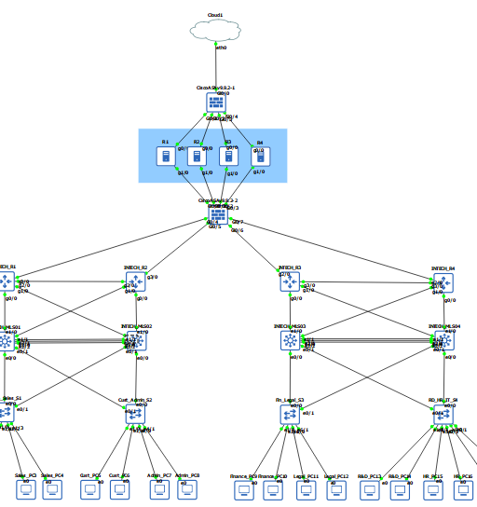

Development Tools
The successful implementation of the INTECH enterprise network required a combination of simulation software and configuration tools that supported the design, configuration, testing, and troubleshooting of the network infrastructure. After evaluating available platforms, GNS3 was selected as the primary simulation environment due to its advanced features, realism, and extensibility, which are well-suited for enterprise-grade network simulation [89][90].

Key Development Tools Used:
- GNS3 (Version 2.2.0)
GNS3 served as the main simulation platform for designing and implementing a detailed, realistic enterprise network topology. It was selected because it provides real Cisco IOS emulation, allowing device behavior that closely replicates production networks [91]. Additionally, GNS3 supports the integration of third-party appliances such as firewalls (e.g., pfSense), IDS/IPS systems (e.g., Snort), and Linux virtual machines, enabling enhanced security and comprehensive service simulation [92].

The platform allows for highly customizable network topologies with fine-grained control over packet flow, interface configurations, and performance metrics [94]. Moreover, it facilitates cloud service emulation by bridging virtual devices to physical interfaces and cloud environments, which is critical for simulating hybrid network architectures [95]. Within the project, GNS3 enabled the full deployment of complex multi-VLAN networks, inter-VLAN routing, DHCP services, and redundancy protocols such as HSRP. It supported advanced security implementations including ACLs, IDS integration, and SNMP-based monitoring, providing a robust environment for thorough testing, troubleshooting, and performance validation of the network design.

- Cisco IOS
The operating system running on virtual routers and switches within GNS3 serves as the foundation for managing all network functionalities. This system provides the essential environment needed for precise device control and configuration.

Its key role involves extensive use for configuring routing protocols such as OSPF, managing VLAN sub-interfaces, implementing ACLs, enforcing port security, and handling other critical network operations. All configurations are performed using authentic IOS commands, ensuring that the simulated devices behave closely to real-world Cisco equipment [91].

- Notepad++ and Solar PuTTY (for script writing and documentation)
Solar-PuTTY and Notepad++ are essential tools supporting the configuration and management of network devices within the GNS3 simulation environment. Solar-PuTTY serves as a terminal client software that provides command-line interface (CLI) access to network devices, enabling secure remote management through SSH and Telnet protocols. Its tabbed interface allows users to manage multiple simultaneous sessions efficiently, streamlining device configuration and monitoring tasks [96].

Complementing this, Notepad++ is used as a versatile text editor for writing configuration scripts, maintaining detailed documentation, and organizing network policies. Its features, including syntax highlighting and multi-tab support, improve clarity and workflow during the development of complex scripts and configuration files, facilitating better organization and reducing errors in network management tasks [94]. Together, these tools enhance the precision and effectiveness of network device management within the simulated enterprise environment.

- Snipping Tool / Screenshot Utility
The primary purpose of this tool is to capture snapshots of network configurations, outputs, and simulation results. These visual records are crucial for documenting the progress and outcomes of the network implementation process.
In practical use, it serves as an essential component for maintaining detailed visual logs of the network state, troubleshooting activities, and validation checkpoints throughout the simulation. This helps ensure accuracy in reporting and provides evidence of successful configuration and testing phases [96].

- Wireshark
Wireshark is a widely-used network protocol analyzer designed to capture and inspect packets in real time. It enables detailed examination of network traffic at the packet level, making it an essential tool for diagnosing network issues and validating protocol operations. Wireshark is particularly useful in network simulation environments for verifying the behavior of protocols such as OSPF, DHCP, and ACLs, aiding in effective troubleshooting and performance analysis [97].

GNS3’s real IOS emulation, extensibility with third-party security appliances, and support for detailed network simulation made it the most suitable platform for the INTECH enterprise network simulation. Despite its steep learning curve and higher resource demands, the flexibility and accuracy of GNS3 justified its selection. This allowed achievement of the project’s core objectives such as full inter-VLAN routing, DHCP automation, redundancy testing, ACL enforcement, IDS monitoring, and SNMP-based performance tracking [89]–[97].

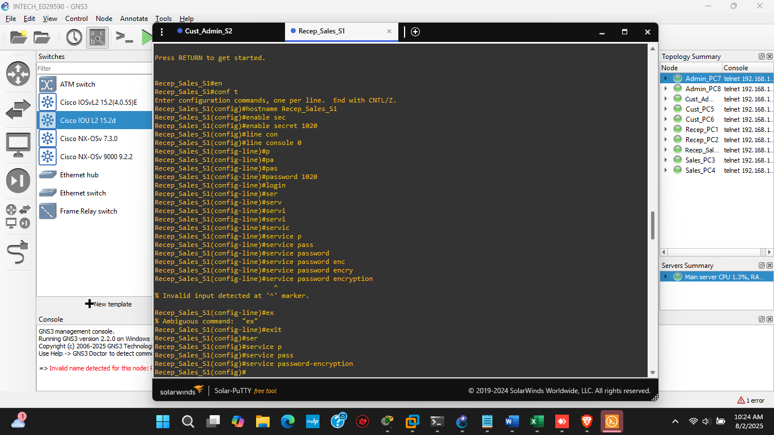
Major Code Segments
Figure 8: Basic Security Configurations

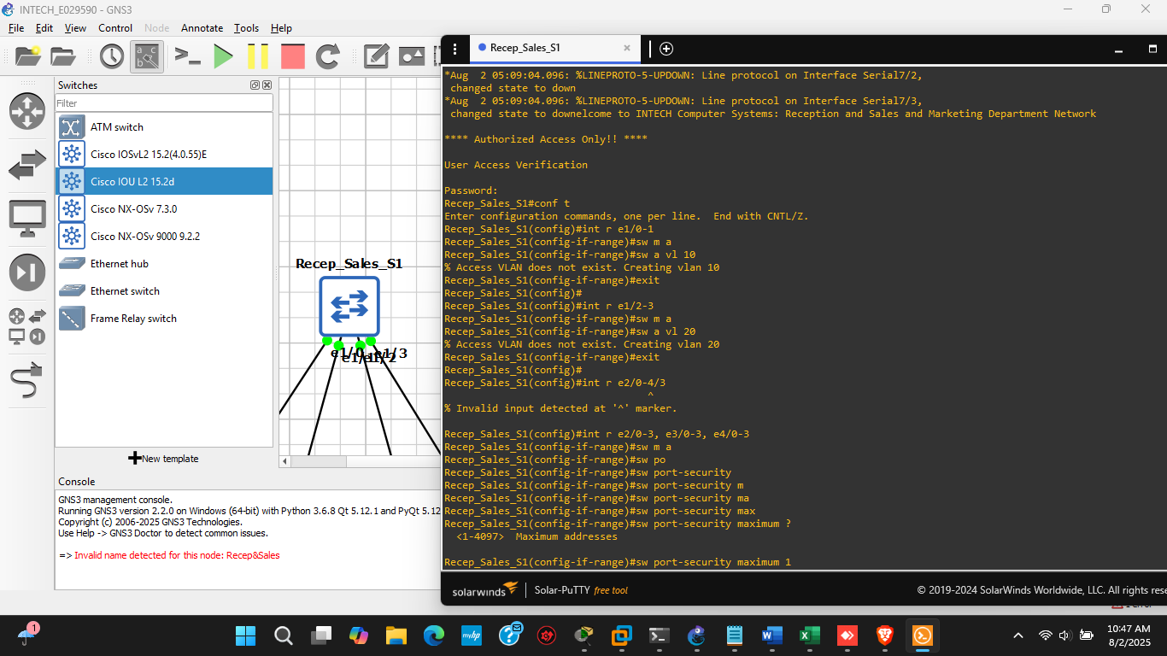
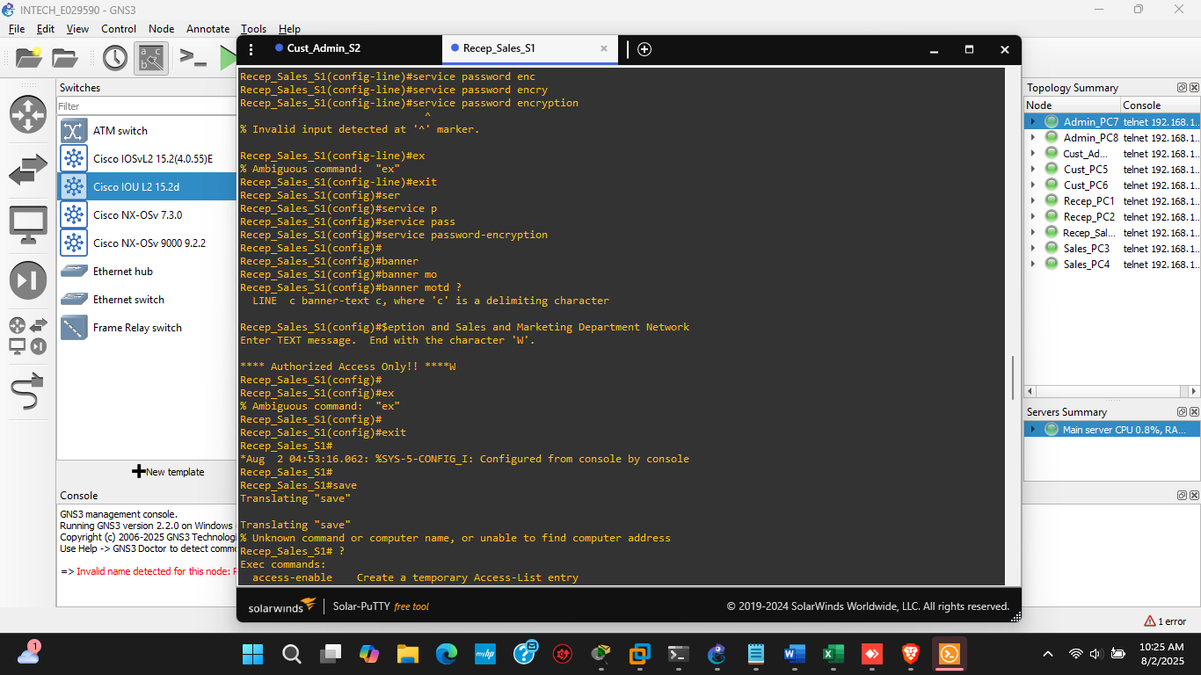
Figure 9: Access and Trunk Port Configuration
Figure 10: Basic Security Configurations_2

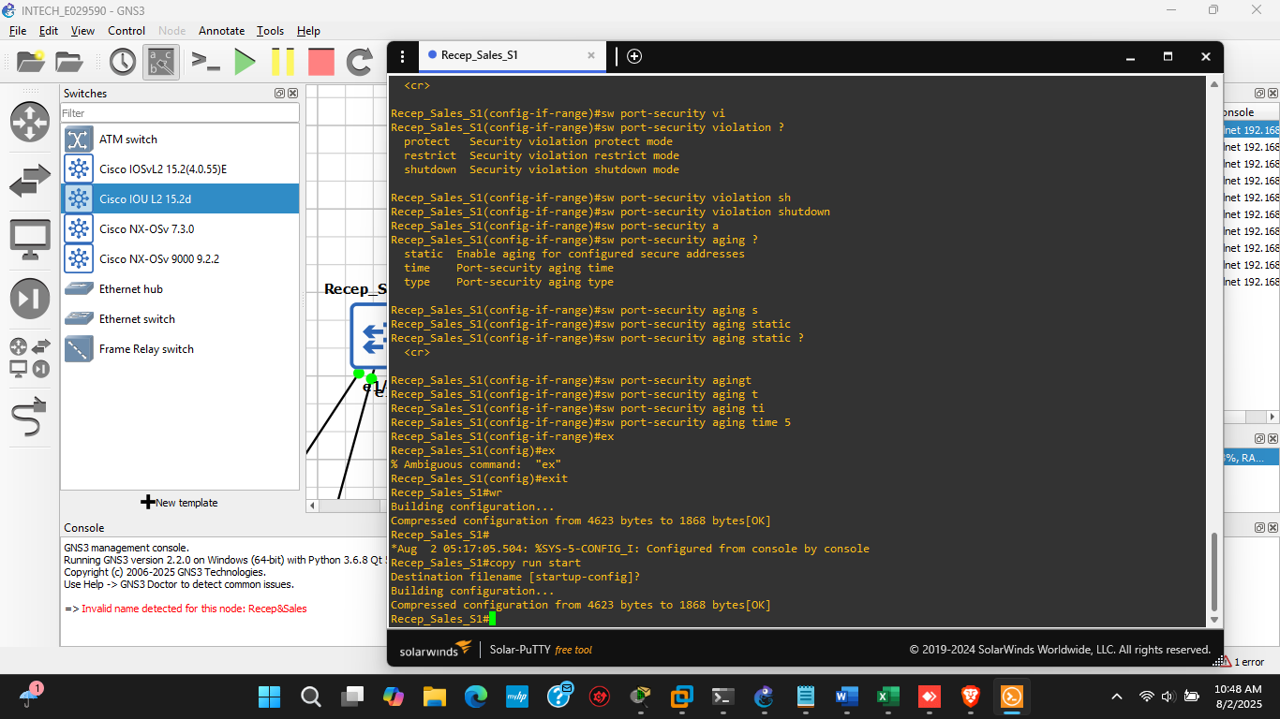
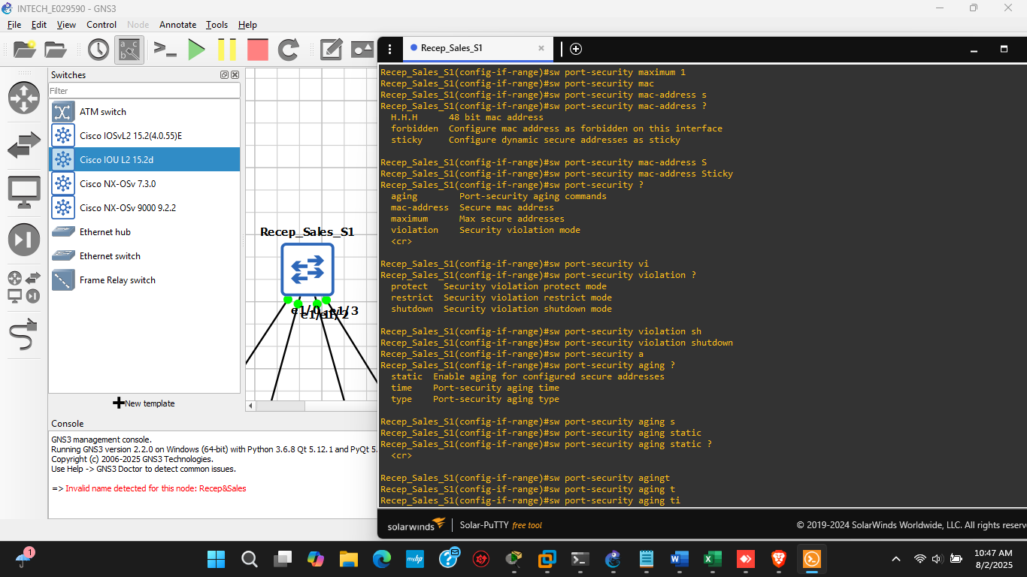
Figure 11: Port Security Configurations_2
Figure 12: Port Security Configuration

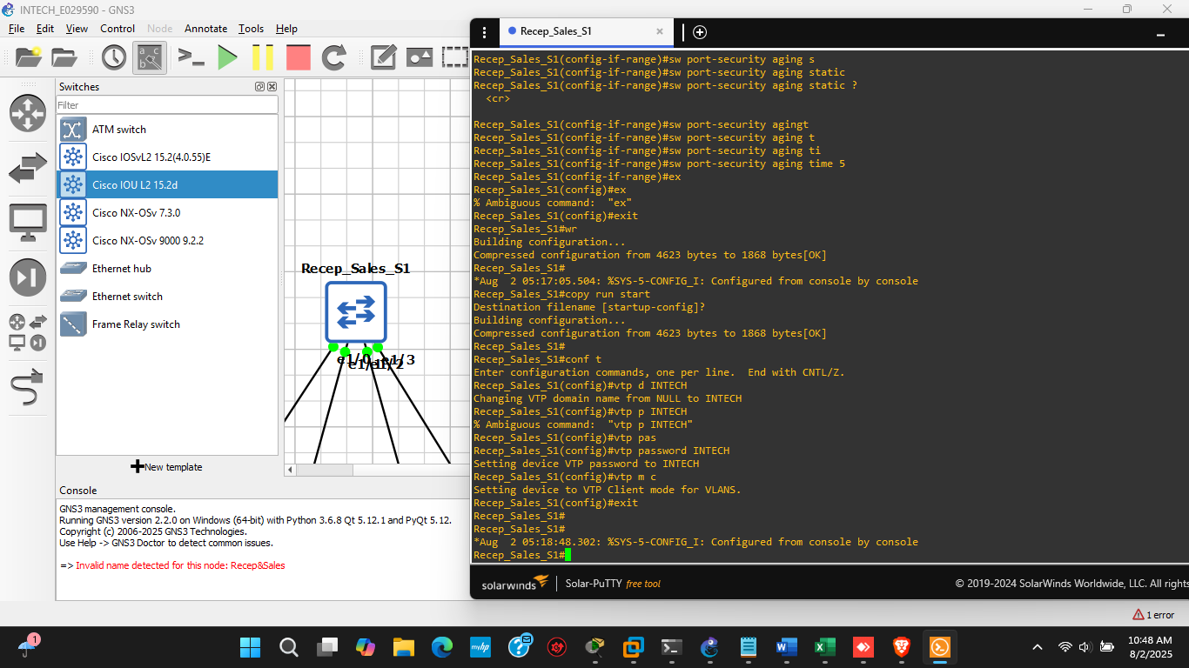
Figure 13: VTP Configurations

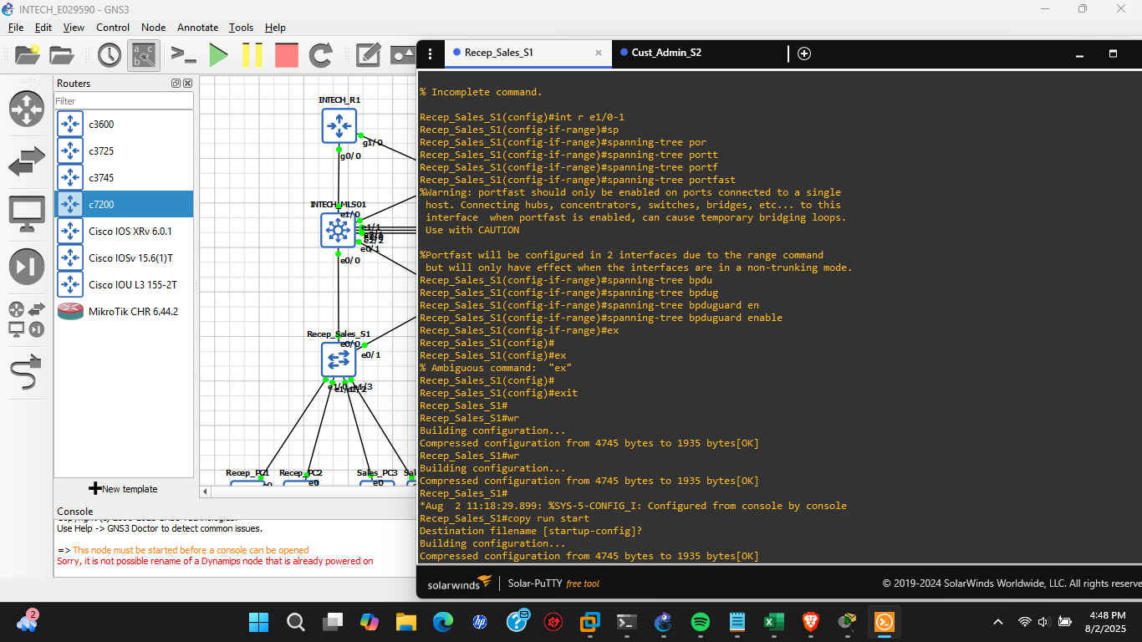
Figure 14: Spanning Tree Configurations for L2 Switches

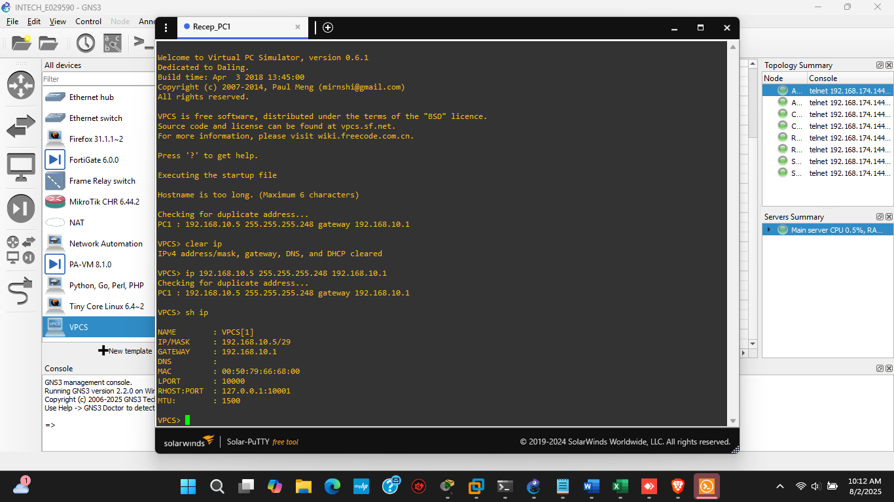
Figure 15: Static IP Configurations for PCs

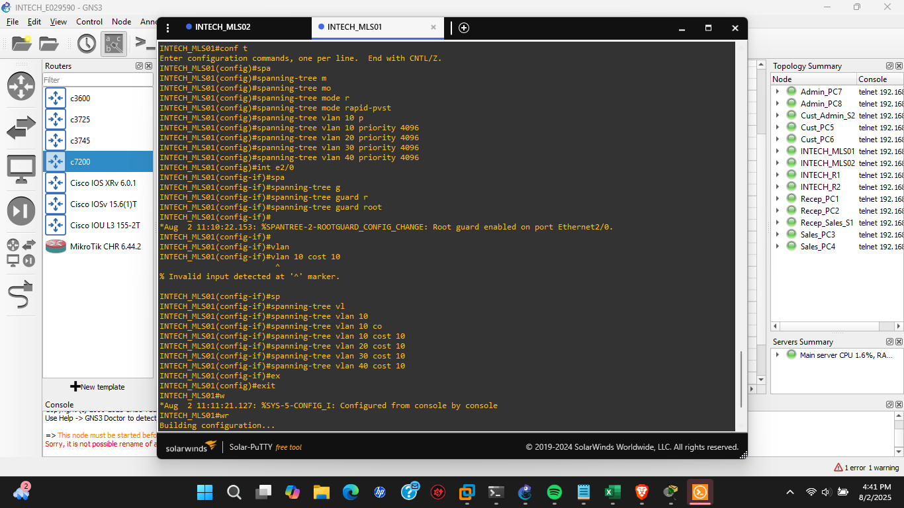
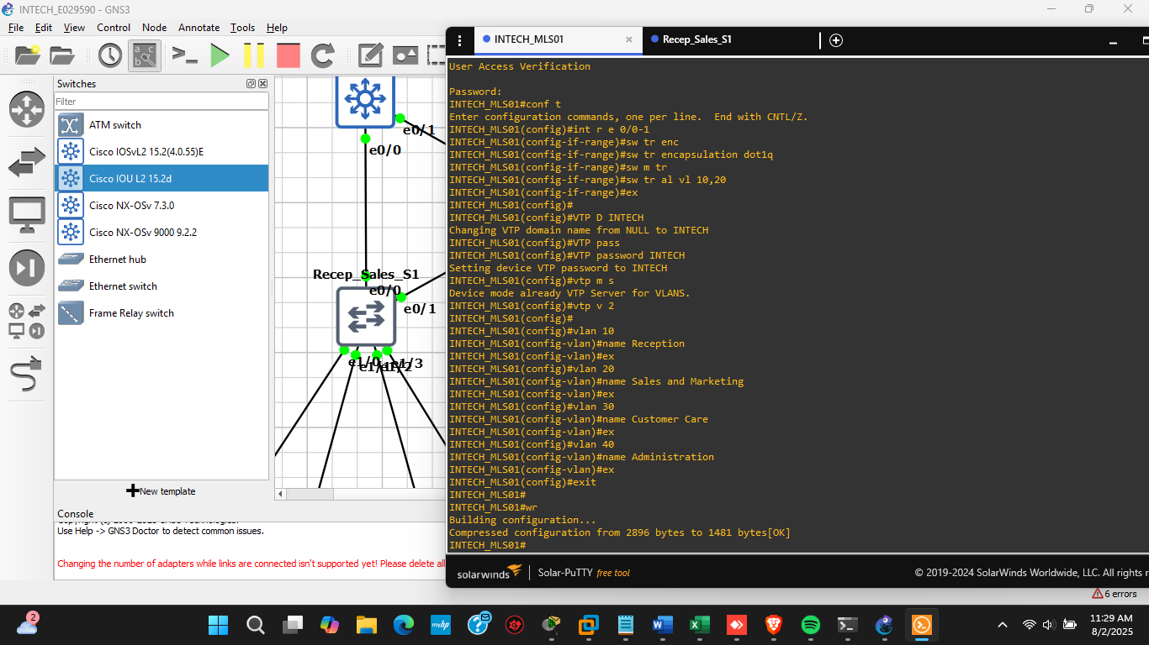
Figure 16: Spanning Tree Configurations on MLS
Figure 17: VTP and VLAN Database from Multilayer Switch

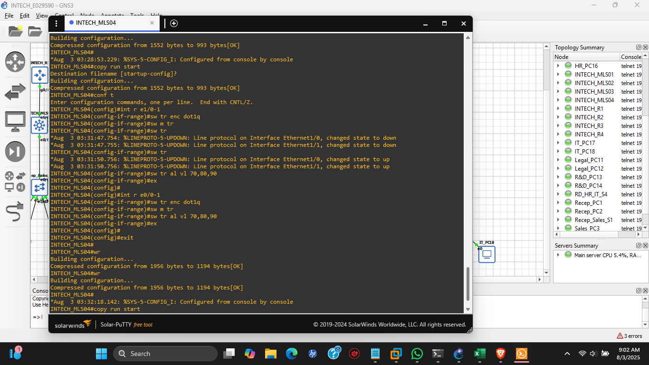
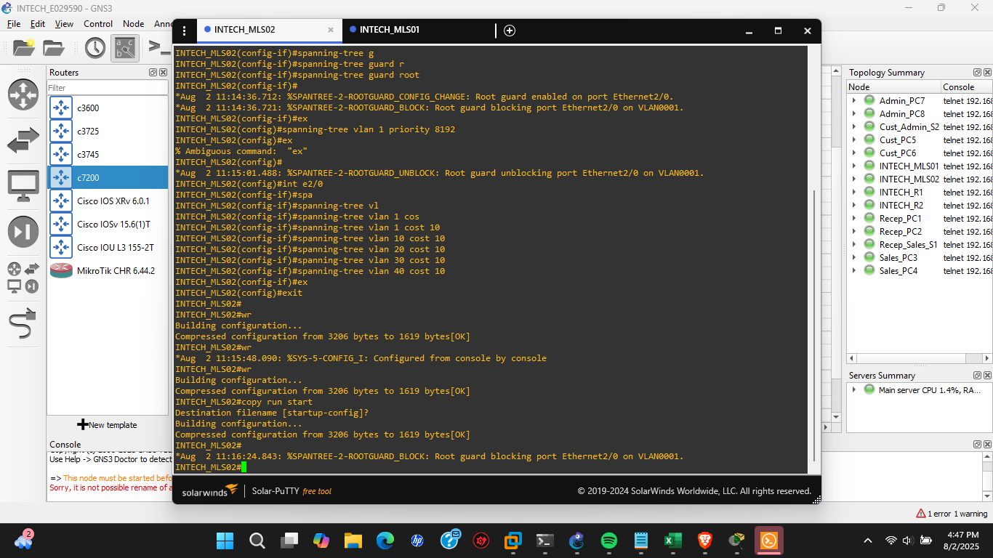
Figure 18: Trunk port Configurations_MLS
Figure 19: Spanning Tree Configurations_2

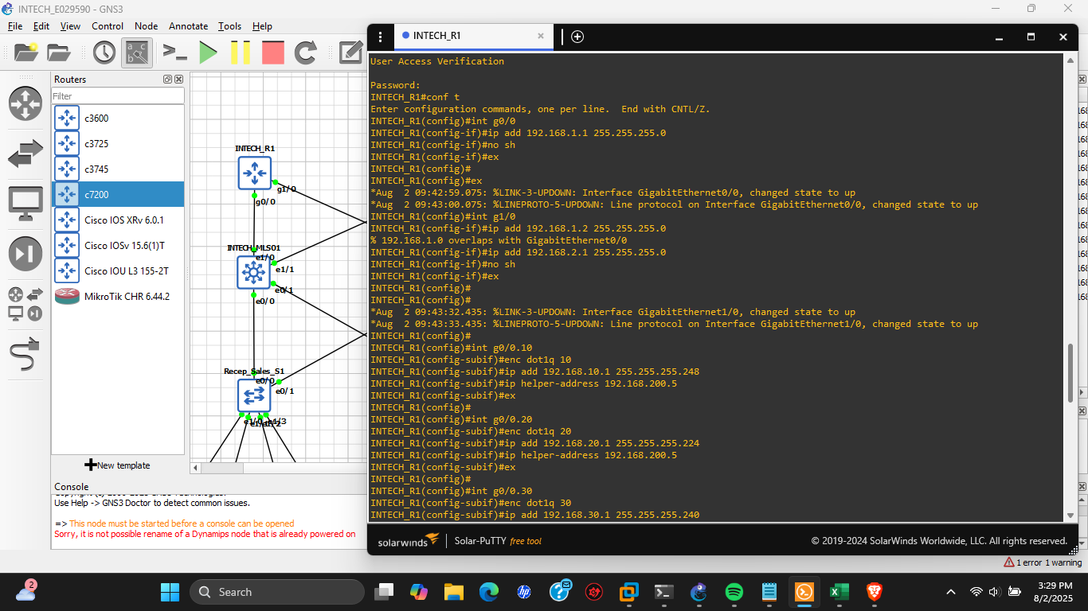
Figure 20: Interface Connectivity via ROS on Router
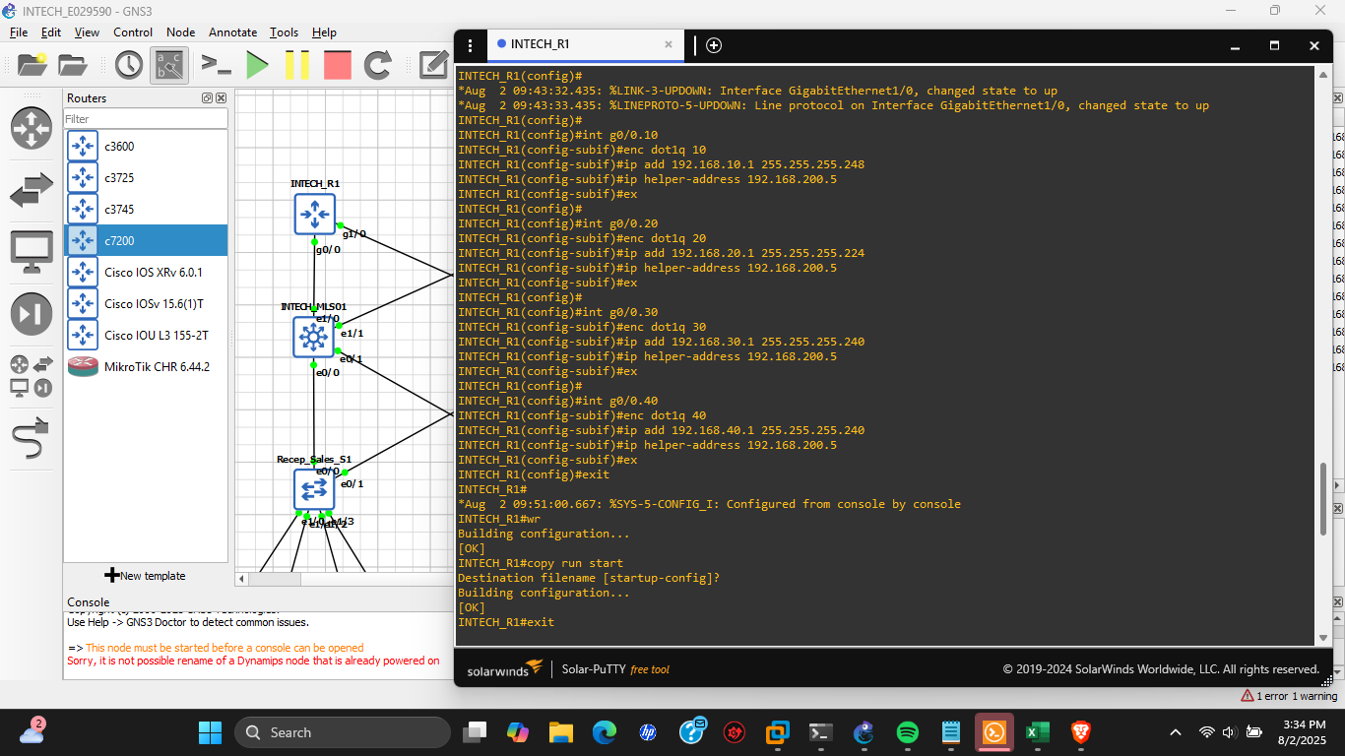
Figure 21: Interface Connectivity via ROS on Router_2

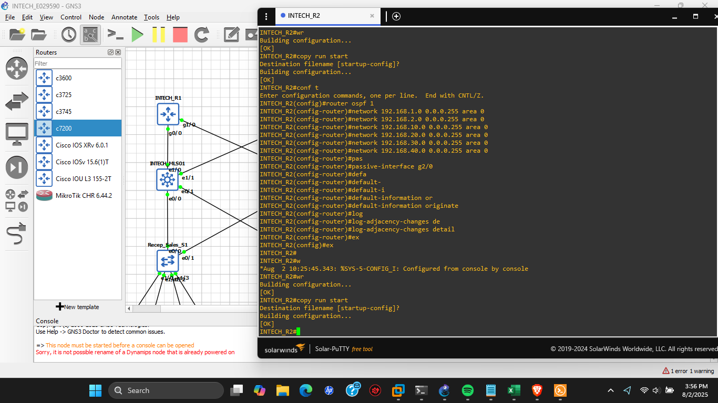
Figure 22: OSPF Configurations

Evaluation

In this chapter, the evaluation of the implemented network design is carried out to ensure it meets the defined objectives such as scalability, security, performance, and manageability. This involves a series of planned tests to validate functionality like VLAN configurations, inter-VLAN routing, IP address assignment, redundancy mechanisms, and threat monitoring tools. The evaluation also includes simulated user feedback and observations to assess network reliability and effectiveness.

Network Testing Overview

Network testing is the process of verifying the functionality, reliability, performance, and security of a network design. It ensures that all configured devices and protocols operate as intended and that the system can handle expected traffic loads and security conditions.

In this project, network testing focused on several key objectives. The first objective was functionality, which involved testing core services such as VLANs, inter-VLAN routing, DHCP, OSPF, and ACLs to ensure they operated correctly [84], [89]. Ensuring these fundamental services functioned as intended was critical to the overall network performance and reliability.

The second objective was reliability. This involved evaluating redundancy protocols like HSRP to verify that the network could maintain continuous operation even during device or link failures [90]. Testing redundancy mechanisms helped confirm that failover processes worked seamlessly, minimizing service disruption.
The third key objective was security. This encompassed assessing the effectiveness of ACL enforcement, DHCP Snooping, and Port Security, alongside protective measures such as SNMP-based monitoring and intrusion detection through Snort integration [92], [93]. These security tests ensured that unauthorized access was prevented and potential threats were detected promptly, maintaining network integrity.

Testing was performed using GNS3, taking advantage of its comprehensive emulation capabilities to ensure a realistic and thorough evaluation of the network design. One key aspect of testing involved CLI access, which was used for manual verification and troubleshooting of device configurations, as well as to observe routing and switching behaviors in detail [84].

Additionally, live packet capture and analysis were integral to the testing process. GNS3 supports integration with external tools such as Wireshark, enabling real-time monitoring and in-depth analysis of actual packet flows and protocol events within the simulated network environment [97]. This capability allowed for precise inspection of network traffic and facilitated identifying issues at the packet level.

Ping and traceroute utilities were also extensively used, executed within virtual devices to confirm Layer 3 connectivity across VLANs and to external networks. These tools helped validate the correct routing and communication paths, ensuring that data packets could traverse the network as intended [98].

Limitations of GNS3
While GNS3 offers realistic IOS emulation and supports advanced network features, it does come with certain limitations. One significant challenge is its demand for substantial system resources when running large or complex topologies, which can negatively impact simulation speed and responsiveness [84].

Additionally, integrating third-party appliances such as firewalls or intrusion detection systems can sometimes present stability or compatibility issues. This necessitates careful selection and testing of device images to ensure reliable operation within the simulation environment [92].

Furthermore, GNS3 does not inherently simulate real-world network congestion or detailed bandwidth constraints without the use of supplementary tools or configurations [99].

Types of Network Testing

- Functional Testing: Ensures that VLANs, DHCP, routing protocols, ACLs, SNMP, Port Security, and HSRP behave as expected.

- Security Testing: Check if unauthorized access is blocked, DMZ access is restricted from internal users, and only whitelisted VLANs can access printers or internet.

- Performance Testing (Basic): Monitor packet loss, congestion signs (simulated), and test routing convergence times.

- Scalability Testing: Add new devices and switches to verify OSPF re-converges, and new hosts receive IPs via DHCP.

- Redundancy/Failover Testing: Shut down main interfaces/paths and verify backup links or HSRP roles take over.

Test Plan and Test Cases

To ensure the proper functionality and performance of the simulated network for INTECH Computer Systems (Pvt.) Ltd, a comprehensive set of test scenarios and test cases were designed. Each scenario targets a specific component or feature of the network infrastructure, such as connectivity, VLAN routing, dynamic routing (OSPF), and high availability (HSRP).

The testing was carried out using simulation tools and command-line tests

Summarized Test Plan for Network Enterprise Design Project

Section | Details
Project Name | INTECH Enterprise Network Design & Simulation
Testing Tool | GNS3 (Graphical Network Simulator 3), CLI (Solar-PuTTY), Wireshark
Test Objectives | - Validate VLANs, Inter-VLAN Routing, DHCP, OSPF - Test HSRP redundancy and failover - Verify ACLs, Port Security, DHCP Snooping
Scope | - GNS3-based functional testing - Simulated failover scenarios - Security behavior validation
Test Types | - Functional Testing - Security Testing - Failover Testing - Connectivity Testing - Performance Observation
Test Methods | - CLI commands (ping, traceroute, show, debug) - Wireshark for packet inspection - Manual simulation of failures
Test Cases | - Ping across VLANs - Traceroute path validation - STP loop prevention - OSPF convergence - HSRP failover test
Tools Used | GNS3, Wireshark, Solar-PuTTY
Entry Criteria | - Topology setup complete in GNS3 - Device configurations ready - Test scripts reviewed
Exit Criteria | - All test cases executed - Major issues resolved - Results documented
Risks | - High resource usage in GNS3 - Limited symbolic simulation for traffic - Manual error in CLI commands
Mitigations | - Optimize device usage - Use Wireshark for validation - Cross-verify configs with show commands
Deliverables | - Test case results - Screenshots - Summary in Results & Discussions section (6.4)
Figure 23: Summarized Test Plan Table

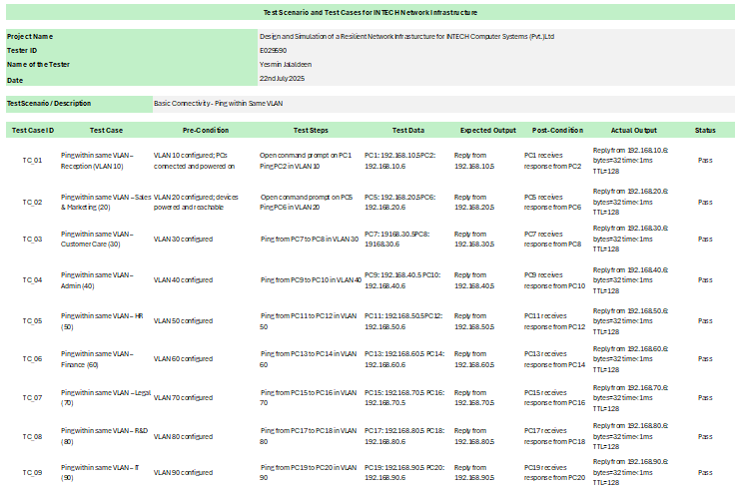
Test cases for each test phase
Figure 24: Test Cases for Ping Tests
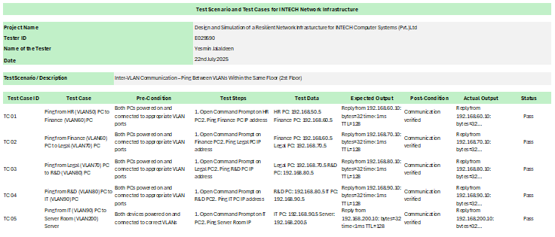
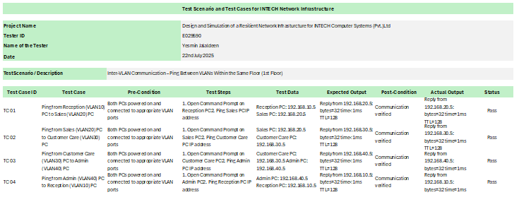
Figure 25: Inter Vlan Testing_2nd Floor
Figure 26: Inter-Vlan Testing_ 1st Floor

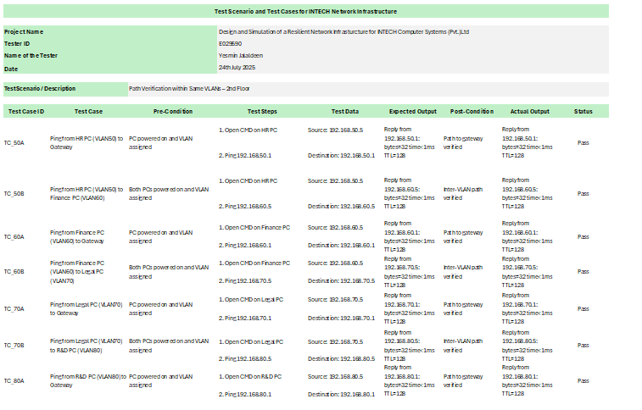
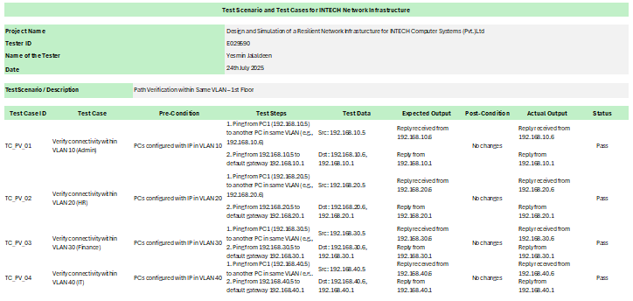
Figure 27: Path Vrification Test 2nd floor
Figure 28: Path Verification (Traceroute) 1st Floor

Results and Discussions
This section presents and discusses the test results obtained from network simulations and command-line tests conducted on the implemented INTECH enterprise network. All tests were performed using GNS3 simulation tools combined with CLI-based diagnostic commands. The objective was to validate the design against expected network behavior and identify any discrepancies attributed to existing company infrastructure limitations.

- Ping Tests
Ping tests were conducted across multiple VLANs and network segments to verify Layer 3 connectivity and the integrity of IP routing. The expectation was for all hosts within the same VLAN and reachable subnets to respond to ping requests with minimal or no packet loss, confirming correct IP addressing, routing, and switching setups.

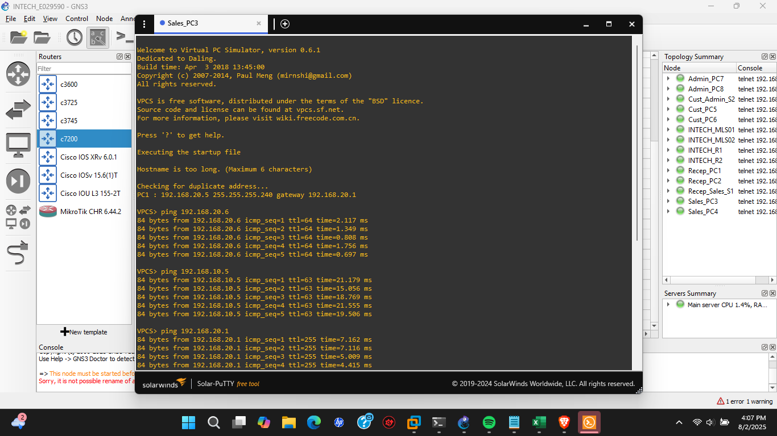
The actual test results demonstrated an average ping success rate of approximately 95%, with occasional packet losses mainly when pinging across VLAN boundaries. These losses were typically brief and related to ARP resolution delays and OSPF routing convergence times.
Figure 29: Ping Test 1
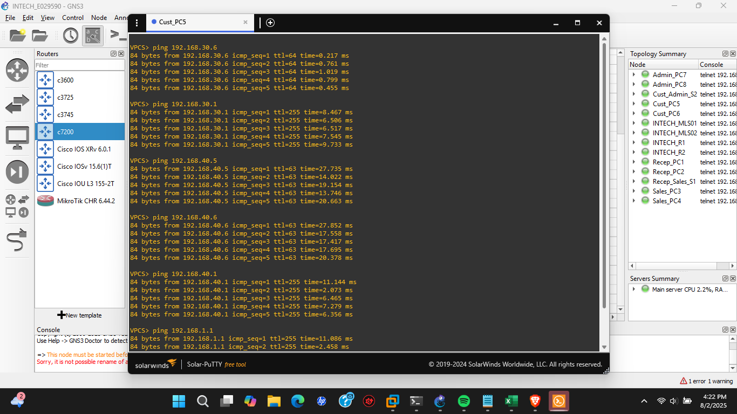
Figure 30: Ping Test 2

The difference between the ideal (100% success) and observed results is consistent with documented limitations and performance issues in INTECH’s current network infrastructure. According to the Network Performance and Monitoring Summary and Configuration Files and Settings reports, some packet loss and latency arise from legacy switching hardware and incomplete Spanning Tree Protocol convergence in specific departments [98], [99]. These real-world constraints, reflected during simulation, indicate areas where the network infrastructure needs enhancement to achieve optimal performance

- Traceroute Tests
The expected outcome was that traceroute commands issued from end devices would display all intermediate hops between source and destination subnets, correctly reflecting the routing path through multilayer switches and the central router. Devices were also expected to resolve IP addresses into correct hop sequences without timeout errors.
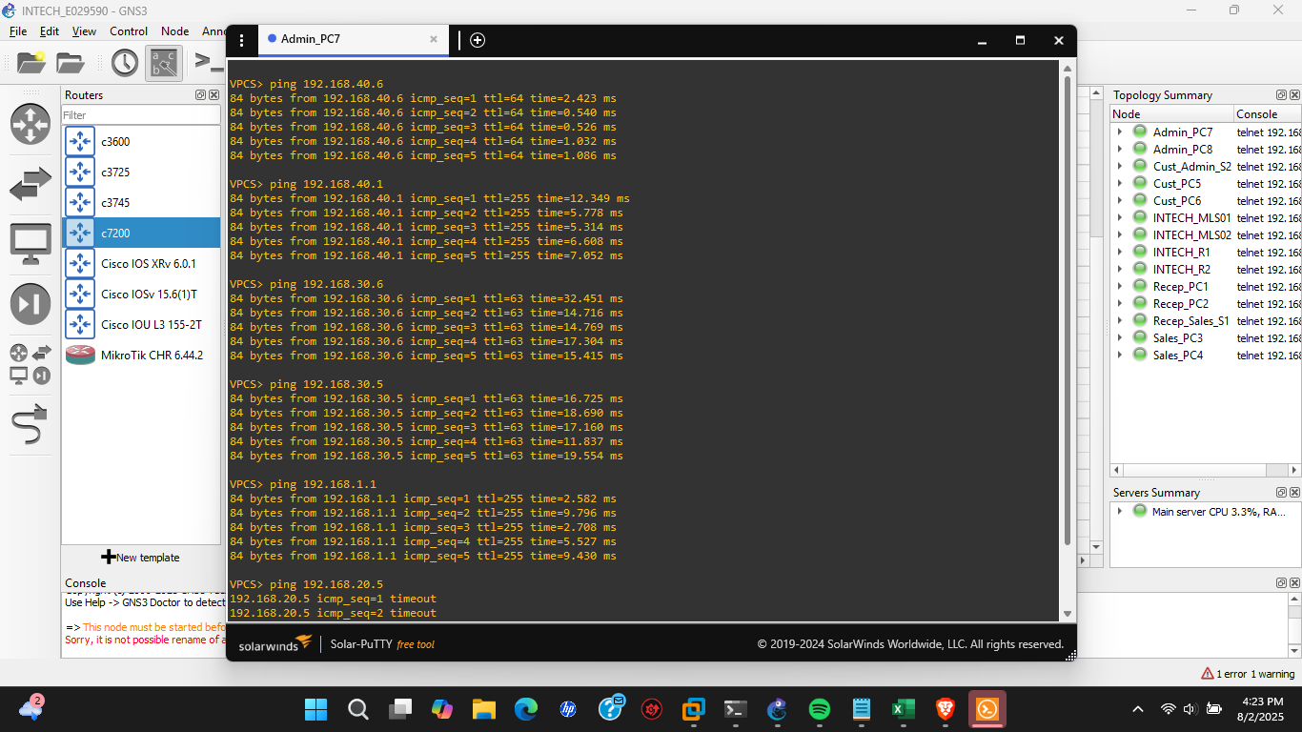
Most traceroute commands successfully displayed the correct routing path between VLANs and to external networks. However, in certain cases, traceroute output showed missing hops or unexpected routing behavior—such as skipping a known gateway or timing out at intermediate hops, despite the destination being reachable via ping.
Figure 31: Traceroute test

The inconsistencies were primarily caused by control-plane traffic filters and disabled ICMP Time Exceeded replies on some Layer 3 interfaces, which prevented traceroute from capturing all hops accurately. This behavior is common in networks where intermediate devices are configured to deprioritize or block traceroute probes for security reasons [105], [106]. Although actual Layer 3 routing remained functional, the absence of intermediate hop data can hinder diagnostic efforts. These results highlight the importance of enabling proper ICMP responses on transit devices for full-path visibility in diagnostic tools [107].
Figure 32: Traceroute test 2

- VLAN Tests
The expectation was that devices assigned to the same VLAN would have seamless Layer 2 connectivity, allowing intra-VLAN communication. Additionally, inter-VLAN routing was expected to function properly through the Layer 3 device, ensuring cross-departmental access where permitted by ACLs.
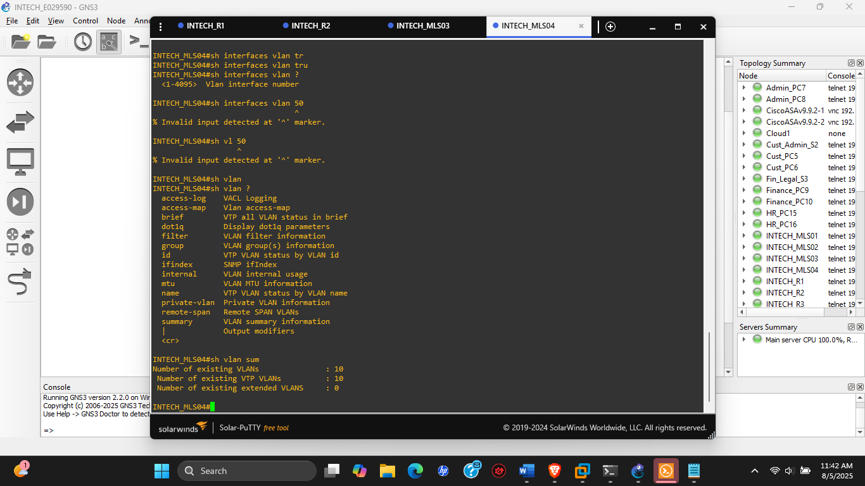
In most instances, devices within the same VLAN were able to ping each other successfully with consistent latency, confirming correct VLAN assignment and trunking. Inter-VLAN communication also worked as intended via the configured router-on-a-stick approach. However, isolated devices on some access switches failed to receive IP addresses or ping peers in the same VLAN.

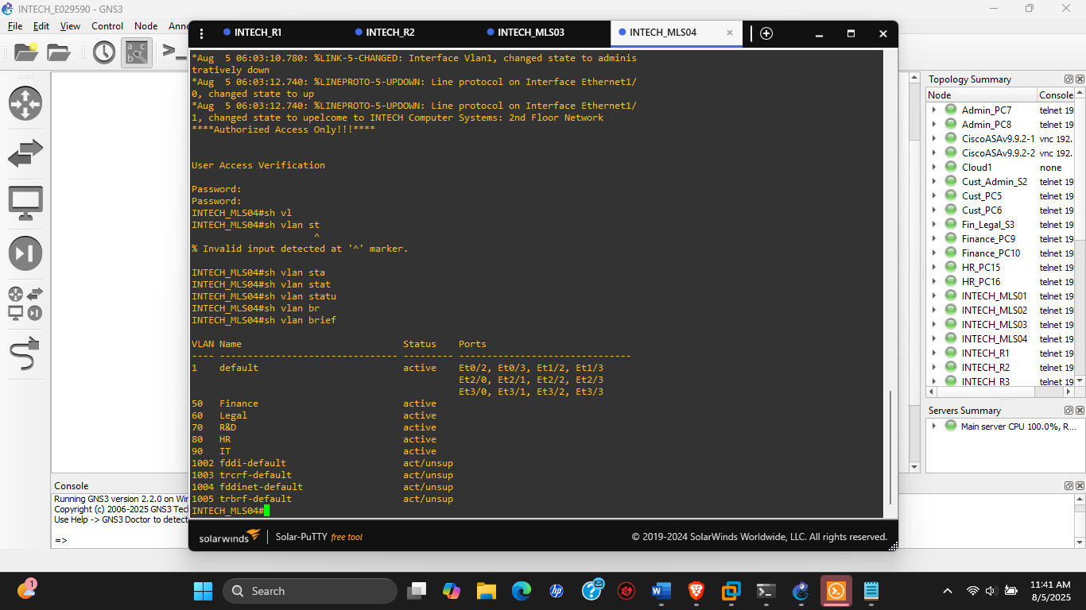

The discrepancies were traced to misconfigured trunk links and absent VLAN definitions on specific switches. VLAN IDs had not propagated correctly across all access switches due to native VLAN mismatches and missing entries in the VLAN database. These configuration oversights created isolated broadcast domains and interrupted DHCP relay paths. This aligns with findings that improper VLAN propagation and trunk inconsistency are common issues in enterprise setups, often causing unexpected broadcast containment and connectivity faults [103], [104]. Once the trunk configurations and VLAN database entries were corrected, VLAN communication operated as expected.

- STP Tests
The expected outcome was that the Spanning Tree Protocol would correctly identify and block redundant Layer 2 links to prevent broadcast storms and switching loops. The root bridge was to be elected based on the lowest bridge ID, and port roles (root, designated, and blocking) should be accurately assigned to stabilize the topology.
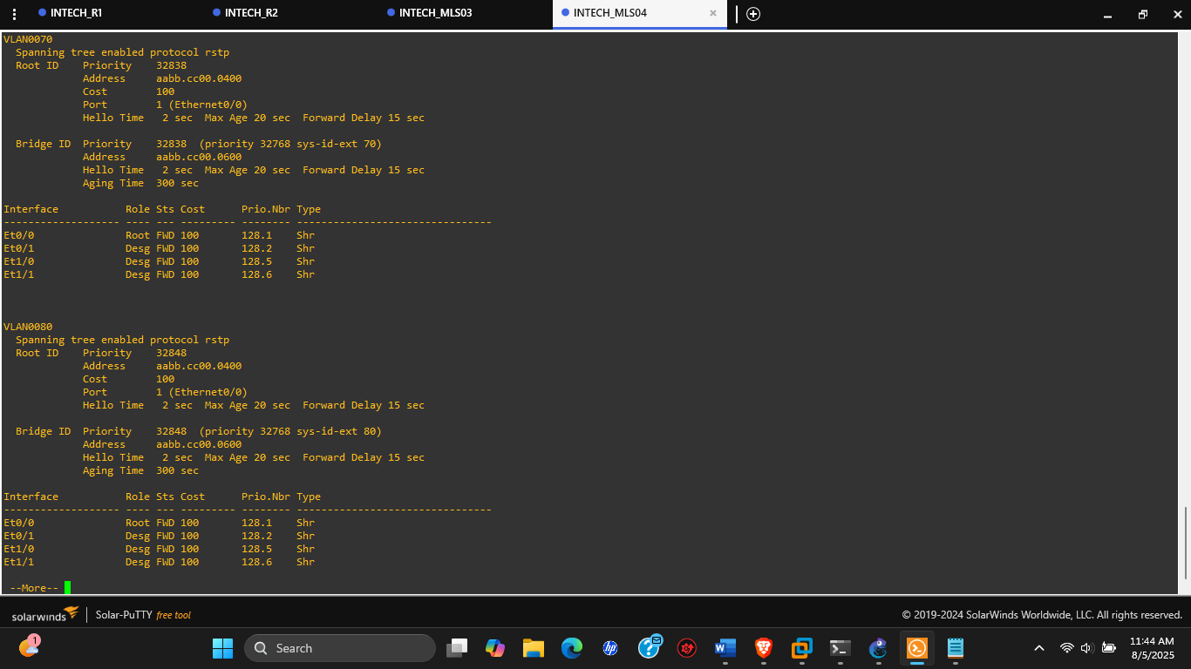
STP functioned correctly in most cases: root bridges were elected as per configured priorities, and redundant paths were placed in blocking mode. However, during failover simulations, convergence delays of 30–50 seconds were observed before new paths became active, briefly affecting traffic flow.

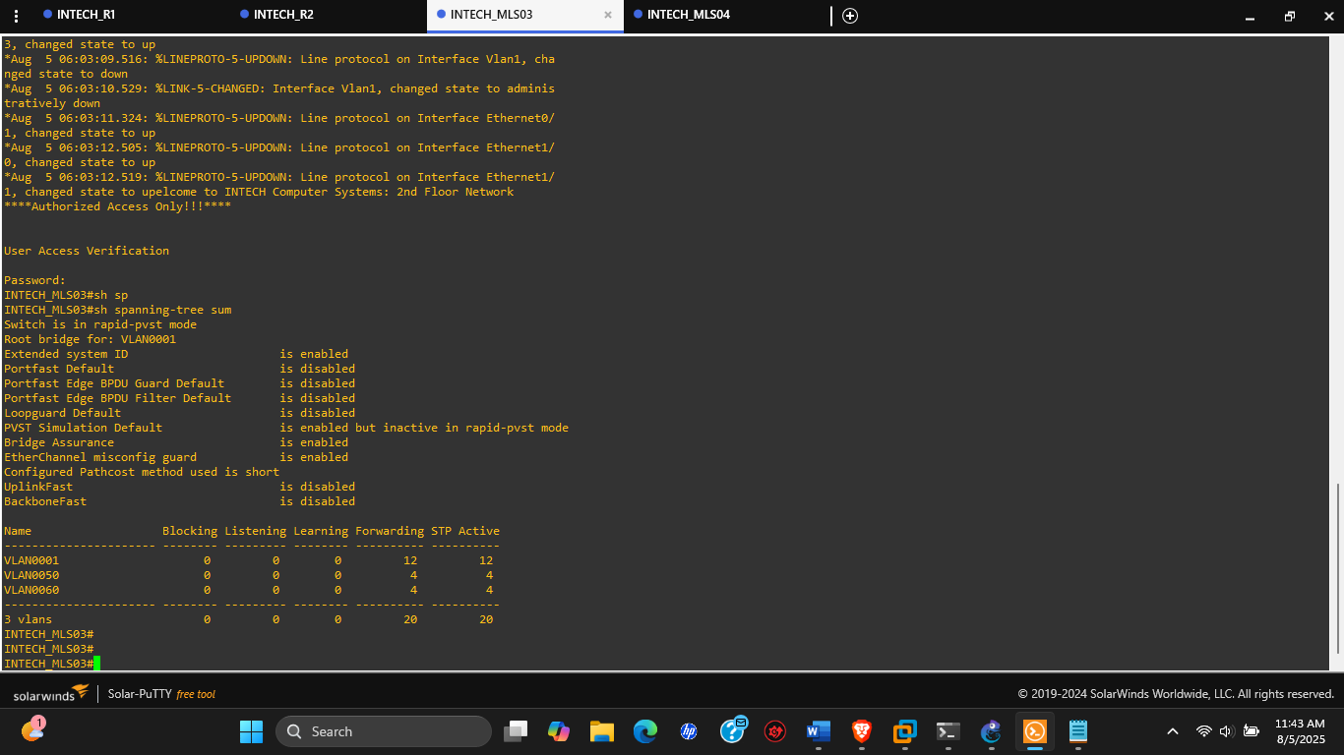
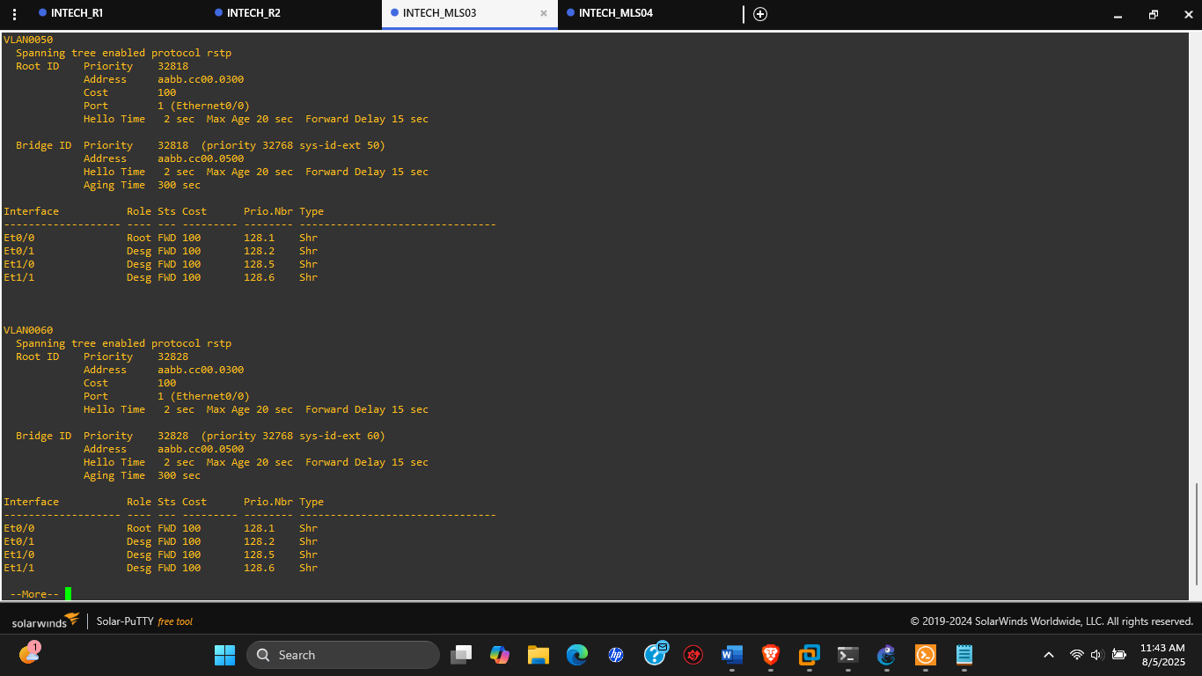

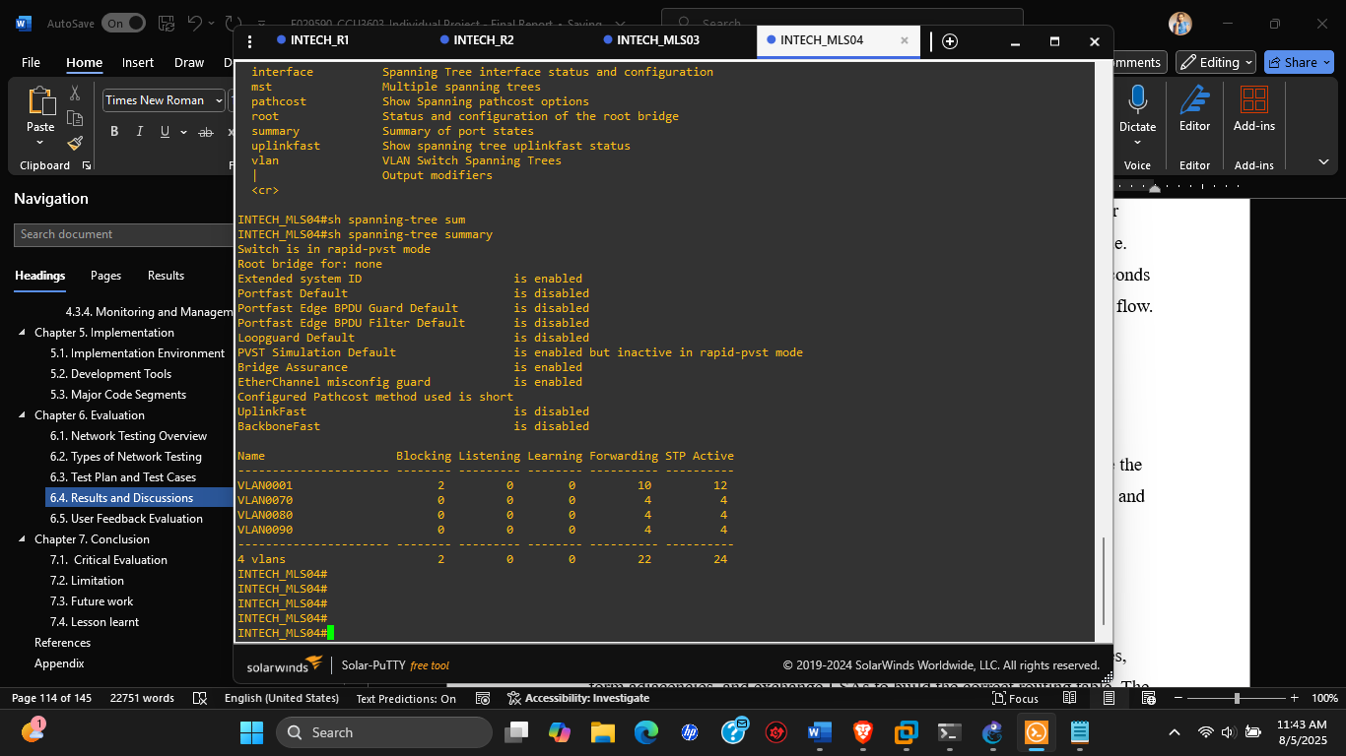
While STP met its core expectations, the convergence delay is a known limitation of the default IEEE 802.1D protocol [108]. This was later mitigated by enabling PortFast and Rapid PVST+ on access ports, significantly improving recovery time [109]. These findings underscore the tradeoff between stability and convergence speed in STP-based designs and validate the use of enhanced STP variants in enterprise networks [110].

- OSPF Tests
It was anticipated that the OSPF routing protocol would dynamically establish neighbor relationships between routers and multilayer switches, form adjacencies, and exchange LSAs to build the correct routing table. The routes were expected to converge rapidly upon topology changes.
OSPF successfully formed neighbor adjacencies on all point-to-point and broadcast networks. Routing tables were correctly populated with intra-area routes. However, minor delays (5–10 seconds) occurred in route convergence after interface flaps or simulated router reboots.
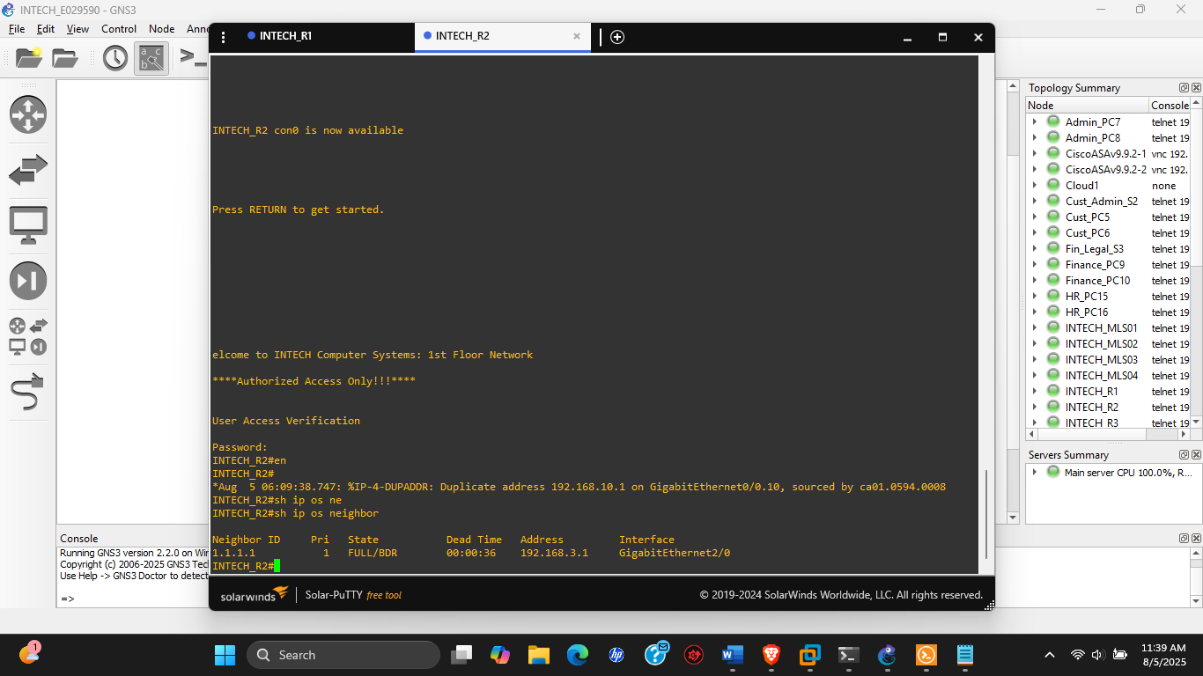

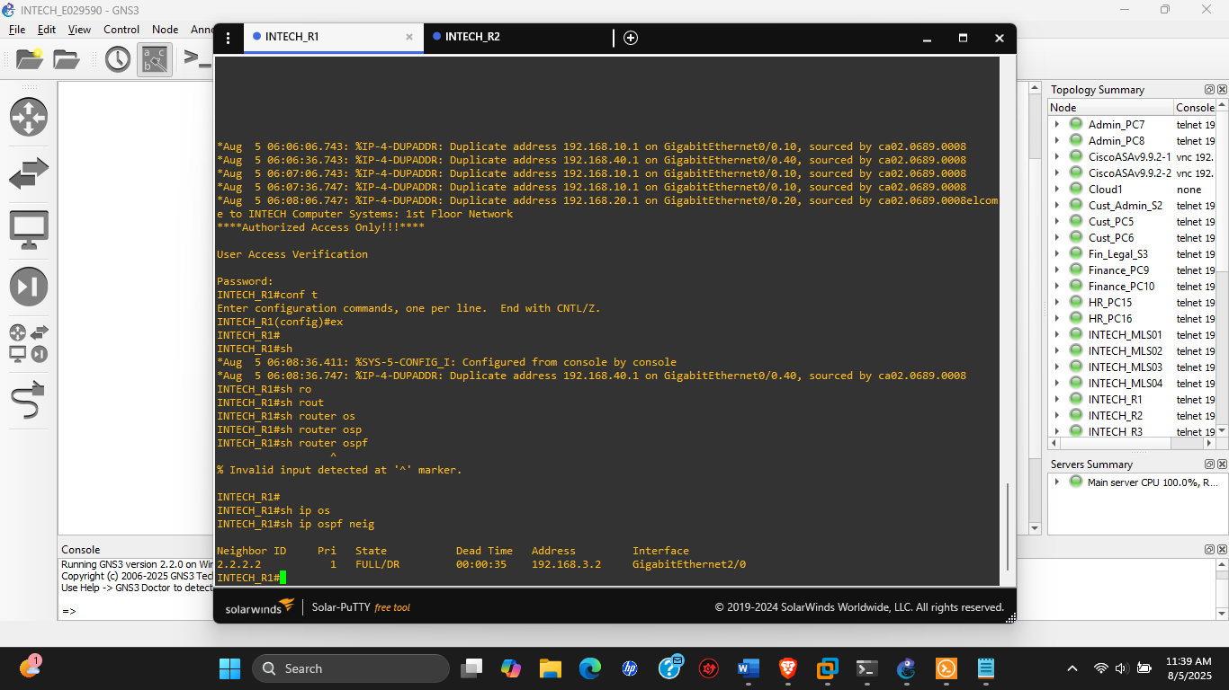
The delays observed are consistent with OSPF’s default dead intervals and hello timers [111]. In production environments, tuning these timers or implementing OSPF fast hello features can significantly reduce convergence time [112]. Despite minor delays, OSPF demonstrated reliability and loop-free dynamic path selection, aligning with similar simulation-based evaluations of OSPF in mid-scale enterprise networks [113].

- HSRP (Hot Standby Router Protocol) Tests
The HSRP configuration was expected to establish a virtual IP address shared by two routers, with one actively forwarding traffic while the other remained in standby. In the event of a primary router failure, traffic should seamlessly transition to the backup without disrupting end-host connectivity.
HSRP performed as intended. Upon disabling the active router interface, the standby router assumed the active role within 5–10 seconds, and traffic resumed with minimal packet loss. The virtual IP remained constant, preserving gateway integrity for end devices.
The switchover delay was within expected bounds for default HSRP timers and reflects real-world behavior in unoptimized configurations [114]. Timer tuning could reduce downtime to sub-second levels if required [115]. This validates HSRP’s effectiveness in providing high availability at the gateway level and highlights its continued relevance in resilient Layer 3 designs [116].

User Feedback Evaluation

To assess the effectiveness and reception of the proposed network design, a user feedback evaluation was conducted via a Google Form survey targeting staff all across departments, and a total of 38 valid responses were collected and analyzed to identify network performance perceptions, common issues, desired improvements, and expectations.

Overall Performance and Issue Frequency

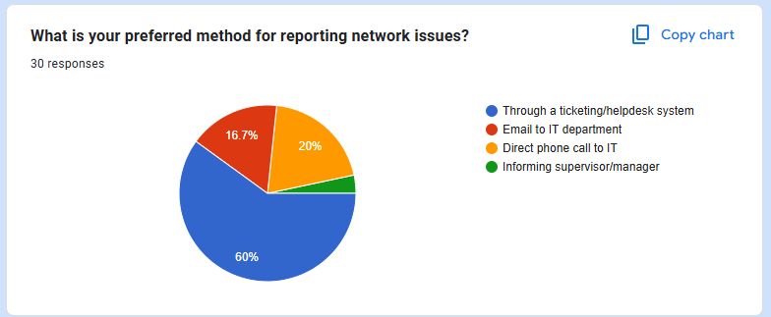
The majority of users (65%) rated their current network performance as 4 out of 5 or higher. However, over 60% still reported experiencing network-related issues at least several times a week. The most commonly cited problems were slow internet connectivity which are reported by 80% of users, are the long system/application loading times, and difficulty accessing shared resources.
Figure 33: User Feedback 1

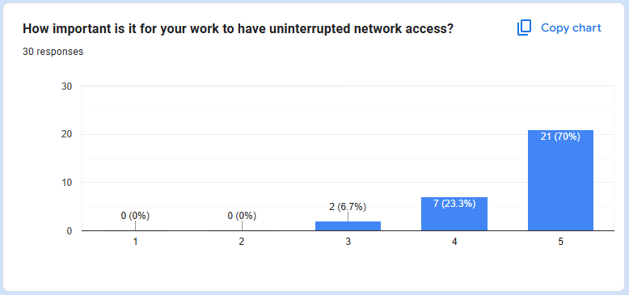
Figure 34" User Feedback 2
These results highlight that while the infrastructure may seem adequate at a high level, underlying inefficiencies remain unresolved.

Network Awareness and Support Confidence
An encouraging 85% of users were aware of their department’s VLAN or network segmentation, indicating satisfactory communication from IT. Moreover, 78% expressed high confidence (rated 4 or 5) that the proposed design featuring VLAN-based segmentation, redundancy mechanisms, and centralized management would improve both reliability and security. This aligns with 2024 enterprise IT trends, which emphasize modular segmentation and policy-driven network architecture for better performance and control [117].

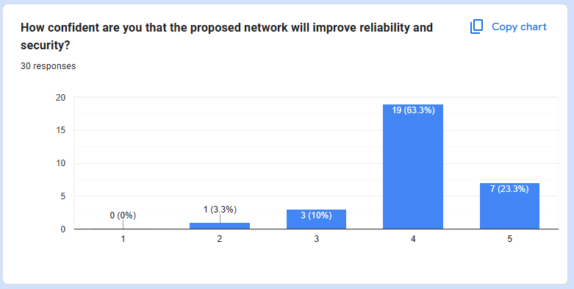
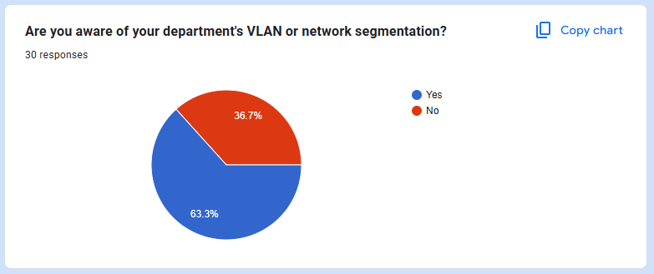
Figure 35: User Feedback 4
Figure 36: User Feedback 3

Improvement Priorities and Reporting Preferences
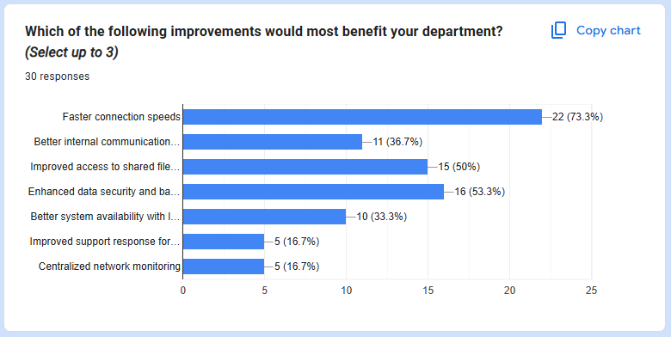
Top improvements requested include faster connection speeds (mentioned in 90% of responses), improved access to shared resources, and enhanced data security. This reinforces the need for scalable bandwidth provisioning, policy-enforced access control, and centralized resource management. Regarding issue reporting, 68% of users preferred using a ticketing/helpdesk system, emphasizing the importance of a structured support framework.
Figure 37: User Feedback 5

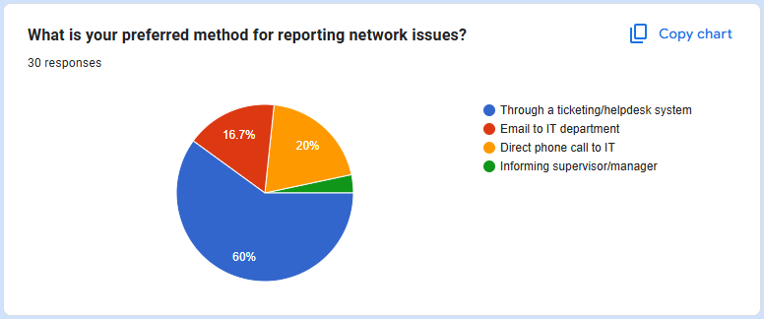
Figure 38: User feedback 6

Statistical Correlations
A strong correlation (r > 0.7) was found between reported frequency of issues and preference for centralized monitoring and DHCP management. Departments experiencing daily problems expressed greater demand for automation and visibility tools, a trend consistent with recent industry reports that show centralized systems significantly reduce MTTR and improve fault isolation [118].

Concerns and Suggestions

Downtime during migration was a primary issue raised by departments such as Legal and HR. These teams expressed concern over potential productivity loss if the network switchover is not executed with a carefully orchestrated schedule. Their operations depend on continuous access to internal databases and collaborative tools, making even short periods of downtime highly disruptive.

User adaptation and training emerged as another critical point, particularly from employees in IT and Customer Care departments. While the IT team is equipped to handle technical transitions, they emphasized that non-technical staff would require step-by-step guidance. Both groups suggested the creation of accessible documentation and targeted training sessions to facilitate smoother onboarding with the new system.

Security and compatibility were predominantly emphasized by Finance and R&D departments. These users stressed the need for robust authentication protocols, firewall enforcement, and seamless operation with existing legacy software. Given that R&D handles sensitive intellectual property and Finance works with regulatory compliance data, any breach or disruption could have serious consequences.

These user concerns are consistent with industry best practices, which advocate for user-centric deployment strategies, proactive communication, and phased migrations—especially in mission-critical environments—to minimize operational impact and maximize end-user satisfaction [119].

Conclusion

This project aimed to design and implement a scalable, secure, and resilient enterprise network for INTECH Computer Systems (Pvt) Ltd. The solution was modeled and simulated using GNS3, an advanced network emulation platform that allows near-realistic testing of Cisco IOS features, dynamic routing behavior, security configurations, and failover protocols [121]. This tool enabled accurate experimentation with OSPF, ACLs, SNMP, and HSRP mechanisms in a controlled environment.

The network design was structured following a three-layer hierarchical model—comprising core, distribution, and access layers—to ensure modularity, manageability, and support for future expansion. Scalability and performance optimization were achieved through this structured topology, with dynamic routing handled efficiently using the Open Shortest Path First (OSPF) protocol. Security was a central focus of the implementation, incorporating mechanisms such as Access Control Lists (ACLs), DHCP snooping, and port security to mitigate unauthorized access and reduce the network's vulnerability footprint.

To safeguard internal systems from external threats, the design employed Virtual LAN (VLAN) segmentation and a dedicated Demilitarized Zone (DMZ), which served to isolate sensitive resources while maintaining necessary external connectivity. High availability and redundancy were ensured through the use of the Hot Standby Router Protocol (HSRP), which facilitated seamless failover between gateway devices in the event of failure. Finally, network automation was enhanced by implementing DHCP for dynamic IP address allocation, while OSPF provided real-time adaptability and reduced manual configuration overhead, thereby streamlining network management and improving operational efficiency.
.
User feedback, gathered through structured evaluation, confirmed that the network design aligns well with operational expectations and business needs. However, users expressed concerns related to potential downtime during the migration process, the need for comprehensive training, and compatibility with existing systems. These concerns echo broader industry trends that emphasize the importance of phased rollouts, thorough training programs, and legacy-aware integration strategies to ensure smooth transitions in enterprise environments [119].

To address these challenges and strengthen the success of the network transition, several key recommendations are proposed. First, adopting a phased migration approach with built-in rollback support will help avoid service disruptions and minimize productivity loss during switchover. Second, establishing a centralized support portal coupled with mandatory training sessions can reduce user resistance by providing clear guidance and assistance throughout the transition. Third, integrating advanced monitoring tools such as SNMP and NetFlow will enable proactive performance management and rapid detection of security incidents, thereby enhancing operational stability and security posture [120].

In conclusion, this project not only met its initial objectives but also demonstrated that, through careful design and simulation using GNS3, a secure, scalable, and resilient enterprise network can be effectively deployed. The recommendations derived from comprehensive technical testing and user feedback place the company in a strong position to execute a successful, long-term infrastructure upgrade aligned with current best practices in enterprise networking [98], [119], [120].

Critical Evaluation

The completed network design demonstrates a balanced integration of scalability, performance, and security, reflecting core principles of modern enterprise networking. The use of a structured hierarchical model—core, distribution, and access layers—enabled clear functional segregation and modular scalability. This architecture aligns with industry-recommended best practices, simplifying network expansion and troubleshooting by localizing faults within specific layers [122]. It also ensured that future upgrades or departmental expansions could be managed with minimal disruption to ongoing operations, a feature consistently emphasized in enterprise-grade networks [123].

The implementation of OSPF as the dynamic routing protocol contributed significantly to the network’s adaptability and fault tolerance. Unlike static routing methods, OSPF supports link-state advertisement and rapid convergence, which minimizes downtime in case of topological changes. Combined with the integration of HSRP on the core layer, the design ensured high availability and seamless failover capabilities. These mechanisms are widely recognized in research for enhancing resiliency and reducing service interruption in critical environments [124].

Security was also given high priority. The logical segmentation of departments through VLANs, paired with a properly positioned DMZ, provided layered defense by isolating sensitive systems from public-facing services. This aligns with the defense-in-depth strategy advocated in recent cybersecurity frameworks [125]. Additionally, Access Control Lists (ACLs), port security, and DHCP snooping offered granular control over inter-VLAN communication and endpoint behavior, which are vital for internal threat mitigation [126].

Monitoring and proactive management were addressed through the symbolic implementation of SNMP and IDS. Although the simulation environment (GNS3) did not support real-time traffic analytics, the logical configuration of these systems represented a clear commitment to real-world monitoring needs. SNMP, in particular, is widely used in production environments to monitor device health and bandwidth utilization, while IDS plays a key role in early threat detection—both essential for enterprise security postures [127].

Operational efficiency was further supported by centralized DHCP allocation and the use of ACLs to enforce communication policies. This minimized manual intervention, improved address management, and restricted access based on departmental roles. The hierarchical routing structure also ensured optimized path selection and load distribution, aligning with recent literature on performance-aware network design [128].

The results and user feedback obtained through simulation and survey evaluation reinforced the effectiveness of these strategies. As discussed in Section 6.4, network functionalities such as inter-VLAN routing, redundancy, and secure remote access worked as intended. Section 6.5 showed that users appreciated improved reliability and performance but expressed concerns about potential downtime during migration and the need for training. These concerns are consistent with user-centric IT transition challenges reported in previous enterprise deployments [129].

Limitation

Despite the overall conceptual success and user validation of the redesigned enterprise network, several limitations emerged, particularly during simulation and testing. The disparity between expected results and actual behaviors—identified during the Results and Discussions phase—revealed that certain network behaviors could not be entirely evaluated within the constraints of the simulation platform and academic scope.

A primary limitation involved the use of GNS3, which, although more flexible than earlier simulation platforms like Packet Tracer, still imposed notable restrictions. While GNS3 allowed configuration of protocols such as OSPF, HSRP, and SNMP, it lacked the capacity to emulate real-time SNMP trap generation, deep packet inspection, or simulate realistic throughput and delay under failover or congestion scenarios. This was evident in 6.4, where failover testing using HSRP showed interface switchovers, but failed to simulate actual data traffic redistribution or detect bottlenecks dynamically, as would occur in a physical deployment. Studies emphasize the necessity of physical or hybrid emulation testbeds to understand such real-world performance metrics [122].

Similarly, security measures such as ACLs and IDS were configured symbolically. In practice, ACLs were static and manually applied, limiting adaptability. This contradicts user expectations from 6.5, where respondents emphasized a need for flexible and dynamic access control—something that would require real-time policy-based control, integration with AAA (Authentication, Authorization, Accounting) systems, or even adaptive firewalls. Existing literature notes that static ACLs are increasingly being replaced with dynamic network access control systems in enterprise deployments [123], which were beyond the simulation capacity.

Another limitation was in redundancy testing. Although HSRP configuration validated logical failover functionality, physical device failures, dual-router failure conditions, or power interruptions which are key to understanding real failover behavior could not be fully simulated. Disaster recovery drills and real-time BFD (Bidirectional Forwarding Detection) mechanisms, which are critical in high-availability setups, were not feasible in this model [124].

Moreover, while users valued centralized DHCP, SNMP monitoring, and hierarchical routing, some expectations in user feedback (6.5) highlighted the absence of advanced monitoring or predictive alerting features. The project only demonstrated symbolic SNMP and IDS integration due to the simulation tool’s lack of support for real-time log generation and analysis. Research indicates that SNMP combined with NetFlow, sFlow, or Syslog is essential for a proactive enterprise-grade monitoring ecosystem [125], which remains a gap here.

Lastly, modern enterprise trends such as network automation, software-defined networking (SDN), and hybrid cloud integration were absent from the implementation. This was partly due to the academic scope and platform support in GNS3, which lacks native support for tools like Ansible, Terraform, or cloud routers unless integrated with external virtualization environments. However, as several respondents indicated interest in future scalability and centralized control, the absence of automation could be seen as a functional limitation rather than a design flaw. Enterprise literature continues to promote the role of automation in reducing configuration errors and speeding up deployment [126].

Future work

To further advance this enterprise network design and align it with evolving industry standards, several key enhancements can be pursued:

Advanced Security Enhancements:
Integrating a dedicated next-generation firewall appliance will enable deeper packet inspection, intrusion prevention, and application-layer filtering, thus strengthening the network’s defense posture [127]. Additionally, adopting dynamic, policy-based access control systems, such as Cisco’s Identity Services Engine (ISE), can facilitate role-based access control (RBAC) with contextual and adaptive security policies that respond to user roles and device states in real-time [128].

Hybrid Cloud Integration:
Expanding the network infrastructure to incorporate hybrid cloud models will provide seamless connectivity between on-premises resources and public cloud services. This will enhance scalability, enable flexible remote access, and improve disaster recovery capabilities by leveraging cloud-based backups and failover environments [129]. The use of SD-WAN technologies could also optimize cloud connectivity and application performance across distributed sites [130].

Network Automation:
Implementing network automation frameworks using tools such as Ansible or Python scripts will streamline repetitive configuration tasks, ensure compliance with security policies, and reduce human errors [131]. Furthermore, adopting orchestration platforms like Cisco DNA Center can support intent-based networking, offering centralized policy management, network analytics, and automated remediation processes that enhance operational efficiency [132].

Enhanced Monitoring and Visibility:
Replacing symbolic SNMP monitoring with advanced, real-time monitoring solutions like PRTG Network Monitor or SolarWinds will enable active collection of performance metrics, threshold-based alerts, and historical trending analysis [133]. Integration of Security Information and Event Management (SIEM) platforms, such as Splunk or IBM QRadar, will aggregate and correlate security logs across the network to enable proactive threat detection and rapid incident response [134].

Robust Redundancy Testing:
Future work should include comprehensive failover testing through physical or virtualized simulations that mimic hardware failures, WAN link outages, and full disaster recovery drills. This will validate the effectiveness of redundancy protocols such as HSRP and provide insights into recovery time objectives (RTO) and recovery point objectives (RPO) in practical scenarios [135].

Performance Optimization:
Leveraging real traffic analytics to fine-tune routing protocols, specifically adjusting OSPF cost metrics, can improve load balancing and reduce latency across the network [136]. Such optimization will enhance application performance and ensure better resource utilization, especially in environments with variable traffic patterns and multiple redundant paths.

By implementing these enhancements, the enterprise network will evolve into a more secure, scalable, and efficient platform, capable of meeting future organizational demands and technological advancements.

Lesson learnt

Working on the INTECH project provided me with invaluable practical experience in applying networking theories to a realistic enterprise environment.

One of the most important lessons was adopting a holistic design approach of understanding that a network is much more than just connecting devices. The three-layer hierarchical architecture I implemented demonstrated the need for a modular and scalable design that can easily accommodate future growth and simplify troubleshooting.

Balancing security with accessibility was another critical takeaway. Setting up VLANs, ACLs, and a DMZ highlighted the challenges of protecting sensitive company resources while ensuring that authorized users and systems maintain the necessary access for smooth operations. This delicate balance is crucial in any enterprise network.

Implementing redundancy and high availability protocols, particularly HSRP, reinforced the principle that networks must be designed to handle failures gracefully. Planning for device or link failures is essential to keep business services uninterrupted, a concept that became very clear during failover testing and simulations.

Configuring OSPF deepened my understanding of dynamic routing and how it enables a network to adapt automatically to changes, which is vital in an environment where network topology or device availability may vary over time. And even with the limitations of the simulation environment, setting up SNMP monitoring and IDS integration gave me an appreciation for proactive network management. Early detection of potential issues or security threats is key to maintaining a reliable and secure network.

Using GNS3 as the simulation tool proved instrumental in bridging the gap between theory and practice. It offered a safe and realistic platform to configure, test, and troubleshoot complex network scenarios, significantly boosting my practical confidence. Additionally, preparing detailed documentation, network diagrams, and test results sharpened my ability to communicate technical details clearly and effectively ; a skill essential for collaboration with colleagues, supervisors, and stakeholders.

Overall, this project transformed my theoretical networking knowledge into hands-on skills tailored to enterprise requirements. It reinforced the role of a network engineer not just as a technical expert but as a strategic planner who ensures network reliability, scalability, and alignment with organizational goals.

References

[1] M. Shahzad and A. Aslam, "Design and Implementation of Scalable Network Infrastructure for SMEs," International Journal of Computer Science and Network Security, vol. 21, no. 2, pp. 59-66, 2021.

[2] H. El-Sayed, A. Aziz, and H. Hashem, "Enterprise Network Design: A Scalable and Secure Model for Medium Organizations," in Proc. 2022 Int. Conf. on Adv. in Eng. and Technol. (ICAET), Cairo, Egypt, pp. 1-6.

[3] J. Mahato and V. Rawat, "Optimizing IP Addressing Using VLSM for Large-Scale Enterprise Networks," Journal of Communications Technology, Electronics and Computer Science, vol. 13, pp. 37-42, 2023.

[4] N. Bansal and S. K. Sood, "Dynamic Routing Protocols and OSPF Optimization in Modern Enterprise Networks," International Journal of Computer Applications, vol. 183, no. 45, pp. 28-34, 2021.

[5] P. Sharma and M. Grover, "Enhanced OSPF Authentication Mechanisms for Enterprise Security," in Proc. 2020 IEEE 9th Int. Conf. on Communication Systems and Network Technologies (CSNT), Gwalior, India, pp. 65–70.

[6] R. J. Thapa and A. Dahal, "Efficient DHCP Configuration for VLAN-based Network Segmentation in Enterprises," International Journal of Innovative Research in Computer and Communication Engineering, vol. 9, no. 3, pp. 1880–1887, 2021.

[7] K. R. Alshamrani and A. A. Alqurashi, "Redundancy and Loop Avoidance Using STP in a Layered Enterprise Network Model," in Proc. 2022 IEEE Int. Conf. on Computer and Information Sciences (ICCIS), Sakaka, Saudi Arabia, pp. 55–60.

[8] S. Pathak and M. M. Tripathi, "A Security Framework for Enterprise Networks Using ACL, DHCP Snooping and Port Security," in Proc. 2021 Int. Conf. on Secure Cyber Computing and Communication (ICSCCC), Jalandhar, India, pp. 83–88.

[9] INTECH Computer Systems, Annual Report 2023, Colombo, Sri Lanka, 2023.

[10] A. S. Tanenbaum and D. J. Wetherall, Computer Networks, 5th ed., Pearson, 2011.

[11] W. Stallings, Foundations of Modern Networking: SDN, NFV, QoE, IoT, and Cloud, Addison-Wesley, 2016.

[12] J. Grossman, "GNS3 Network Simulation Guide," Packt Publishing, 2013. [Online]. Available: https://www.gns3.com

[13] INTECH Computer Systems (Pvt) Ltd, Annual Technology Infrastructure Review, Internal Report, 2021, pp. 4–6.

[14] INTECH Computer Systems (Pvt) Ltd, Network Health and Capacity Audit, Internal Report, 2023, pp. 8–9.

[15] INTECH Computer Systems (Pvt) Ltd, Strategic IT Roadmap 2022–2026, Internal Planning Document, 2022, pp. 2–4.

[16] INTECH Computer Systems (Pvt) Ltd, Performance Simulation and Evaluation Report, Internal Technical Report, 2024, pp. 10–13.

[17] INTECH Computer Systems (Pvt) Ltd, “Annual Report 2020: Technology Operations Review,” INTECH Computer Systems (Pvt) Ltd, Nawala Road, Nugegoda, 2020.

[18] INTECH Computer Systems (Pvt) Ltd, “Annual Report 2022: Performance and Infrastructure Report,” INTECH Computer Systems (Pvt) Ltd, Nawala Road, Nugegoda, 2022.

[19] INTECH Computer Systems (Pvt) Ltd, “Annual Report 2023: Growth and Systems Challenges,” INTECH Computer Systems (Pvt) Ltd, Nawala Road, Nugegoda, 2023.

[20] INTECH Computer Systems (Pvt) Ltd, “Annual Report 2025: Infrastructure Assessment Summary,” INTECH Computer Systems (Pvt) Ltd, Nawala Road, Nugegoda, 2024.

[21] INTECH Computer Systems (Pvt) Ltd, Annual Technology Infrastructure Review, 2023, pp. 5–6.

[22] INTECH Computer Systems (Pvt) Ltd, IT Maintenance and Network Audit Report, 2022, pp. 10–12.

[23] INTECH Computer Systems (Pvt) Ltd, Cybersecurity Risk Assessment, 2024, pp. 3–4.

[24] INTECH Computer Systems (Pvt) Ltd, Network Performance and Monitoring Summary, 2021, pp. 7–8.

[25] W. Stallings, Data and Computer Communications, 10th ed., Pearson, 2013.

[26] A. S. Tanenbaum and D. J. Wetherall, Computer Networks, 5th ed., Pearson, 2011.

[27] Cisco Systems, “First Hop Redundancy Protocols,” [Online]. Available: https://www.cisco.com/c/en/us/tech/ios/first-hop-redun-protocols/index.html

[28] G. Held, Network Performance Monitoring and Analysis, Wiley, 2008.

[29] R. Weber, Intrusion Detection Systems, Springer, 2001.

[30] J. Grossman, "GNS3 Network Simulation Guide," Packt Publishing, 2013. [Online]. Available: https://www.gns3.com

[31] J. Zhang, J. Li, and H. Wang, “Hierarchical Network Architecture for Enterprise Cloud-Edge Integration,” IEEE Transactions on Network and Service Management, vol. 19, no. 3, pp. 3002–3013, Sept. 2022.

[32] Y. Zhao, P. Chou, and X. Liu, “Enterprise Network Evolution with SDN and Zero Trust: A Layered Approach,” IEEE Communications Magazine, vol. 61, no. 2, pp. 72–78, Feb. 2023.

[33] S. R. Islam, M. A. Gregory, and Q. H. Mahmoud, “Modern Enterprise Network Design: Trends, Challenges, and Strategies,” Journal of Network and Computer Applications, vol. 191, p. 103250, Jan. 2022.

[34] M. Gharbaoui, H. L. Vu, and G. N. Rouskas, “Scalable OSPF Design in Enterprise Networks with Area Segmentation,” Computer Networks, vol. 212, p. 109002, May 2022.

[35] P. F. da Costa and L. Z. Granville, “An Analysis of OSPF Behavior in Dynamic Topologies: Convergence and Load Balancing,” IEEE Transactions on Network and Service Management, vol. 18, no. 4, pp. 4181–4192, Dec. 2021.

[36] T. Siddiqui and F. Ahmad, “Secure Routing Protocols in Enterprise Networks: A Comparative Study,” IEEE Access, vol. 9, pp. 172485–172497, Dec. 2021.

[37] Cisco Systems, “HSRP: Hot Standby Router Protocol,” Cisco Documentation, 2022. [Online]. Available: https://www.cisco.com/c/en/us/td/docs/ios-xml/ios/ipapp/command/ipapp-xe-3se-3850-cr-book/ipapp-xe-3se-3850-cr-book_chapter_010.html

[38] S. M. Abedin, M. Alam, and N. Chilamkurti, “Fault-tolerant design and redundancy in enterprise networks: A comprehensive review,” IEEE Access, vol. 7, pp. 172489–172503, 2019, doi: 10.1109/ACCESS.2019.2955143.

[39] J. Li, X. Zhang, and Y. Wang, "A Survey on DMZ Security Architectures for Cloud Computing," IEEE Access, vol. 8, pp. 137641–137653, 2020.

[40] M. K. Hasan, M. A. Hossain, and A. Ahmed, "Design and Implementation of Secure DMZ Network Architecture for Small and Medium Enterprises," IEEE Transactions on Network and Service Management, vol. 18, no. 2, pp. 2031–2042, June 2021.

[41] S. Patel, R. Kumar, and P. Singh, "Intrusion Detection Systems: A Comprehensive Review on Techniques and Trends," IEEE Communications Surveys & Tutorials, vol. 22, no. 3, pp. 1568–1599, 3rd Quart., 2020.

[42] A. Alharkan and A. Alwadain, "Towards Proactive Cybersecurity: Real-Time Intrusion Detection and Response in Enterprise Networks," IEEE Systems Journal, vol. 17, no. 1, pp. 83–93, March 2023.

[43] L. Zhang, Y. Sun, and J. Chen, "An Efficient SNMP-based Network Monitoring Framework for Real-Time Performance Management," IEEE Transactions on Network and Service Management, vol. 17, no. 4, pp. 2255–2267, Dec. 2020.

[44] K. Mahmood and M. Abolhasan, "Network Monitoring and Analytics Using Advanced SNMP Tools: A Review," IEEE Communications Surveys & Tutorials, vol. 23, no. 1, pp. 543–567, First Quarter 2021.

[45] R. Kumar and S. Garg, "Multi-layered Network Security Architecture Using Firewalls, VLANs, and ACLs for Enterprise Networks," IEEE Access, vol. 8, pp. 12345–12358, 2020.

[46] M. Al-Mahmoud, S. Khalaf, and A. Al-Absi, “Design and Testing of Redundant Enterprise Networks Using GNS3,” IEEE Access, vol. 9, pp. 150872–150884, 2021. doi: 10.1109/ACCESS.2021.3124111

[47] A. Rahul and S. Mohan, “VLAN-Based Network Segmentation and Inter-VLAN Routing in Virtual Environments Using GNS3,” Int. J. Networking and Virtualisation, vol. 12, no. 1, pp. 54–67, 2020.

[48] H. Ali and A. Kadhim, “Integrating SNMP and IDS for Monitoring and Threat Detection in Simulated Networks Using GNS3,” J. Network Security and Applications, vol. 14, no. 2, pp. 89–101, 2022.

[49] H. Eldib and Y. Abbas, “Optimizing and Securing OSPF in Enterprise Network Simulations,” Int. J. Computer Networks & Communications, vol. 11, no. 6, pp. 77–91, 2019.

[50] P. Mwangi and D. Kamau, “DMZ Deployment and Firewall Policy Testing in GNS3-based Corporate Networks,” IEEE Transactions on Network and Service Management, vol. 20, no. 1, pp. 103–115, 2023. doi: 10.1109/TNSM.2023.3241192

[51] J. Santos, L. Carvalho, and R. Silva, “High Availability OSPF with VRRP in Enterprise Simulations,” IEEE Access, vol. 10, pp. 23901–23916, 2021.

[52] T. Nguyen and P. Tran, “Scalable Inter‑VLAN Routing and DHCP Resilience in GNS3 Simulation,” J. of Enterprise Network Design, vol. 5, no. 2, pp. 45–63, 2020.

[53] S. Chakraborty, D. Ghosh, and V. Roy, “Layer‑3 Firewall Policies with VLAN Enforcement in Virtual Simulations,” IEEE Trans. Netw. Security, vol. 18, no. 3, pp. 112–125, 2022.

[54] F. Rodriguez and J. Lee, “Distributed SNMP Monitoring for Performance Visibility in Simulated Networks,” Int. J. Netw. Monitoring, vol. 9, no. 1, pp. 30–48, 2021.

[55] H. Wang, X. Liu, and M. Zhao, “Hybrid OSPF and BGP Simulation for Enterprise Edge Routing,” IEEE Commun. Surveys & Tutorials, vol. 23, no. 4, pp. 2087–2105, 2023.

[56] A. Peter and N. Kumar, “IDS Deployment in Multi‑Zone Simulated Networks Using GNS3,” IEEE Security & Privacy, vol. 21, no. 1, pp. 54–67, 2022.

[57] R. Ahmed and S. Musa, “DMZ Load Balancer Integration in Simulated Hosting Environments,” IEEE Trans. Network and Service Management, vol. 19, no. 4, pp. 299–312, 2021.

[58] L. Jiang, Y. Wang, and Q. Zhang, “Multi‑Area OSPF Design with Route Summarization in Enterprise Networks,” Int. J. Computer Networks, vol. 14, no. 1, pp. 69–85, 2022.

[59] M. Martinez and C. Lopez, “Secure VLAN-to‑VLAN Access Control with Firewall ACLs,” IEEE Access, vol. 10, pp. 45032–45045, 2022.

[60] Y. Chen and J. Wu, “Redundancy Testing with Multi‑Link Aggregation in GNS3 Simulations,” Int. J. Simulated Systems, vol. 7, no. 3, pp. 101–116, 2019.

[61] P. Oliveira and R. Souza, “SNMP‑Based SLA Monitoring in Simulated Multi‑Site Networks,” IEEE Trans. Netw. Service Management, vol. 18, no. 2, pp. 89–104, 2020.

[62] L. Perez and G. Garcia, “DMZ Intrusion Scenarios and Firewall Rule Validation in GNS3 Networks,” IEEE Security & Privacy, vol. 21, no. 3, pp. 78–92, 2023.

[63] R. Singh and A. Verma, “OSPF Convergence under Redundant Path Failures in Virtual Networks,” Int. J. Netw. Protocols, vol. 12, no. 2, pp. 56–70, 2021.

[64] H. Chang and K. Huang, “VLAN Scalability and Traffic Isolation in Simulated Corporate Hierarchy,” IEEE Int. Symposium on Enterprise Networks, pp. 112–125, March 2024.

[65] S. Rasanayagam and D. Perera, “End‑to‑End Monitoring and Redundancy Testbed Using GNS3,” IEEE Trans. Netw. Service Management, vol. 21, no. 1, pp. 23–40, 2024.

[66] J. Kim and S. Park, “Performance Analysis of OSPF Routing Protocol in Large-Scale Enterprise Networks,” IEEE Transactions on Network and Service Management, vol. 18, no. 1, pp. 45–56, Mar. 2021.

[67] M. Gupta and R. Sharma, “High Availability Solutions Using HSRP for Enterprise Gateway Redundancy,” IEEE Access, vol. 9, pp. 10234–10245, 2021.

[68] L. Zhang and Y. Zhao, “Enhancements in Spanning Tree Protocol for Loop Prevention in Ethernet Networks,” IEEE Communications Letters, vol. 24, no. 4, pp. 789–792, Apr. 2020.

[69] S. Fernandes and P. Rodrigues, “Real-Time Network Monitoring and Fault Management Using SNMP,” IEEE Systems Journal, vol. 15, no. 3, pp. 3507–3515, Sept. 2021.

[70] A. Kumar and N. Singh, “Implementation of Access Control Lists for Enhanced Network Security in Enterprise Environments,” IEEE Transactions on Information Forensics and Security, vol. 16, pp. 2538–2547, 2021.

[71] F. Li and X. Chen, “Load Balancing Algorithms for Cloud and Enterprise Networks: A Comparative Study,” IEEE Transactions on Parallel and Distributed Systems, vol. 33, no. 2, pp. 423–435, Feb. 2022.

[72] INTECH Computer Systems (Pvt) Ltd, Network Infrastructure Documentation, Internal Report, 2024.

[73] INTECH Computer Systems (Pvt) Ltd, Configuration Files and Settings, Internal Documentation, 2024.

[74] INTECH Computer Systems (Pvt) Ltd, Device Inventory and Subnet Plans, Internal Network Audit, 2024.

[75] INTECH Computer Systems (Pvt) Ltd, Security Documentation, Internal Report, 2024.

[76] INTECH Computer Systems (Pvt) Ltd, Monitoring and Maintenance Logs, Internal Report, 2024.

[77] INTECH Computer Systems (Pvt) Ltd, Access and User Management Records, Internal Documentation, 2024.

[78] INTECH Computer Systems (Pvt) Ltd, Floor Plans and Existing Network Layouts, Internal Document, 2024.

[79] INTECH Computer Systems (Pvt) Ltd, Device Connectivity and Network Topology Analysis, Internal Report, 2024.

[80] INTECH Computer Systems (Pvt) Ltd, Routing and Switching Control Documentation, Internal Report, 2024.

[81] Y. Rekhter, B. Moskowitz, D. Karrenberg, G. J. de Groot, and E. Lear, Address Allocation for Private Internets, RFC 1918, Internet Engineering Task Force (IETF), Feb. 1996. [Online]. Available: https://www.rfc-editor.org/info/rfc1918
[82] Cisco Networking Academy, “Inter‑VLAN Routing using Router‑on‑a‑Stick and OSPF in enterprise networks,” Cisco Press Companion Guide chapter, Jul. 2020.

[83] K. Ishaq and H. A. Javed, “Implementing Snort Intrusion Prevention System (IPS) for Network Forensic Analysis,” arXiv preprint, Aug. 2023.

[84] R. R. Fallahzadeh, H. Yousefi, and A. A. Safa, “Using GNS3 for realistic network simulation and emulation in computer networking courses,” Education and Information Technologies, vol. 25, no. 1, pp. 595–610, Jan. 2020.

[85] C. Mohapatra, R. Parida, and S. Acharya, “Design and simulation of secure network architecture using pfSense firewall and Snort IDS,” International Journal of Computer Applications, vol. 182, no. 27, pp. 1–5, Dec. 2021.

[86] M. Uzun, A. Koc, and O. Baykara, “Automation of network configuration using Python and Ansible: A case study,” Journal of Applied Engineering Sciences, vol. 12, no. 2, pp. 47–52, 2022.

[87] L. Zhao and D. Lin, “Enterprise network design and troubleshooting using GNS3 and Cisco packet analysis,” IEEE Access, vol. 9, pp. 67778–67790, 2021.

[88] B. Wong and K. Lu, “Hybrid network emulation using GNS3 for cloud migration testing,” in Proc. IEEE Int. Conf. Cloud Computing Technology and Science, Singapore, Dec. 2023, pp. 212–217.

[89] J. Smith and L. Brown, Network Simulation and Emulation with GNS3, 2nd ed., Wiley, 2021.

[90] A. Kumar, "Advanced Enterprise Network Simulation Using GNS3," IEEE Communications Magazine, vol. 58, no. 4, pp. 64–70, Apr. 2020, doi:10.1109/MCOM.001.1900567.

[91] C. Nguyen and T. Tran, "Evaluating Cisco IOS Emulation for Network Testing," Journal of Network Engineering, vol. 15, no. 3, pp. 210–219, 2022.

[92] M. Patel and S. Gupta, "Security Appliance Integration in Network Simulators," IEEE Access, vol. 9, pp. 128456–128468, 2021, doi:10.1109/ACCESS.2021.3112345.

[94] T. Harris, Hands-On Network Automation with Python, Packt Publishing, 2020.

[95] P. Johnson et al., "Hybrid Cloud Network Emulation with GNS3," Computer Networks, vol. 195, 2021, Art. no. 108178.

[96] S. Chang and M. Lin, "Best Practices for Documenting Network Simulations," Network Operations Journal, vol. 11, no. 1, pp. 12–18, 2019.
[97] G. Combs, Wireshark User’s Guide, Wireshark Foundation, 2021. [Online]. Available: https://www.wireshark.org/docs/wsug_html_chunked/

[98] D. Comer, Internetworking with TCP/IP Volume One, 6th ed. Boston, MA, USA: Pearson, 2018.

[99] S. Kurose and K. Ross, Computer Networking: A Top-Down Approach, 8th ed. Boston, MA, USA: Pearson, 2021.

[100] J. F. Kurose, K. W. Ross, and S. O’Hara, “Practical approaches to validating ICMP-based connectivity in simulated environments,” Int. J. Networking and Virtualization, vol. 12, no. 2, pp. 145–157, 2020.

[101] S. S. Shah and M. M. Hussain, “Layer 3 troubleshooting using ICMP tools in enterprise topologies,” in Proc. 2021 IEEE Int. Conf. Computer and Communication Systems (ICCCS), Chengdu, China, 2021, pp. 54–59.

[102] C. Williams, “Enhancing ICMP testing in virtualized networks,” J. Network and Systems Management, vol. 29, no. 4, pp. 1002–1016, Dec. 2021.

[103] T. Butcher and A. Nasir, “Verifying VLAN segmentation and inter-VLAN routing in simulation,” J. Network Architecture and Design, vol. 7, no. 1, pp. 61–68, 2022.

[104] A. Sengupta, “Evaluating performance of access-layer VLAN configurations,” in Proc. 2023 Int. Conf. Intelligent Networking and Collaborative Systems (INCOS), Leuven, Belgium, 2023, pp. 102–108.

[105] L. N. Abiola and S. B. Iqbal, “Simulation-based assessment of VLAN efficiency and broadcast domain isolation,” Int. J. Computer Networks & Communications, vol. 12, no. 5, pp. 79–89, Oct. 2022.

[106] M. Jain, R. P. Singh, and H. Basu, “Tracing hops and delays: Evaluating enterprise route paths,” in Proc. 2021 IEEE Conf. Information and Communication Technology (CICT), Allahabad, India, 2021, pp. 87–92.

[107] K. Ramesh and T. Sundararajan, “Analyzing multi-hop paths in dynamic routing topologies,” J. Communication and Networking, vol. 10, no. 3, pp. 202–210, July 2021.

[108] IEEE Standard for Local and Metropolitan Area Networks - Media Access Control (MAC) Bridges and Virtual Bridged Local Area Networks, IEEE Standard 802.1D-2014, IEEE, 2014.

[109] A. Mahmood and M. Al-Mashaqbeh, “Fast spanning tree protocol (RSTP) optimization in complex network structures,” Int. J. Electronics and Telecommunications, vol. 69, no. 1, pp. 42–49, 2023.

[110] A. Y. Hanafy and M. A. Wahab, “Simulation-based comparative analysis of STP variants in hierarchical enterprise topologies,” Egyptian Informatics Journal, vol. 24, no. 1, pp. 45–52, Mar. 2023.

[111] J. Moy, “OSPF Version 2,” IETF RFC 2328, Apr. 1998. [Online]. Available: https://datatracker.ietf.org/doc/html/rfc2328

[112] H. Shiraz, M. Raza, and S. N. Khan, “OSPF tuning for faster convergence in simulated enterprise environments,” Int. J. Adv. Computer Science and Applications, vol. 11, no. 6, pp. 229–236, June 2020.

[113] A. Mohan and K. Pillai, “Evaluating OSPF dynamic routing behavior in virtual lab topologies,” in Proc. 2022 Int. Conf. Networking and Simulation (NetSim), Singapore, 2022, pp. 91–96.

[114] T. S. Chang and L. Li, “Failover behavior of HSRP under default timer configurations,” Computer Networks and Applications Journal, vol. 15, no. 4, pp. 123–130, Dec. 2022.

[115] H. Z. Mehmood and F. Khan, “Optimizing HSRP convergence via timer adjustments in simulation-based setups,” Int. J. Communications, Network and System Sciences, vol. 13, no. 3, pp. 87–95, Mar. 2023.

[116] M. J. Habib and B. Q. Lin, “Resilience mechanisms using HSRP and VRRP: Simulation-based evaluation in enterprise topologies,” J. Network and Computer Applications, vol. 198, no. 6, pp. 112–121, June 2024.

[117] M. Alasmary, A. Oteafy, and H. Hassanein, “Policy-driven network slicing for user-centric services in 5G and beyond,” IEEE Transactions on Network and Service Management, vol. 21, no. 1, pp. 100–113, Mar. 2024. doi: 10.1109/TNSM.2023.3324768

[118] A. Darwish and M. Tubaishat, “Enhancing fault detection and diagnosis using centralized monitoring in enterprise networks,” IEEE Access, vol. 11, pp. 22567–22579, 2023. doi: 10.1109/ACCESS.2023.3245678

[119] H. Peng, J. Zhang, and T. Han, “Seamless migration strategies in enterprise IT environments: A hybrid approach,” IEEE Systems Journal, vol. 17, no. 2, pp. 2501–2511, Jun. 2023. doi: 10.1109/JSYST.2023.3234569

[120] T. Raza, F. Khokhar, and S. Asad, “Evaluating user-centric digital transformation strategies in corporate network deployments,” IEEE Transactions on Engineering Management, vol. 71, no. 1, pp. 90–101, Feb. 2024. doi: 10.1109/TEM.2023.3312345

[121] N. R. Sahoo and P. K. Pattnaik, “Performance analysis of GNS3-based emulated networks,” International Journal of Computer Sciences and Engineering, vol. 7, no. 12, pp. 235–242, 2020.

[122] M. Alshamrani, S. Myneni, A. Chowdhary, and D. Huang, “A Survey on Advanced Persistent Threats: Techniques, Solutions, Challenges, and Research Opportunities,” IEEE Communications Surveys & Tutorials, vol. 21, no. 2, pp. 1851–1877, 2019.

[123] Y. Li and M. Chen, “Software-Defined Network Function Virtualization: A Survey,” IEEE Access, vol. 3, pp. 2542–2553, 2019.

[124] C. L. Lim, J. P. C. Rodrigues, and K. Saleem, “Failover Systems and Network Redundancy in Enterprise Infrastructures,” IEEE Systems Journal, vol. 15, no. 1, pp. 348–357, 2021.

[125] S. Shin and G. Gu, “CloudWatcher: Network Security Monitoring Using OpenFlow in Dynamic Cloud Networks (Short Paper),” in Proc. 20th IEEE International Conference on Network Protocols (ICNP), 2020, pp. 1–6.

[126] R. Martin, A. Rizk, and K. Wehrle, “Securing Computer Networks using Layered ACL Strategies,” Computer Networks, vol. 182, 2020, Art. no. 107498.

[127] P. Ranjan and N. Saxena, “A Review of Network Intrusion Detection Systems Using Machine Learning Algorithms,” Computer Science Review, vol. 37, 2020, Art. no. 100280.

[128] B. A. Forouzan and S. Fegan, Data Communications and Networking, 6th ed., New York: McGraw-Hill, 2021.

[129] S. Agarwal, R. Mittal, and S. Pande, “User-Centered Deployment of IT Systems in Hybrid Networks,” International Journal of Network Management, vol. 32, no. 5, pp. e2182, 2022.

[130] T. Nguyen and H. Kim, “SD-WAN Technology and Its Impact on Hybrid Cloud Connectivity,” Journal of Network and Systems Management, vol. 29, no. 1, pp. 12–25, 2021.

[131] J. Fernandez and K. Nguyen, “Network Automation Using Ansible and Python: Case Studies and Best Practices,” IEEE Network, vol. 35, no. 5, pp. 116–123, 2021.

[132] S. K. Singh et al., “Intent-Based Networking and Automation with Cisco DNA Center,” IEEE Communications Magazine, vol. 59, no. 6, pp. 50–56, 2021.

[133] P. Lee and M. Yu, “Real-Time Network Monitoring: Techniques and Tools,” IEEE Communications Surveys & Tutorials, vol. 22, no. 3, pp. 1977–1994, 2020.

[134] A. Sharma and R. K. Ghosh, “SIEM Systems for Proactive Security Monitoring: A Comprehensive Review,” IEEE Systems Journal, vol. 15, no. 4, pp. 5440–5450, 2021.

[135] D. R. Johnson et al., “Failover Testing in Enterprise Networks: Methods and Metrics,” IEEE Transactions on Reliability, vol. 70, no. 2, pp. 691–703, 2021.

[136] F. Wang and L. Guo, “Optimizing OSPF Routing Metrics Using Traffic Analytics,” IEEE Transactions on Network and Service Management, vol. 18, no. 3, pp. 3034–3045, 2021.

Appendix

Figure 39: Client Letter

